ABSTRACT
Small boarding houses often run on spreadsheets, paper receipts and messages that are not connected to one another, which the general-purpose property management systems on the market do not fit. This study designed, developed and evaluated Hivelet, a web-based apartment management system delivered as a Progressive Web Application, for the Fe Galang Da Silva Boarding House, a 33-unit property in Legazpi City. The owner's existing practices were analyzed, and her own records, 937 income rows and 1,327 expense allocations, were transferred into the system, which exposed problems the spreadsheet had hidden. The system was built in three Agile iterations with Vue, Express and PostgreSQL, and provides tenant and room management, inquiries about units, financial tracking with optional GCash payment through Adyen, maintenance requests with notifications, role-based access control, and installation from the browser on a phone or computer, without an app store. It was pilot tested at the unit and integration, system, and acceptance levels, and 82 of the 83 tests executed passed (98.8 percent), with no critical defect. Three tenants completed every task they attempted, 31 of 34 attempts without help. The system was then evaluated on the eight characteristics of the ISO/IEC 25010:2011 quality model, following the ISO/IEC 25040 evaluation process, on two kinds of evidence: measures from the tests, and a survey of the owner, three tenants, a prospective tenant and a technical evaluator. The respondents rated it 4.53 overall, Very High Quality, with every characteristic at least High Quality; Portability rated highest and Maintainability and Usability lowest, and the measurements agreed with the ratings on every characteristic but Usability. The results show that an integrated system can be fitted to a small, cash-based property without changing how its owner keeps her accounts. The study met its general objective: Hivelet was designed, developed and evaluated as a web-based apartment management system that integrates the boarding house's administrative workflow, communication and operational control.
TABLE OF CONTENTS

LIST OF TABLES

LIST OF FIGURES

If a list is empty, press Ctrl+A and then F9 to update every field. After pasting into the final document, give each pasted caption the Table Caption or Figure Caption style (or keep this file's), or the lists will not find them.

1 INTRODUCTION

1.1 Background of the Study
Administrative processes in apartment management typically involve tenant record keeping, financial tracking, and maintenance coordination, which become increasingly complex as the number of units increases (Burke, 2026). While web-based property management systems have been developed to support these functions, small enterprises adopt such tools slowly: in the Philippines, adoption by micro, small, and medium-sized enterprises is held back by limited infrastructure, technical capacity, and resources (Mia et al., 2024), and a small boarding house is such an enterprise.
In small-scale boarding house operations, administrative tasks are still managed using standalone spreadsheet files and manual documentation. In the boarding house studied, these records were kept on a USB flash drive, exposing them to risks in data integrity such as accidental deletion, file corruption, duplication, and lack of version control. In addition, tenant concerns and maintenance requests are often communicated through informal channels such as messaging applications or verbal reporting, resulting in untracked requests, delayed responses, and inconsistent follow-up.
These conditions reflect fragmented administrative workflows, where records, communication, and transactions are managed across separate, non-integrated tools. Consequently, property owners may experience difficulties in maintaining accurate records, monitoring financial transactions, and ensuring timely resolution of tenant concerns. Existing property management and rental platforms aim to address such inefficiencies through centralized data storage and real-time processing (Kotkar et al., 2026), and a review of 213 studies found that real estate as a whole still needs to improve its adoption of digital technologies and online platforms to move from traditional to smart practice (Ullah et al., 2018). Many of these systems, however, are designed with assumptions aligned to large-scale or commercial property environments, such as stable infrastructure, structured workflows, and dedicated administrative personnel, which do not reflect the operational conditions of small-scale, resource-constrained boarding houses.
In the Philippine context, these challenges are further reinforced by limited access to integrated digital tools and continued dependence on manual record-keeping among small enterprises (Mia et al., 2024), and at the boarding house studied, rent is still collected in cash. As a result, many small-scale apartment operations continue to function under fragmented and informal administrative processes despite the availability of existing digital solutions.
These limitations are also reflected in local implementations. Magno et al. (2024) developed an apartment rental management system to address issues such as disorganized data management, difficulty in tracking tenant payments, missed billing deadlines, and reliance on paper-based records. Their findings demonstrate that digitizing transaction tracking and task organization improves administrative efficiency and data accuracy. However, the system primarily focuses on financial transactions and task management, without integrating communication, booking, and tenant interaction workflows into a unified system.
Similarly, Pavia et al. (2022) developed a property management system for Hospitality Management students at Bicol College, demonstrating how digital platforms can enhance coordination, record-keeping, and service management within a controlled academic environment with predefined workflows and institutional support. While the study confirms the effectiveness of system-based management, these conditions differ significantly from small-scale boarding house operations, where administrative processes are informal, decentralized, and constrained by limited resources.
Boarding house studies in the Philippines show the same pattern. In Ormoc City, Pernate et al. (2025) built a mobile application for finding and booking boarding house rooms, and in Surigao City, Mangca (2023b) built a web-based booking system with SMS notifications; both center on how a tenant finds and books a room rather than on the administration that follows.
Taken together, these local studies demonstrate that while digital solutions can improve specific aspects of property management, they are often implemented either as function-specific systems or within controlled environments. As such, they do not fully address the fragmented and non-integrated nature of administrative workflows in real-world, resource-constrained boarding house settings.
Many existing systems therefore remain misaligned with the operational realities of small-scale apartment management environments. This reveals a critical gap: the absence of an integrated platform that consolidates tenant management, financial tracking, communication, and booking within a single, context-appropriate system.
This study presents Hivelet, a web-based apartment management system designed to address these limitations by centralizing administrative processes and providing a structured mechanism for managing tenant records, financial transactions, and maintenance concerns within a unified platform, specifically tailored for resource-constrained residential settings.

1.2 Objectives of the Study
The primary objective of this study is to address the mismatch between existing property management systems and the operational realities of small-scale, resource-constrained boarding houses by designing, developing, and evaluating Hivelet, a web-based apartment management system that improves administrative workflow integration, communication, and operational control. Specifically, the study aims:
1. To analyze the existing apartment management practices of the Fe Galang Da Silva Boarding House to determine the challenges in tenant management, financial tracking, communication, and booking processes, and establish system requirements based on the identified operational gaps and user needs.
2. To develop the Hivelet system to feature tenant and room management, booking and reservation management, financial tracking with optional online payment recording, a maintenance ticketing and notification system, role-based access control for administrators and tenants, and Progressive Web Application (PWA) support for responsive cross-device accessibility.
3. To pilot test the developed Hivelet system for functionality, responsiveness, and operational performance.
4. To evaluate and optimize the system based on the ISO/IEC 25010 software quality model in terms of: Functional suitability, Performance efficiency, Compatibility, Usability, Reliability, Security, Maintainability, Portability.

1.3 Significance of the Study
The development of Hivelet, a web-based apartment management system implemented as a Progressive Web Application (PWA), is significant in addressing the operational challenges of fragmented and manual administrative workflows in small-scale, resource-constrained boarding house environments.
For property administrators and owners, the study provides a centralized system that reduces dependence on manual record-keeping practices such as spreadsheets kept on a USB flash drive, which are prone to data inconsistency, loss, and duplication. By integrating tenant records, financial transactions, and maintenance concerns into a unified platform, the system supports more reliable information management and improves administrative coordination in environments affected by cash-based transactions and limited digital infrastructure.
For tenants, the study improves communication efficiency by providing a structured mechanism for submitting and tracking maintenance concerns and viewing relevant account information. This reduces reliance on informal communication channels such as messaging applications and verbal reporting, which often result in delayed responses and untracked requests.
For future researchers, the study contributes a localized implementation of a Progressive Web Application-based property management system designed specifically for small-scale residential contexts. The system architecture, integration approach, and evaluation using the ISO/IEC 25010 model may serve as a reference for further research, particularly in developing systems that address the gap between enterprise-level property management solutions and resource-constrained residential operations.

1.4 Scope and Delimitations
This study focuses on the design, development, and evaluation of Hivelet, a Progressive Web Application (PWA) created to transition the 33-unit Fe Galang Da Silva Boarding House, at 32 Sampaguita Street, Barangay 4 Sagpon, Old Albay District, Legazpi City, near Bicol University, from spreadsheet- and paper-based administration to a centralized digital management system. To achieve this, Hivelet integrates comprehensive room and tenant management capabilities, facilitating seamless onboarding, the secure digital storage of records, real-time monitoring of room availability, and a public-facing booking module that allows prospective renters to submit reservation inquiries without requiring full system access. Furthermore, the application features a financial tracking component dedicated to monitoring cash flow, expenses, and tenant payments; while this primarily supports manual, cash-based transaction recording, it offers an optional online payment through GCash for added convenience. Operational communication is also streamlined through a structured issue ticketing system, enabling tenants to log maintenance requests that administrators can systematically assign, track, and update until resolution.
Despite these comprehensive features, the scope is bound by specific delimitations regarding system accessibility and financial processing: although the PWA utilizes cached resources for limited offline access and responsive design for diverse devices, core functionalities, such as data encoding, real-time synchronization, and booking updates, strictly require an active internet connection to maintain data consistency. Additionally, the supplementary online payment feature lets a tenant pay a bill through GCash using the Adyen payment gateway; each such payment is recorded as pending and counts only after the administrator verifies it. The feature explicitly excludes refunds, which are made from the gateway's own dashboard, automated reconciliation against bank records, and direct banking integration. Ultimately, to ensure the system effectively resolves the boarding house's operational inefficiencies, Hivelet was evaluated against the ISO/IEC 25010 software quality standard, with a specific emphasis on measuring its functional suitability, performance efficiency, compatibility, usability, reliability, security, maintainability, and portability.

2 THEORETICAL FRAMEWORK
This chapter establishes the theoretical and empirical foundation of the Hivelet system by synthesizing literature on property management systems, Management Information Systems (MIS), financial analytics, digital communication systems, and Progressive Web Applications (PWA). Rather than treating these domains independently, the study positions them as interconnected operational components within apartment management environments. The framework argues that inefficiencies in small-scale residential operations emerge primarily from fragmented administrative structures, where records, financial monitoring, communication, and operational coordination exist across disconnected tools and processes. The reviewed literature collectively supports the need for an integrated, centralized, and accessible management system tailored for resource-constrained apartment environments.

2.1 Review of Related Literature

2.1.1 Fragmentation and Operational Inefficiencies in Property Management
The increasing complexity of apartment and boarding house operations has intensified the need for structured and centralized management systems. The reviewed studies identify fragmentation of administrative workflows as one of the primary operational issues in residential property management (Burke, 2026; Setty, 2022): as tenants, transactions, and maintenance activities increase, manual documentation, spreadsheet-based tracking, and informal communication become difficult to manage consistently and accurately.
Burke (2026), examining apartment complexes of 50 to 500 units, finds operational, tenant, regulatory, labor, and technology challenges that differ from those of commercial properties. Thevaraju et al. (2019) describe the same condition at an apartment of eight blocks and more than 1,000 units whose maintenance transactions were recorded by hand, and built a web system, developed with the Agile methodology, through which management handles apartment and tenant data, maintenance requests, notices, and complaints. Across the sector, Ullah et al. (2018), reviewing 213 studies of smart real estate technology, find that real estate still needs to improve its adoption of digital technologies and online platforms to move from traditional to smart practice.
This condition is also reflected in local implementations. Magno et al. (2024) observed that apartment administrators commonly experience difficulties in tracking payments, organizing tenant records, and managing paper-based transactions, and that digitization improves data consistency and transaction monitoring. Pavia et al. (2022) show that a property management system improved coordination and service operations in a mock hotel for hospitality students, an institutional setting with predefined workflows and technical support that differs significantly from resource-constrained apartment operations.
Together, these studies show that the main challenge in apartment management is not the absence of digital tools but the absence of a structure that consolidates administrative functions into one environment, where fragmented workflows become cohesive and traceable processes.

2.1.2 Management Information Systems as the Foundation of Centralization
This theoretical foundation is grounded in Management Information Systems (MIS), which emphasize the transformation of fragmented operational data into centralized and actionable information for decision-making. According to Laudon et al. (2026), MIS functions as an organized system that collects, processes, stores, and distributes information to support operational control, coordination, and administrative decision-making. Within apartment management, this framework explains why manual and semi-digital operations become inefficient: information is distributed across isolated records, disconnected tools, and inconsistent communication channels. Figure 2-1, adapted from Laudon et al. (2026), illustrates the flow from operational inputs through processing to outputs that support decision-making.
Figure 2-1. Management Information System (MIS) framework, adapted from Laudon et al. (2026).
[IMAGE FILE: images/Figure 2-1 - Management Information System (MIS) framework, adapted from Laudon et al. (2026).png]
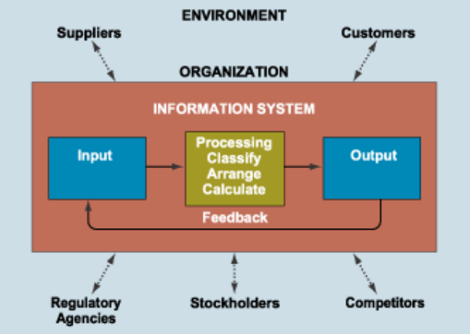
Ghasemaghaei et al. (2018) find that a firm's data analytics competency, which includes the quality of its data, improves its decision-making performance. Pressman and Maxim (2020) explain that integrated software systems improve consistency, maintainability, and operational reliability by reducing redundancy and streamlining data flow across system components.
Within apartment management, these principles support a centralized architecture that integrates tenant information, maintenance records, communication, and financial transactions in one environment. Property management studies point the same way, locating operational inefficiency where information systems lack interoperability and centralized accessibility (Burke, 2026; Magno et al., 2024).

2.1.3 Financial Analytics and Administrative Decision Support
Financial management is one of the most critical components of apartment administration, since payment monitoring, expense tracking, and cash flow visibility shape managerial decisions. The reviewed studies emphasize that financial inefficiencies emerge when payment records are kept through fragmented or manual processes (Encarnacion et al., 2025; Magno et al., 2024; Setty, 2022).
Encarnacion et al. (2025) demonstrate that a structured payment monitoring system improves administrative oversight in student boarding houses by providing organized financial ledgers, payment summaries, and transaction visibility. Magno et al. (2024) observed that digital transaction tracking improves billing management and payment monitoring compared with paper-based systems, and Setty (2022) explains that centralized financial management systems improve transparency and reduce administrative errors by consolidating transaction records into one database. In the Philippines, Caparos et al. (2025) developed a cloud-based property management system with automated billing, secure access controls, and real-time tenant communication for a real estate business in Region XII, which its staff rated positively on usability, security, operational efficiency, and tenant experience, security highest.
Read with Ghasemaghaei et al. (2018), these studies treat financial records not merely as reports but as decision support, most useful when they are integrated into a centralized operational framework rather than kept as a standalone feature.

2.1.4 Digital Communication and Structured Issue Resolution
Operational efficiency in apartment environments also depends on communication and maintenance coordination. The reviewed studies identify informal communication as a contributor to delayed responses, inconsistent issue tracking, and reduced tenant satisfaction (Jing & Lim, 2021; Saputra et al., 2025).
Jing and Lim (2021) found, among residents of high-rise apartments in China, that management service quality affects residential satisfaction and the willingness to recommend, and that the quality of the management process matters most. Interviewing 150 dormitory residents, Altinay et al. (2024) found that dormitory management needed improvement in information management, communication, and service quality, and proposed digital communication platforms, regular maintenance schedules, and more transparent financial management. Yet in traditional management settings, tenant concerns are reported verbally or through messaging applications, so requests go unrecorded and follow-up is inconsistent.
Saputra et al. (2025) built a web-based room management system for a boarding house that handles room data, tenant registration, payment invoices, and complaints; in acceptance testing with its administrator and ten tenants, 90 percent were satisfied, and the system reduced administrative workload and data entry errors. Recording a complaint as a request is what makes it traceable from report to resolution.
Communication with prospective tenants has followed the same pattern. In Ormoc City, where rooms in boarding houses were found through newspapers, posters, friends, and social media, Pernate et al. (2025) built a mobile application with real-time listings, booking, and digital transactions, developed with Agile and evaluated with ISO/IEC 25010, which owners rated Excellent and tenants Very Good. In Surigao City, Mangca (2023b) developed a web-based boarding house booking system with SMS notifications, and its boarders and owners credited the notifications with reducing miscommunication (Mangca, 2023a). Each centers on how a tenant finds and books a room.
Closest to this study, Canlas et al. (2026) developed FixHub, a maintenance reporting system for dormitories in the Philippines, using the Agile methodology, and evaluated it with ISO/IEC 25010 and the Technology Acceptance Model through surveys of tenants, administrators, and IT professionals, who rated it very highly on every criterion. Its scope is maintenance concerns, emergency alerts, and complaints.
The literature therefore treats structured communication and maintenance ticketing as integral parts of an apartment management system rather than supplementary features: a concern recorded in one system can be traced, coordinated, and followed to completion.

2.1.5 Progressive Web Applications as an Accessibility and Integration Framework
While centralized systems improve operational coordination, effective implementation also depends on accessibility across devices and varying infrastructure conditions. Progressive Web Applications (PWAs) provide a technological framework for addressing these challenges in resource-constrained environments (Biørn-Hansen et al., 2017; Muawwal, 2024).
Muawwal (2024) shows that a PWA, built from a web app manifest and a service worker, gives a website the features of an installed application without a separate native application for each platform: it could be installed on mobile and desktop devices and remained accessible offline or on an unstable connection. Biørn-Hansen et al. (2017) likewise explain that PWAs reduce development complexity by letting a single application operate across multiple platforms without separate native implementations. Because a PWA is used like an installed application but delivered as a website, its usability has also been given heuristics of its own (Anuar & Othman, 2024).
These characteristics matter in small-scale apartment operations, where limited infrastructure, inconsistent connectivity, and varied devices can keep conventional enterprise systems out of reach. Mia et al. (2024) find that small and medium-sized enterprises in the Philippines meet barriers of infrastructure, technical capacity, and resources when they adopt digital technology, which makes accessibility and simplicity of deployment critical considerations. A PWA is therefore the delivery layer that keeps the centralized functions of an MIS accessible across devices and conditions.

2.1.6 Synthesis of Literature
The reviewed literature collectively demonstrates that operational inefficiencies in apartment management environments primarily emerge from fragmented administrative structures rather than the complete absence of digital technologies. Property management studies identify persistent issues involving disconnected workflows, inconsistent record management, delayed communication, and operational redundancy (Burke, 2026; Magno et al., 2024). Information systems and software engineering literature explains these inefficiencies as consequences of fragmented information processing and lack of centralized operational visibility (Ghasemaghaei et al., 2018; Pressman & Maxim, 2020).
Financial analytics studies further establish that structured and centralized financial data improves administrative oversight and operational transparency (Encarnacion et al., 2025; Setty, 2022). Similarly, communication and maintenance coordination studies emphasize that operational accountability improves when issue resolution processes are formalized through structured digital workflows rather than informal communication channels (Jing & Lim, 2021; Saputra et al., 2025).
Meanwhile, PWA literature provides the technological framework that enables these integrated operational components to remain accessible within environments characterized by limited infrastructure (Mia et al., 2024) and varying device conditions (Biørn-Hansen et al., 2017; Muawwal, 2024). Recent housing systems have also been evaluated with ISO/IEC 25010 (Canlas et al., 2026; Pernate et al., 2025), the quality model this study uses.
Despite their complementarity, these studies are commonly implemented in isolation. Existing systems frequently focus on specific operational functions such as financial management, communication, or tenant tracking independently, resulting in partial solutions that fail to address the interconnected nature of apartment management workflows. Consequently, the literature reveals a need for an integrated operational framework that centralizes administrative processes, formalizes communication, supports financial monitoring, and remains accessible within resource-constrained residential environments.

2.2 Gap Bridged by the Study
Based on the synthesis of literature, a significant research gap emerges regarding the absence of an integrated apartment management system specifically designed for small-scale and resource-constrained residential operations. Existing systems are commonly developed either as enterprise-oriented platforms or as isolated functional solutions focusing on individual administrative tasks such as payment monitoring, room booking, tenant management, or maintenance coordination (Magno et al., 2024; Mangca, 2023b; Pernate et al., 2025; Saputra et al., 2025; Setty, 2022). Puspasari et al. (2025), for example, developed a web-based boarding house information system that monitors room status and sends billing notifications through WhatsApp, but its only user is the boarding house manager, so tenants cannot see their own bills or report a concern through it.
While these systems demonstrate improvements in specific operational areas, small-scale apartment and boarding house operations face conditions they were not built around: administrative work that grows with every unit (Burke, 2026), and limited infrastructure, technical capacity, and resources (Mia et al., 2024). As a result, many administrators continue to rely on fragmented workflows involving manual documentation, spreadsheet-based records, informal communication channels, and disconnected transaction monitoring processes.
Furthermore, although studies support the importance of centralized information systems, financial analytics, structured communication, and accessible deployment architectures, few implementations integrate these components into a single operational framework tailored for localized, resource-constrained residential settings.
This study addresses this gap through the development of Hivelet, a Progressive Web Application-based apartment management system designed specifically for small-scale apartment operations. The system integrates centralized MIS principles, financial tracking mechanisms, structured issue ticketing, tenant management, booking coordination, and accessible cross-device deployment within a unified operational environment.
By consolidating these interconnected administrative functions into a single platform, the study transforms fragmented workflows into cohesive, traceable, and structured system processes, thereby aligning theoretical principles with practical implementation within real-world residential management contexts.

2.3 Concept of the Study
This study is grounded in the concept of improving apartment management by integrating its core processes into a centralized digital platform. Apartment operations involve interconnected activities such as tenant management, payment tracking, booking coordination, and maintenance handling. In traditional setups, these processes are often managed manually and separately, resulting in delays, inconsistencies, and increased administrative workload.
Figure 2-2 illustrates the study's conceptual framework using the Input-Process-Output (IPO) model, a standard software engineering approach that maps how system components interact to transform inputs into outputs.
Figure 2-2. Conceptual Framework.
[IMAGE FILE: images/Figure 2-2 - Conceptual Framework.png]
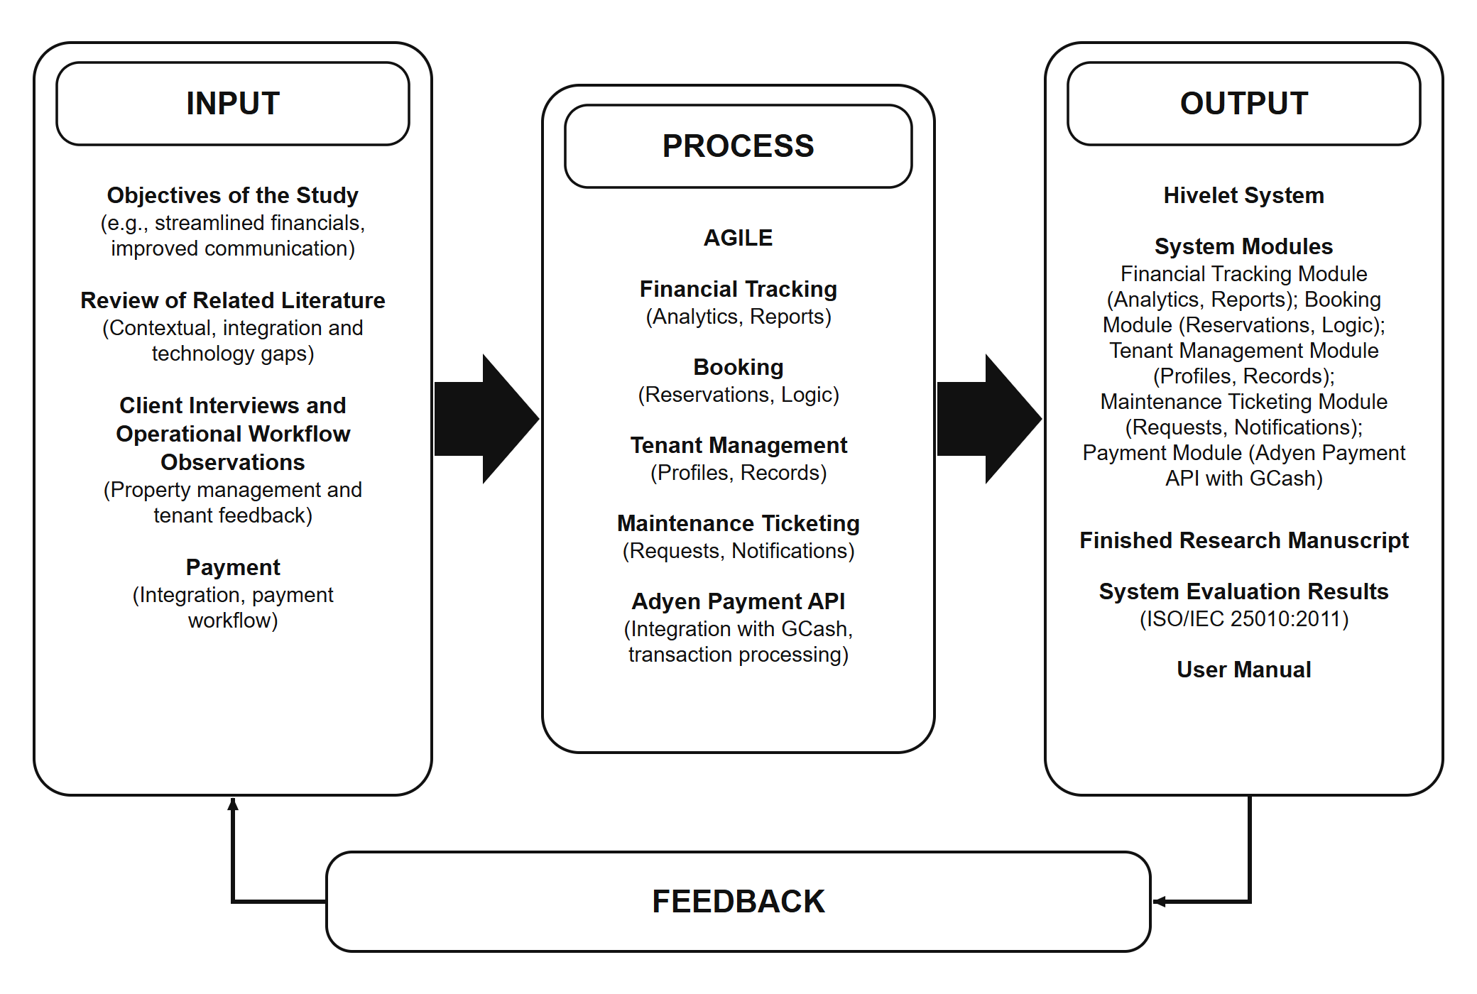
In this study, the Input phase consists of the study objectives, review of related literature, client interviews, needfinding observations, and analysis of existing administrative and payment workflows. These inputs provide both theoretical and contextual foundations, allowing the researchers to identify operational gaps, user requirements, and system constraints within the apartment management environment. The Process phase applies the Agile Software Development Life Cycle, integrating iterative stages of planning, design, development, testing, deployment, and review. Within this phase, the system modules are implemented, including financial tracking (analytics and reports), booking management (reservation logic), tenant management (profiles and records), maintenance ticketing (requests and notifications), and an optional online payment integration using the Adyen API with GCash. These processes transform identified requirements into a functional and structured system aligned with real-world operational needs. The Output phase includes the developed Hivelet system, its functional modules, and generated outputs such as financial reports exportable as Excel files, inquiry and tenancy records, and payment records. It also includes the completed research manuscript, system evaluation results based on ISO/IEC 25010 standards, and the user manual. These outputs reflect the system's effectiveness in improving administrative efficiency, data organization, and communication within the apartment management process. Feedback is incorporated across all phases, allowing continuous system refinement based on user evaluation and operational performance, ensuring that the system remains adaptive and responsive to real-world conditions.

2.4 Definition of Terms
Hivelet – A web-based apartment management system developed as a Progressive Web Application (PWA) for the Fe Galang Da Silva Boarding House, designed to centralize and integrate tenant management, financial tracking, booking inquiries, and maintenance issue reporting into a unified operational platform that supports small-scale, resource-constrained administrative environments.
Progressive Web Application (PWA) – A web-based application architecture that enables app-like functionality through browsers, providing responsive design, offline capability, and cross-device accessibility without requiring installation from an app store, making it suitable for low-resource and hybrid operational environments.
Resource-Constrained Environment – Refers to small-scale residential or boarding house operations characterized by limited financial resources, minimal technical infrastructure, and constrained administrative manpower, where management processes are typically dependent on hybrid manual and basic digital tools rather than fully integrated systems.
Fragmented Workflow – A condition in which administrative processes such as tenant management, financial recording, and maintenance reporting are handled using disconnected tools (e.g., spreadsheets, paper records, and messaging applications), resulting in inconsistent data, delayed coordination, and reduced operational efficiency.
Centralized System – A system architecture in which all operational data and processes are managed within a single integrated platform, enabling consistent data storage, real-time access, and unified control over administrative functions.
Small-Scale Apartment Management – Refers to the administrative operation of residential boarding houses or apartments with limited units, minimal staff, and constrained digital infrastructure, where management processes are often hybrid, combining manual and basic digital tools.
Management Information System (MIS) – An information system framework that processes raw operational data into structured and meaningful information to support decision-making, coordination, and control within an organization or operational environment.
Booking Inquiry – A system feature that allows prospective tenants to submit room availability requests through the platform, which are reviewed and processed by administrators for approval or scheduling purposes.
Financial Tracking – A system function that records and monitors tenant payments and operational expenses in a structured digital format, ensuring accurate financial records and supporting administrative monitoring of income and expenditures.
Cash Flow Monitoring – The process of generating summarized financial reports based on recorded transactions, providing insights into income, expenses, and overall financial movement within the apartment system.
Issue Ticketing System – A structured digital mechanism that allows tenants to submit maintenance or facility-related concerns, which are then tracked, assigned, and resolved by administrators through a centralized workflow system.
User Authentication – A security process that verifies the identity of users accessing the system to ensure authorized entry and protect sensitive operational data.
Role-Based Access Control (RBAC) – A security model that restricts system access based on user roles (e.g., admin, tenant), ensuring that users can only access functions relevant to their responsibilities.
Optional Online Payment Feature – A supplementary system function that allows tenants to settle a bill through GCash using the Adyen payment gateway, without serving as the primary financial processing mechanism of the system. A payment made this way enters a pending state and is settled only after the administrator verifies it.
ISO/IEC 25010:2011 – An international software quality standard (International Organization for Standardization & International Electrotechnical Commission [ISO/IEC], 2011a) that defines eight characteristics of product quality: functional suitability, performance efficiency, compatibility, usability, reliability, security, maintainability and portability, divided into thirty-one sub-characteristics. It also defines a model of quality in use, with five characteristics: effectiveness, efficiency, satisfaction, freedom from risk and context coverage. The 2023 revision renamed usability as interaction capability and portability as flexibility, added safety as a ninth characteristic, and moved quality in use into a separate standard (ISO/IEC, 2023).
Adyen – The payment gateway through which a tenant may pay a bill online with GCash. In this study it runs on Adyen's test account, and each payment it reports is recorded as pending until the owner verifies it.
GCash – A Philippine mobile wallet, offered in Hivelet as the optional online way to pay a bill.
Landlady – The person who runs the Fe Galang Da Silva Boarding House day to day on behalf of its owner, and the system's only administrator.
Owner – In Chapter 4, the landlady in her role as the system's administrator (Section 3.3).
Tenant – A person renting a unit, who uses the system through their own account to view their bills, receipts and repair requests and to pay online.
Prospective Tenant – A person looking for a room who uses only the public website, without an account, to view the units and their rates and to send an inquiry.
Technical Evaluator – An information technology professional from outside the research team who rated the system against ISO/IEC 25010:2011.
User Acceptance Testing (UAT) – Testing in which the intended users perform their own tasks on the live system, to decide whether it meets their needs (Section 4.3.7).
Weighted Mean – The average rating of a survey item: the sum of each rating multiplied by the number of respondents who chose it, divided by the number of respondents (Section 3.3).
50% Share – A system-computed figure equal to half that row's Rent Amount, kept for ledger parity with the owner's historical spreadsheet.

3 MATERIALS AND METHODS
This chapter presents the strategies, tools, and methods used in the development of the Hivelet system, and the instruments and procedures used in evaluating the system's functionality, performance, and user acceptability.

3.1 Materials
This section presents the materials used in the documentation of the study and in the development of the Hivelet system. These materials include the software and hardware components used in the design, development, testing, and deployment of the Progressive Web Application (PWA). The software tools include programming languages, frameworks, and database technologies, while the hardware consists of the physical equipment used for system development and evaluation. Each material, its purpose, and its contribution to the Hivelet system is discussed in the succeeding subsections.

3.1.1 Software
The development of the Hivelet system required modern front-end and back-end technologies to ensure a responsive, accessible, and secure Progressive Web Application (PWA) for both property administrators and tenants of a small-to-medium apartment system.
Table 3-1. Software requirements
Software | Version
Visual Studio Code | 1.85+
Vue 3 with TypeScript | 3.5 / TypeScript 5.7
Vite (build tool) | 5.4
Tailwind CSS | 4.0
Node.js with Express.js (TypeScript) | LTS (v18+) / Express 4.19
PostgreSQL, hosted on Supabase | 17.6
Adyen Web Drop-in / API Library | 6.44 / 32.0

The development environment ran on Windows 10 or higher to ensure long-term system compatibility, stability, and security.
As outlined in Table 3-1, the development used Vue 3 with TypeScript, built with Vite and styled with Tailwind CSS, to create a responsive and mobile-adaptive user interface. Node.js and Express.js, also written in TypeScript, served as the back-end framework responsible for server-side logic such as booking management, financial tracking, and issue ticket processing. TypeScript was used on both sides so that errors in the shape of a record are caught before the system runs, which matters in a system that holds the owner's actual financial records.
PostgreSQL, hosted on Supabase, was used as the system's database management tool to store and organize structured data such as tenant records, transaction history, and system logs. PostgreSQL was chosen for its row-level security, which lets the database itself enforce who may read or change each record, and for database triggers, which keep a history of every room rate change regardless of how the change is made. Google Chrome was the primary browser for development and testing due to its reliability and optimization for modern web applications.
Additionally, the user interface was prototyped directly in code rather than in a separate design tool. Each screen was built as a working prototype in Vue and Tailwind CSS, generated with the help of an AI coding assistant and reviewed by the researchers, so that the landlady and the tenants could try it on their own phones with real data. The design rules the screens follow, covering color, type, layout and wording, are recorded in the system's design guideline.

3.1.2 Hardware
To ensure efficient development, testing, and deployment of the Hivelet system, specific hardware specifications were used during the development process. Since the system follows a Progressive Web Application (PWA) architecture, both computer workstations and mobile devices were required.
Table 3-2. Workstation hardware specifications
Component | Minimum specification
Processor | Intel Core i5 or AMD Ryzen 5
Memory (RAM) | 8 GB DDR4
Storage | 256 GB Solid State Drive (SSD)
Internet connection | 25 Mbps broadband or fiber

As detailed in Table 3-2, the workstation used for local development, database management, and system testing required an SSD to ensure fast processing and smooth execution of development tools. For mobile testing, a mid-range Android device was planned to evaluate system responsiveness and performance under real-world conditions. As shown in Table 3-3, this baseline mobile setup ensured that the development team could evaluate the system's UI/UX layout and mobile adaptability using modern device standards.
Table 3-3. Mobile testing hardware specifications (baseline)
Component | Version
Operating system | Android 13 or higher
Processor or chipset | Octa-core (MediaTek Helio G99 or equivalent)
Memory (RAM) | 8 GB
Storage | 256 GB
Display | 6.78-inch FHD+ (for UI/UX layout testing)

During testing, the workstation was a Dell XPS 15 laptop with Google Chrome 154; the response times were taken on it over the boarding house's Wi-Fi and on an iPhone 15 in Safari over mobile data, and the offline, installation and browser tests also used an Infinix GT20 with Android and Chrome. The administrator used her own laptop, an Acer Nitro V 15, with Chrome.

3.2 Software Methodology
The researchers used the Agile Software Development Life Cycle (SDLC) in the development of the Hivelet system. Agile is an iterative and flexible software development approach that emphasizes continuous improvement, stakeholder collaboration, and incremental delivery of system components rather than a rigid, linear process (Pressman & Maxim, 2020).
As illustrated in Figure 3-1, the dynamic and resource-constrained nature of small-scale apartment management requires a development approach that can adapt to changing operational needs. In this context, Agile was selected as the most appropriate methodology as it allowed continuous interaction with the landlady and management of the Fe Galang Da Silva Boarding House, ensuring that system features were aligned with actual administrative workflows such as tenant management, financial tracking, booking coordination, and maintenance handling.
Figure 3-1. Agile Software Development Life Cycle.
[IMAGE FILE: images/Figure 3-1 - Agile Software Development Life Cycle.png]
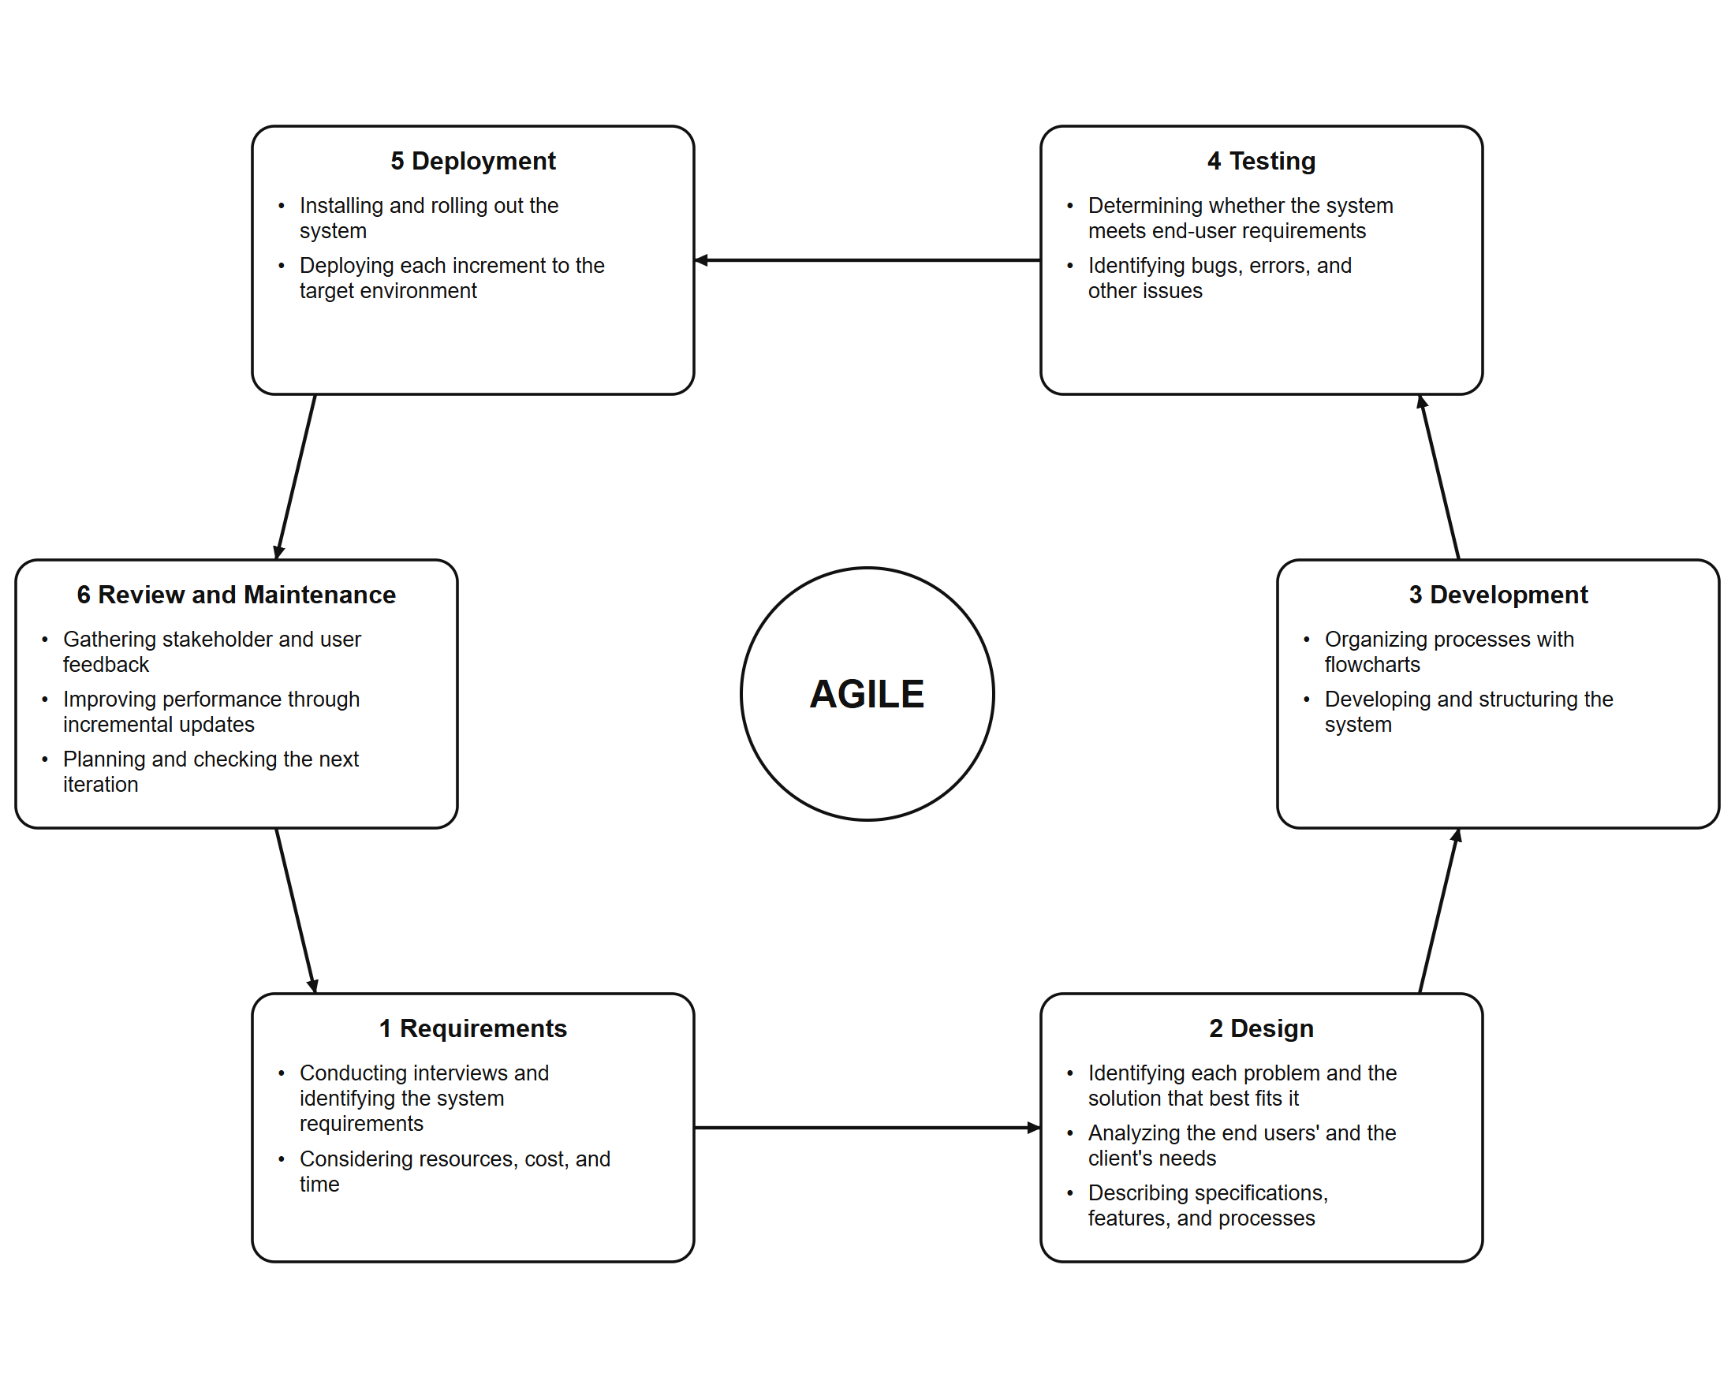
Unlike traditional SDLC models, Agile supports early identification of system issues through iterative cycles of development and testing. This enabled the researchers to refine system components based on real-time feedback, resulting in a more reliable, user-centered, and context-appropriate solution. Furthermore, the Agile approach facilitated progressive evaluation of the system throughout its development. The system was assessed using the ISO/IEC 25010:2011 software quality model encompassing functional suitability, performance efficiency, compatibility, usability, reliability, security, maintainability, and portability (ISO/IEC, 2011a). This ensured that the developed system not only meets user requirements but also adheres to established software quality standards.
Additionally, the flexibility of Agile allowed the system to be continuously improved, modified, and adapted without compromising performance. This is particularly important in ensuring that Hivelet remains functional under varying conditions such as limited infrastructure, unstable internet connectivity, and evolving user needs.

3.2.1 Requirements
In this phase, the researchers conducted needfinding through direct collaboration with the landlady and management of the Fe Galang Da Silva Boarding House. This aligns with the first objective of the study, which focuses on identifying user needs and operational challenges. Data were gathered through interviews with the landlady, the first in February 2026, through observation, and through a review of her income and expense workbook, to examine existing administrative practices, including the use of manual ledgers, fragmented financial tracking, and unstructured communication for maintenance requests. These findings revealed inefficiencies such as inconsistent record-keeping, delayed communication, and lack of centralized monitoring. Two later rounds of written questions, answered on 17 September and 12 October 2026, settled what the interviews had left open. Based on these insights, the researchers defined the system requirements, scope, and core functionalities of Hivelet. Emphasis was placed on the need for a centralized digital platform capable of integrating booking, financial tracking, and maintenance management within a unified system.

3.2.2 Design
During the Design phase, the identified requirements were translated into system architecture and interface prototypes. The researchers developed the interface as working prototypes in code, covering three user roles: public users, tenants, and administrators. Each prototype was reviewed with the landlady on the device she uses, and the findings were applied in the next iteration (Chapter 4, Table 4-19). The system was designed with consideration for a resource-constrained environment, characterized by limited infrastructure, unstable internet connectivity, and minimal administrative resources. To address these constraints, Hivelet was structured as a lightweight Progressive Web Application (PWA) with optimized performance, simple navigation, and minimal system requirements.
Workflows for booking, financial monitoring, and maintenance requests were mapped and refined through stakeholder feedback to ensure alignment with real-world operations.

3.2.3 Development
This phase corresponds to the second objective of the study, which focuses on developing the system. The researchers implemented the Hivelet system using Vue 3 with TypeScript for the front-end interface, ensuring responsiveness across devices. The back-end was developed using Node.js and Express.js in TypeScript to manage core functionalities such as booking processing, financial computations, and maintenance ticket handling. An optional online payment feature was implemented through the Adyen payment gateway, allowing a tenant to settle a bill through GCash without replacing the primary cash-based financial workflow. PostgreSQL, hosted on Supabase, was used as the database management system to store tenant records, transaction data, and system logs. The system was developed incrementally, following Agile principles, allowing continuous refinement based on feedback and testing results.

3.2.4 Testing
Aligned with the third objective, testing was carried out in four layers, each answering a different question. The test levels, unit and integration, system, and acceptance, are those defined in ISO/IEC/IEEE 29119-1 (International Organization for Standardization, International Electrotechnical Commission, & Institute of Electrical and Electronics Engineers [ISO/IEC/IEEE], 2022), and each test was planned as a measure of the ISO/IEC 25010 sub-characteristics listed in Table 3-6.
Automated verification. Twenty check suites were written alongside the system. They verify every endpoint and the separation of roles, re-derive the owner's ledger and exported reports from the database, check the payment gateway's message signatures, and confirm that no screen presents stored or empty data as a live figure. They run against the live system without writing to it, and were run after every significant change.
Screen-versus-database audit. Each figure shown on each screen was compared with a read-only query of the live database for the same records, to confirm that a screen shows a person what the database holds for them.
Offline, installation, accessibility and simultaneous-use tests. With an automated browser, the installed application was opened without a connection and on throttled slow connections, and the live system was read by several simulated simultaneous users, with every save blocked in the browser so that no record was written. The same browser scanned the screens against the Web Content Accessibility Guidelines, levels A and AA (World Wide Web Consortium, 2023).
Functional walkthrough and user acceptance testing. A 26-step walkthrough exercised every function that writes data once, on the one vacant unit. The owner and three tenants then used the live system for their own tasks on their own devices, observed by the researchers, and the owner and two of the tenants used it at the same time. Results are reported in Chapter 4, Section 4.3.

3.2.5 Deployment
After successful testing, the Hivelet system was deployed to Vercel, a cloud hosting service, with its database hosted on Supabase, where the system is accessible through a public web address for real-world usage and evaluation. A pilot implementation was conducted with selected users to validate real-world performance before full deployment. The researchers performed the final system configuration, database migration, and environment setup to ensure smooth operation.

3.2.6 Review and Maintenance
This phase complemented the evaluation procedure by implementing refinements and system improvements based on the results gathered from testing and the ISO/IEC 25010 evaluation. Following Agile principles, identified issues related to functional suitability, performance efficiency, compatibility, usability, reliability, security, maintainability, and portability were addressed through iterative optimization and maintenance activities.

3.3 Evaluation Procedure
The testing and the evaluation followed the ISO/IEC 25000 series of standards on software quality, Systems and software Quality Requirements and Evaluation (SQuaRE). The quality model was that of ISO/IEC 25010:2011, which divides the quality of a software product into eight characteristics and thirty-one sub-characteristics, and defines a separate model of quality in use, the quality experienced by users in their own context (ISO/IEC, 2011a). The evaluation followed the five steps of the evaluation process in ISO/IEC 25040: establishing the evaluation requirements, specifying the evaluation, designing it, executing it and concluding it (ISO/IEC, 2011b). Each characteristic was judged on two kinds of evidence. Measured quality came from the tests described in Section 3.2.4, each expressed as a measure of a sub-characteristic in the form ISO/IEC 25023 uses, a ratio X = A / B such as the number of executed test steps that gave the correct result over the number executed (ISO/IEC, 2016b). Rated quality came from the survey questionnaire, in which every item was assigned to one sub-characteristic before it was answered (Table 3-6). Quality in use was measured during the user acceptance test as effectiveness (tasks completed), efficiency (time and wrong turns per task) and the contexts covered, following ISO/IEC 25022 (ISO/IEC, 2016a). The survey used the 2011 edition's characteristics; the 2023 revision of ISO/IEC 25010, which renames Usability and Portability and adds Safety, was used only to show where each result falls in the newer model.
This phase directly supports the fourth objective of the study, which focuses on evaluating and optimizing the system using the ISO/IEC 25010 Software Quality Model. To ensure a realistic measurement of system performance and usability, the evaluation was conducted during actual use in the deployment environment, with a specific emphasis on eight key attributes: functional suitability, performance efficiency, compatibility, usability, reliability, security, maintainability, and portability.
A structured survey questionnaire was administered to four groups: the administrator of the boarding house, its tenants, prospective tenants, and technical evaluators with a background in information technology. Each group rated only the characteristics it is in a position to judge: tenants did not rate Security or Maintainability, prospective tenants, who see only the public website, rated neither, and only technical evaluators rated Maintainability, the group with the background to judge it. Responses were measured using the 5-point Likert scale (Likert, 1932) in Table 3-4, and mean scores were interpreted using the ranges in Table 3-5.
Participants. The landlady, who runs the boarding house day to day on behalf of its owner, took part as the system's only administrator. Because she is the one person who uses the owner's side of the system, Chapter 4 refers to her, in that role, as the owner. Tenants were chosen by purposive and convenience sampling (Etikan et al., 2016): from the tenants at the boarding house on the evening of the test, the researchers chose ones who pay in cash on site, ones less used to mobile applications, users of both Android and iPhone handsets, and residents of more than one cluster. Three tenants were observed because the number of new usability problems found falls quickly with each additional tester (Nielsen & Landauer, 1993). One prospective tenant, a person who does not live at the boarding house and was invited by the researchers to use the public website as someone looking for a room would, used it on their own phone without an account: they browsed the units and rates and sent an inquiry about a unit. The administrator's reply was tested separately by the team. The technical evaluator was an IT professional who works in software quality assurance; he reviewed the running system and did not inspect the source code.
Instruments. Four instruments were used. Task cards were read aloud to each tester, in English and Filipino. An observation sheet recorded, for each task, whether it was completed without help, with help, or not at all, the time taken, and the number of wrong turns. A defect log was kept. The fourth was the ISO/IEC 25010 survey questionnaire, with a separate section for each of the four respondent groups (the administrator, tenants, prospective tenants and technical evaluators); the tenant and prospective tenant sections were in English and Filipino.
Data gathering. Each tester gave written consent before taking part. Each used their own account on their own device while a facilitator read the tasks without indicating where to tap and an observer completed the observation sheet. Testers were asked to think aloud, saying, for example, whether they expected a change to their personal details to save, whether a payment showed as settled once the owner confirmed it, and whether a repair request appeared once sent; they were not interviewed during or after their tasks. When a tester was stuck, help followed a fixed order: a neutral prompt after about thirty seconds ("What are you looking for?"), then a hint about where to look, and only then a demonstration. A task finished after the prompt counted as completed without help, one finished after the hint as completed with help, and one that needed a demonstration as not completed. Photographs were taken for documentation, only with the tester's permission; no screen was recorded. Each respondent answered the survey after using the system, without the researchers viewing their answers: the tenants and the prospective tenant straight after their tasks, the administrator the same evening, and the technical evaluator the day after the evaluators' review. Page load times were measured once per screen on the devices named in Section 3.1.2, with the browser's cache cleared for a first load.
Statistical treatment. For each survey item the weighted mean was computed as
WM = Σ(f × w) / N
where f is the number of respondents choosing a rating, w the rating (1 to 5) and N the number of respondents, and interpreted using Table 3-5. The composite mean of each characteristic is the mean of its item means, computed per respondent group and then as the mean of the group means, so that one administrator is not outweighed by several tenants on functions only she uses; the overall mean is the mean of the eight composites. For the acceptance test, the task completion rate is the number of tasks completed without help divided by the number attempted, reported with the median time per task and the mean number of wrong turns, following the effectiveness and efficiency measures of the ISO/IEC 25010 quality in use model.
The responses are summarized with descriptive statistics, the weighted mean of each item and the composite mean of each characteristic, and read alongside the results of the tests in Section 3.2.4. No inferential test is made, so the results are reported as descriptions of how the respondents rated the system.
Table 3-4. Likert scale
Scale | Meaning | Description
5 | Strongly Agree | The respondent strongly agrees with the statement
4 | Agree | The respondent agrees with the statement
3 | Neutral | The respondent neither agrees nor disagrees with the statement
2 | Disagree | The respondent disagrees with the statement
1 | Strongly Disagree | The respondent strongly disagrees with the statement

The mean of each item, and the composite mean of each characteristic, is interpreted with Table 3-5. The range from 1 to 5 is divided into five equal intervals of 0.80.
Table 3-5. Interpretation of mean scores
Mean score | Verbal interpretation
4.21 – 5.00 | Very High Quality
3.41 – 4.20 | High Quality
2.61 – 3.40 | Moderate Quality
1.81 – 2.60 | Low Quality
1.00 – 1.80 | Very Low Quality

Table 3-6 assigns every survey item and every test to the sub-characteristic it measures. Item numbers are those of each group's section of the questionnaire (O = administrator, T = tenants, E = technical evaluators, P = prospective tenants).
Table 3-6. Survey items and tests assigned to the ISO/IEC 25010:2011 sub-characteristics
Characteristic | Sub-characteristic | O | T | E | P | Measured by (Section 3.2.4)
Functional Suitability | Functional completeness | 1 | 1, 3 | 1 | 1 | Requirements traceability; walkthrough
 | Functional correctness | 2, 3, 4, 6 |  | 2, 3, 5 |  | Automated verification; screen-versus-database audit; walkthrough
 | Functional appropriateness | 5 | 2 | 4 | 2, 3 | User acceptance test
Performance Efficiency | Time behaviour | 7, 8 | 9, 10 | 6, 7 | 7, 8 | Load and response times on real devices
 | Resource utilization |  |  | 8 |  | Lighthouse; size of the code downloaded
 | Capacity | 9 |  |  |  | Simultaneous-user test
Compatibility | Co-existence | 12 | 15 | 11 |  | (rated only)
 | Interoperability | 10, 11 | 14 | 9, 10 | 10 | Browser matrix; gateway checks; export checks
Usability | Appropriateness recognizability | 13 | 4 | 12 | 4 | User acceptance test
 | Learnability | 17 | 8 | 16 |  | User acceptance test
 | Operability | 14 | 5, 6 | 13 | 5 | User acceptance test
 | User error protection | 15, 16 | 7 | 14, 15 | 6 | Walkthrough
 | User interface aesthetics |  |  |  |  | (not evaluated)
 | Accessibility |  |  |  |  | Accessibility scans (axe-core; WCAG 2.0 to 2.2, A and AA)
Reliability | Maturity |  | 12 |  | 9 | Defect log
 | Availability | 18 | 11 |  |  | (rated only)
 | Fault tolerance | 20 | 13 | 17, 19 |  | Offline and weak-connection tests; walkthrough
 | Recoverability | 19, 21 |  | 18, 20 |  | Live use; offline tests
Security | Confidentiality | 22, 23 |  | 21, 22 |  | Walkthrough; manual protection checks; code review
 | Integrity |  |  |  |  | Gateway signature checks; code review
 | Non-repudiation |  |  |  |  | Audit trail
 | Accountability | 24 |  | 23 |  | Audit trail
 | Authenticity | 25 |  | 24, 25 |  | Manual protection checks; passive external scans
Maintainability | Modularity |  |  | 30 |  | Permission matrix check
 | Reusability |  |  |  |  | (not evaluated)
 | Analysability |  |  | 26, 27 |  | Migration history
 | Modifiability |  |  | 28 |  | Configurable settings
 | Testability |  |  | 29 |  | Automated verification
Portability | Adaptability | 26 | 16, 17 | 31 | 11 | Screen widths; devices used
 | Installability | 27, 28 | 18 | 32, 33 | 12 | Installation tests
 | Replaceability |  |  |  |  | Export in the owner's layout

3.4 Ethical Considerations
The study used the owner's real records and the tenants' real accounts, so it followed the Data Privacy Act of 2012 (Republic Act No. 10173, 2012). Participation was voluntary and could be withdrawn at any time without any effect on a tenant's tenancy. Each tenant used only their own account, which shows only their own records, and received an individual starting password in person, which they replaced at first sign-in. Respondents could give a name so that the researchers could tell the responses apart; the names were removed before the responses were analyzed, and none appears in this paper. Names, contact details and amounts are hidden in every figure in this paper, and faces appear only with consent. Photographs and notes were kept by the research team and will be deleted after the defense.

4 RESULTS AND DISCUSSION
This chapter presents the results of the study in the order of the four specific objectives in Section 1.2: the analysis of existing practices (4.1), the development of the system (4.2), pilot testing (4.3), and evaluation and optimization against ISO/IEC 25010 (4.4), followed by the deployment plan (4.5). Testing and evaluation follow one family of standards, ISO/IEC 25000 (SQuaRE), as declared in Section 3.3: the quality model of ISO/IEC 25010:2011, its measures in the manner of ISO/IEC 25023 and 25022, and the evaluation process of ISO/IEC 25040. Every quality characteristic is judged on two kinds of evidence, what was measured in testing and how the system's users rated it.

4.1 Analysis of Existing Apartment Management Practices and System Requirements
Answers Objective 1.
The Fe Galang Da Silva Boarding House has 33 rentable units in five clusters: the Boarding House (22 units), the Back Apartment (5), the Front Apartment (3), the Penthouse (1) and Linda (2), on three residential floors and a rooftop penthouse level (11, 11, 10 and 1 units). At the time of writing, 32 of the 33 units are occupied. The owner confirmed these figures on 13 September 2026, and they are checked against the live records on every verification run.

4.1.1 Existing Practices and Identified Problems
Before the system, the owner kept a spreadsheet workbook with two sheets, a Monthly Income Report and a Monthly Expenses Report, on a USB flash drive, together with a paper invoice book. Rent was collected in cash on site, and requests arrived by messaging application or in person. Table 4-1 compares each practice with the problem it caused. Inquiries arrived much as Pernate et al. (2025) found for boarding houses in Ormoc City, through social media and word of mouth, and left no record.
Table 4-1. Existing practices and identified problems
Area | Existing practice | Problem identified
Tenant management | Tenant details kept in the income sheet and in the owner's memory | No single record of who lives in which unit, since when, or how many occupants
Financial tracking | Income and expense sheets typed by hand; invoices written in a paper book | Totals depend on manual arithmetic; nothing checks an invoice number against the book; one file on a USB flash drive is the only copy
Communication | Requests sent by messaging application or said in person | Requests are not recorded, so there is no way to follow a request to completion
Booking | Inquiries arrived through Facebook, referrals from other people, contact and text messages, or walk-ins in person | No record of inquiries or which unit an inquiry was about

Figure 4-1 follows each area through the hands that touched it. Every path ends in a record kept apart from the others, or in no record at all, which is where each problem in Table 4-1 begins.
Figure 4-1. The owner's process before the system.
[IMAGE FILE: images/Figure 4-1 - The owner's process before the system.png]
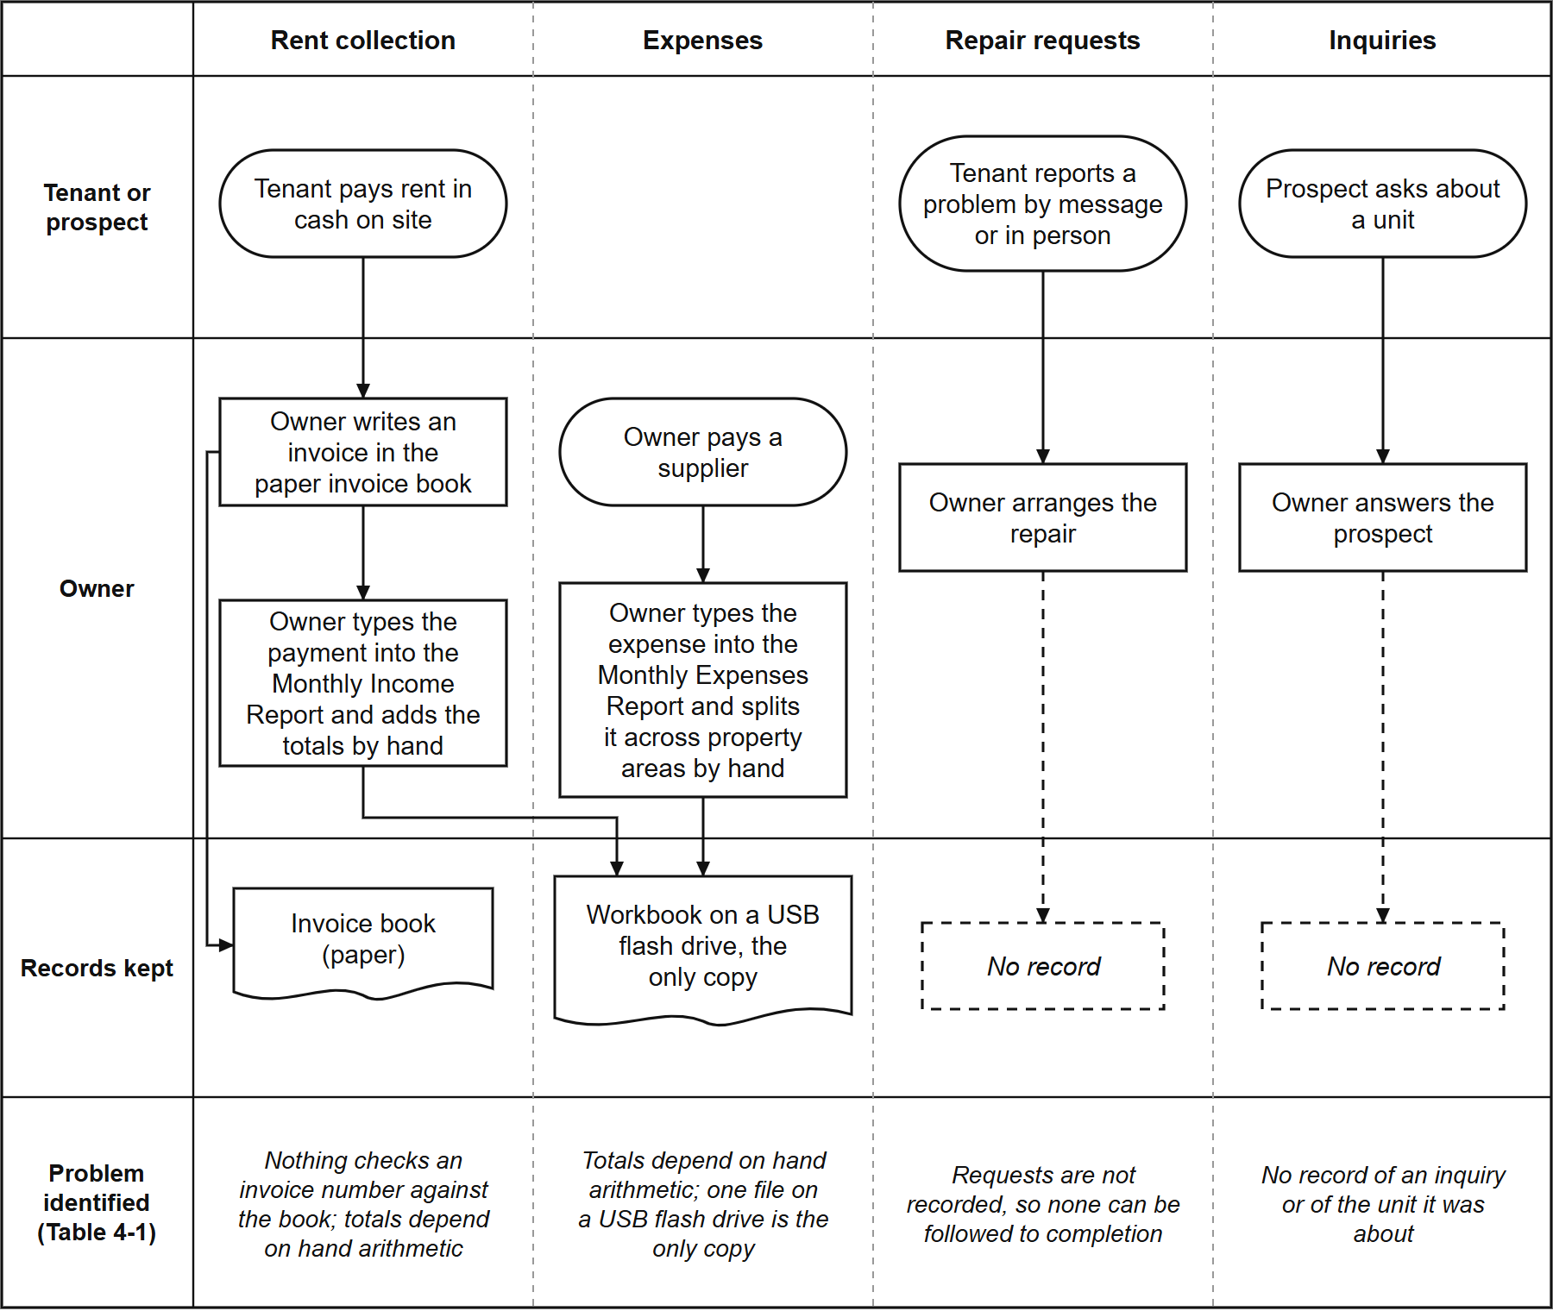
The strongest evidence came from the owner's own records. Transferring her workbook into the system (937 income rows and 1,327 expense allocations) exposed problems the spreadsheet had hidden: 402 of the 937 income rows (43%) had no anniversary date and no deposit, and five invoice numbers were each used for two different payments, once for two tenants on the same day. They were kept exactly as she wrote them and are reported on every verification run. The decisive finding is that the problems did not sit in one area: each area kept its own informal record, and nothing connected one to another, the fragmentation described in Chapter 2 (Burke, 2026; Magno et al., 2024).

4.1.2 System Requirements
The analysis produced 44 functional requirements and 49 business rules, each traced in a traceability matrix to the part of the system that implements it. Graded against the code on 16 September 2026, 25 of the 44 were implemented as worded, 15 in part, 1 in the interface only, and 3 not as worded, although what those three describe is visible to the owner in another form. Table 4-2 traces each gap to the requirement and the module that meets it.
Table 4-2. Identified gaps, system requirements and implementing modules
Identified gap | System requirement | Module (Section)
No single tenant and unit record | Keep one record per unit and per tenant, with occupancy and move-in dates | Tenant and Room Management (4.2.2)
Inquiries not recorded | Let the public view units and send an inquiry about a specific unit | Booking and Reservation (4.2.3)
Manual arithmetic and unchecked receipts | Compute charges, record payments against the owner's own invoice numbers, reproduce the owner's reports | Financial Tracking (4.2.4)
Cash only, no digital option | Offer an optional online payment that the owner verifies before it counts | Financial Tracking (4.2.4)
Requests not followed to completion | Record each request and its status until the owner closes it | Maintenance Ticketing and Notification (4.2.5)
Anyone with the file sees everything | Give the owner and each tenant access to only what their role needs | Role-Based Access Control (4.2.6)
One file on one device | Make the system reachable from any phone or computer | Progressive Web Application (4.2.7)

The analysis also set ten non-functional requirements, one for each ISO/IEC 25010 characteristic and two for auditability and exportability. Table 4-3 lists them with the section that reports how each was met.
Table 4-3. Non-functional requirements and where each is measured
Code | Requirement | Measured in
NFR-001 | The system shall provide the required business functions accurately | Sections 4.3.1 to 4.3.4; Section 4.4.3
NFR-002 | The system shall be understandable to a non-technical administrator | Section 4.3.7; Section 4.4.3 (Usability)
NFR-003 | The system shall protect personal and financial information | Section 4.2.6; Section 4.4.4
NFR-004 | Common operations should respond efficiently under the expected workload | Tables 4-10 and M-25
NFR-005 | The system shall function on modern desktop and mobile browsers | Table 4-21; Section 4.4.3 (Compatibility)
NFR-006 | The system shall preserve data consistency and avoid silent data loss | Sections 4.3.1, 4.3.3 and 4.3.6 (Table M-26)
NFR-007 | The codebase shall use a modular, documented, maintainable architecture | Section 4.4.3 (Maintainability): partly met
NFR-008 | The system shall be deployable to a hosting environment the team can maintain | Section 4.2.1; Table 4-21
NFR-009 | Important financial and administrative changes shall be traceable | Section 4.2.6 (audit trail)
NFR-010 | Relevant business data shall be usable outside the application | Section 4.2.4 (Excel downloads)

NFR-008 originally named the university's server; on the adviser's advice the team deployed the system on its own hosting instead (Section 3.2.5), and the requirement was reworded to match.
Where a requirement needed the owner's answer, it was asked rather than assumed. She confirmed that a bill is overdue from the day after its due date and that she sets rates by hand, so every rate change is recorded and no increase is applied automatically. She also confirmed that a tenant needs no email address to be recorded, and on 20 September 2026 she confirmed the rate of every unit, each of which agreed with her receipts. Her answers of 12 October 2026 settled the rest. The figure at the bottom of her income sheet is a year-to-date total, and her thirteen expense categories stay, with her free to add her own. Tenants do not report cash payments, because the administrator records every payment. The personal spending booked in 2025 was a renovation of her house, past Penthouse spending stays where it was filed, and three months with no receipt for one unit stay blank. Her workbook never recorded the move-in date of each current tenancy, so the system shows those dates as not recorded (Section 4.2.2).

4.2 Development of the Hivelet System
Answers Objective 2. Each feature the objective names has its own subsection.
Figures 4-2 to 4-6 model the system as built, and Figures 4-7 to 4-11 show its screens as they stood on 5 October 2026. The units, rates and statuses in Figures 4-7 and 4-8 are the property's own; the names, payments, expenses and repair requests in Figures 4-7, 4-9, 4-10 and 4-11 are sample records, so that no real tenant's name or payment appears in any figure.

4.2.1 System Architecture and Technology Stack
The system was built in three Agile iterations (Section 3.2). The first (24 July to 28 August 2026) built a working system and transferred the owner's records into it. The second (12 to 14 September) checked the system and its documents against each other, corrected 22 recorded errors and added automated checks. The third (15 September to the defense) took the owner's answers, put the system in her and her tenants' hands, and refined it from their feedback, the testing and the evaluation. Appendix M, Table M-19, sets out what each iteration did in each phase of Section 3.2. Each was tested and reviewed by the means available to it; the formal evaluation against ISO/IEC 25010 was carried out once, in the third, because Section 3.3 places it in actual use. Table 4-4 lists the technology used.
Table 4-4. Technology stack of the developed system
Layer | Technology | Purpose
Presentation | Vue 3.5 with TypeScript 5.7, built with Vite 5.4, styled with Tailwind CSS 4.0 | The screens used by the public, tenants and the owner
Application | Node.js with Express 4.19 in TypeScript | Business rules, calculations and access checks
Data | PostgreSQL 17.6, hosted on Supabase | Storage of all records, with row-level security
Payment gateway | Adyen (Web Drop-in 6.44, API Library 32.0) with GCash | The optional online payment
Client delivery | Progressive Web Application (vite-plugin-pwa) | Installation on a phone or computer without an app store
Hosting | Vercel | Serves the application at a public web address

Figure 4-2 shows where each part runs. The application reaches the browser as a Progressive Web Application and talks to one server program, an Express API on Vercel, which alone reads or writes the database: row-level security is on for every table, so a request that does not pass the API's sign-in and role checks reaches no data. Payment details go from Adyen's own form to Adyen directly, and every change to the database is a numbered, reviewable migration. The system is hosted rather than run on a server at the property or the university: on the adviser's advice the team deployed it on its own hosting (Section 3.2.5), so the boarding house needs no equipment beyond the owner's own laptop and phone.
Figure 4-2. System architecture.
[IMAGE FILE: images/Figure 4-2 - System architecture.png]
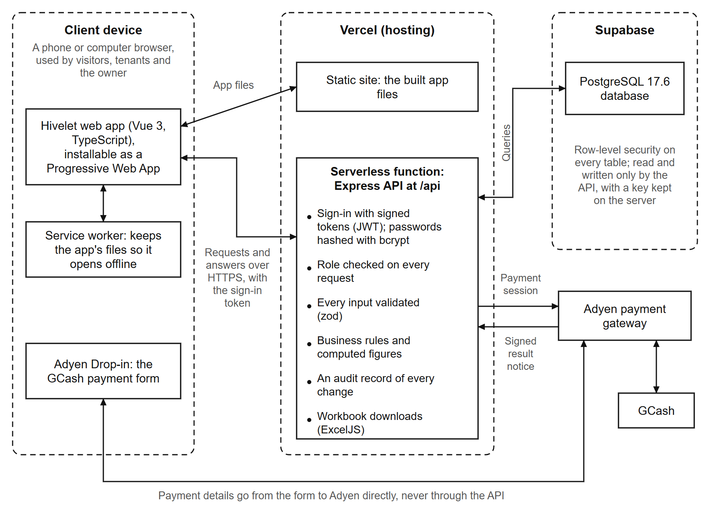
Figure 4-3 is the context diagram: the system as one process, with the four parties outside it and the data that passes between them. Figure 4-4 opens it into eight processes and the stores each reads and writes, in the Yourdon-DeMarco notation. To trace one path: the owner records a cash receipt through process 4.0, Bill and record payments, which writes it to store D3, Bills and receipts, and process 7.0, Produce reports, reads it from there for the Overview and the Excel workbooks. The notifications and the audit record are written by nearly every process and are left out of Figure 4-4 for readability.
Figure 4-3. Context diagram.
[IMAGE FILE: images/Figure 4-3 - Context diagram.png]
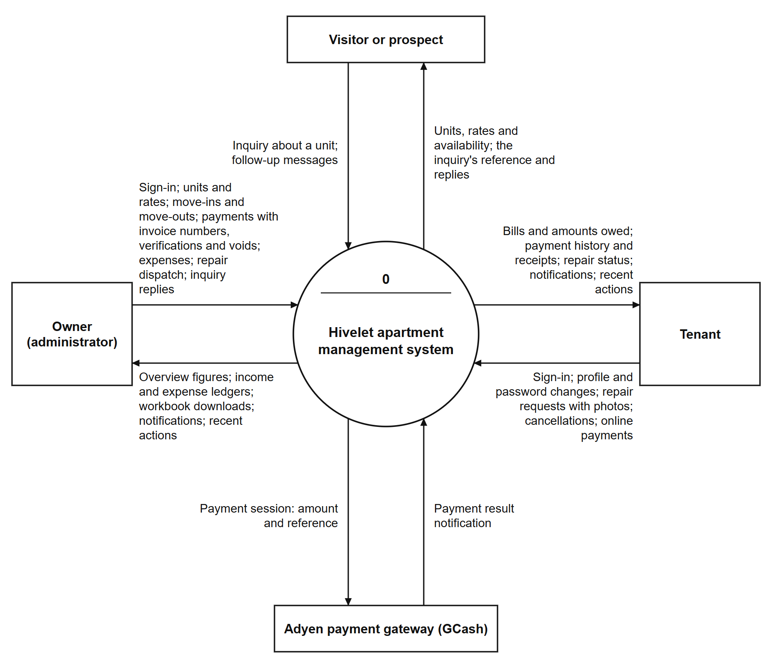
Figure 4-4. Level 1 data flow diagram.
[IMAGE FILE: images/Figure 4-4 - Level 1 data flow diagram.png]
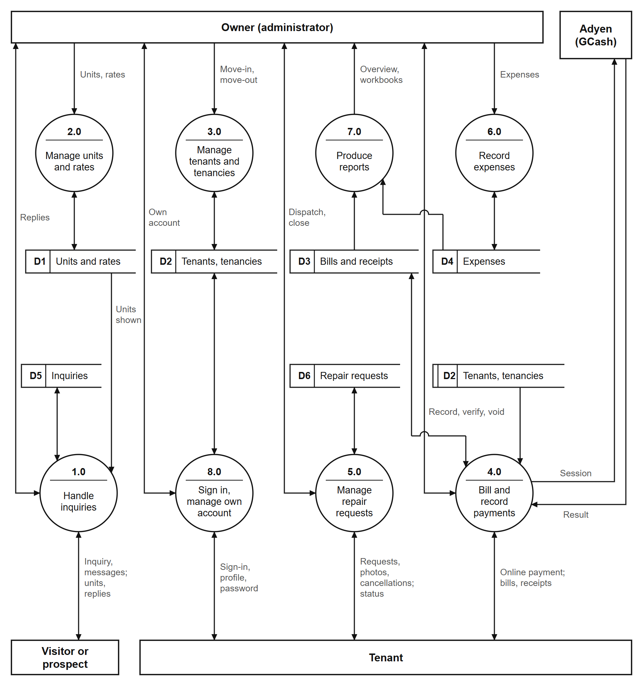
Figure 4-5 shows the same functions from the side of the people who use them. Each use case is a function the server grants to that role and refuses to every other (Table 4-7).
Figure 4-5. Use case diagram.
[IMAGE FILE: images/Figure 4-5 - Use case diagram.png]
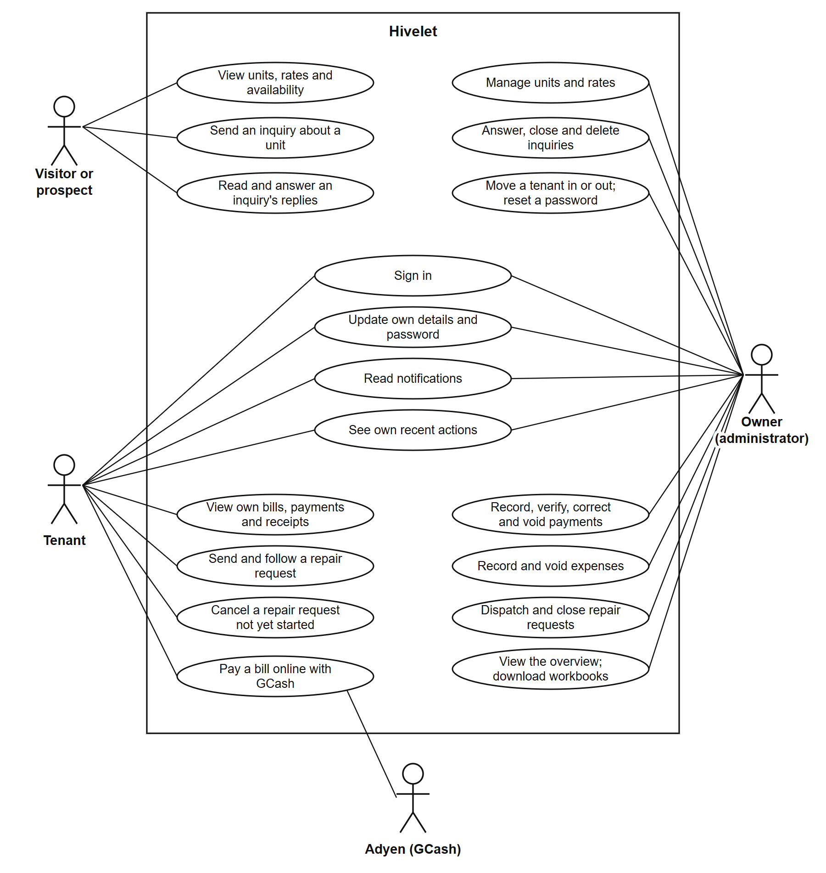
Figure 4-6, in Crow's Foot notation, is the entity-relationship diagram drawn from the database's own catalogue on 5 October 2026: 21 tables, each with a primary key, and 37 foreign keys. Rooms and profiles are its two centers: every bill, payment, receipt, tenancy, repair request and inquiry belongs to one unit, and every tenancy, bill and payment to one person. The two ledgers are kept as the owner kept them. Several rules live in the database itself, so no screen or script can bypass them: one unit cannot have two active tenancies, one invoice number cannot be used twice for the same unit and month, a gateway reference cannot be recorded twice, and the 50% Share and the remitted amount are computed columns. Table 4-5 is an extract of the data dictionary for the table the owner reads most; the complete dictionary, every column of all 24 tables, is in Appendix N.
Figure 4-6. Entity-relationship diagram.
[IMAGE FILE: images/Figure 4-6 - Entity-relationship diagram.png]
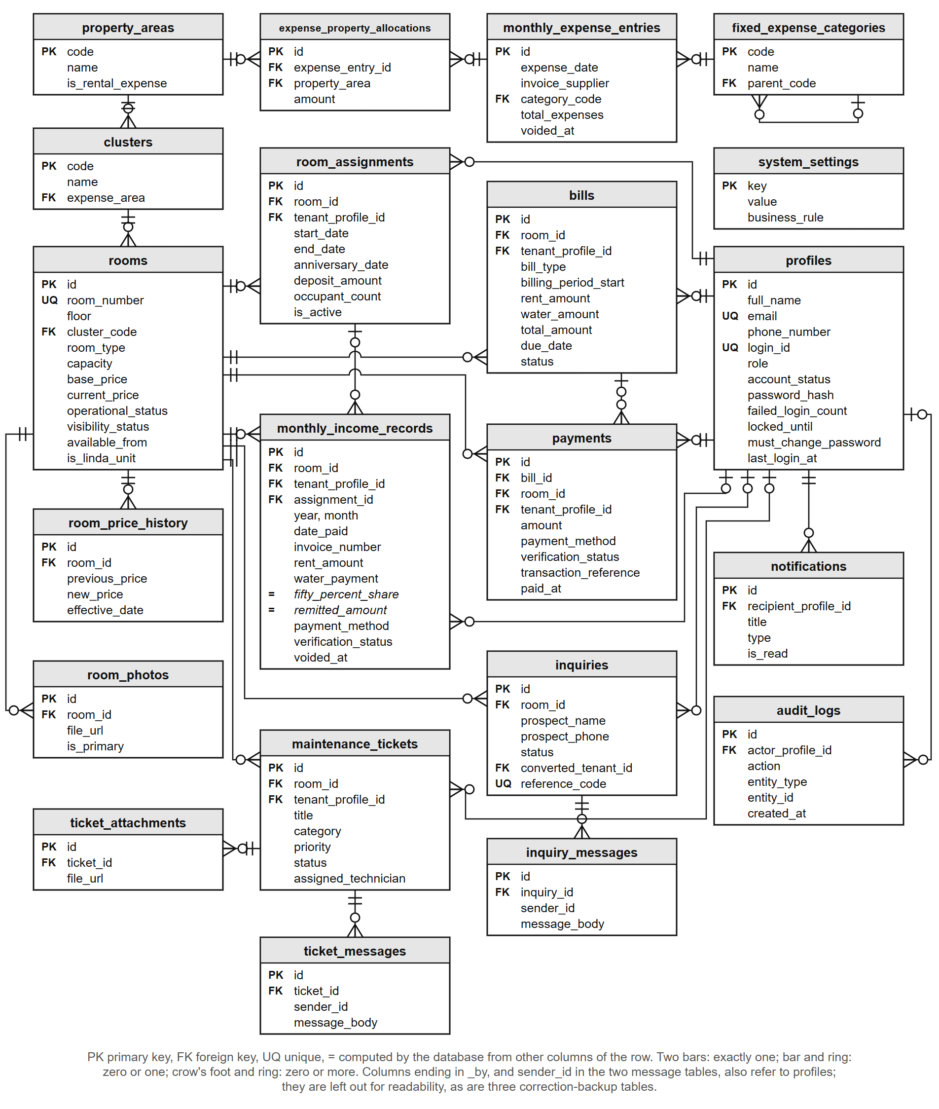
Table 4-5. Data dictionary extract: monthly income records
Column | Type | Null | Key | Description
id | uuid | No | PK | Identifies the receipt
room_id | uuid | No | FK | The unit the payment is for (rooms)
tenant_profile_id | uuid | Yes | FK | The tenant who paid, where one is recorded (profiles)
assignment_id | uuid | Yes | FK | The tenancy the payment belongs to, where known (room_assignments)
year, month | integer | No |  | The ledger month the receipt is filed under
date_paid | date | No |  | The day the money was received
contact_name | varchar(255) | No |  | The name as written on the receipt
invoice_number | varchar(100) | Yes |  | The owner's own invoice number; not repeated for the same unit and month among receipts that are not voided
rent_period_start, rent_period_end | date | No |  | The period the rent covers (BR-033)
rent_amount | numeric(10,2) | No |  | The rent received
occupants | integer | No |  | The number of occupants that month
water_payment | numeric(10,2) | No |  | The water fee, ₱200 per occupant (BR-014)
fifty_percent_share | numeric(10,2) |  | Computed | A system-computed figure equal to half the row's Rent Amount, kept for ledger parity with the owner's historical spreadsheet (BR-035)
remitted_amount | numeric(10,2) |  | Computed | Rent Amount plus Water Payment (BR-038)
payment_method | enumeration | No |  | Cash, GCash, Bank Transfer or Adyen Online
verification_status | enumeration | No |  | Verified, Pending Verification or Rejected
transaction_reference | varchar(120) | Yes |  | The gateway's reference for an online payment; never recorded twice
is_linda_billing, linda_water_charge, linda_electricity_charge | boolean, numeric(10,2) | Yes |  | The two Linda units' charges, recorded separately (BR-040)
voided_at, voided_by, void_reason | timestamp, uuid, text | Yes | voided_by: FK | When, by whom and why a receipt was voided; a voided receipt is kept, never deleted
created_at, updated_at | timestamp | Yes |  | When the row was written and last changed

4.2.2 Tenant and Room Management Module
Figure 4-7 presents the Rooms and rates screen. Each unit carries its cluster, floor, current rate and status, and each tenancy the number of occupants, the move-in date and emergency contacts. When the owner changes a rate, a database trigger records the old rate, the new rate, the date and who made the change, so no path can change a rate without leaving that record. The owner's workbook did not record move-in dates, so for the transferred tenancies the screen says the date is not recorded rather than showing a guessed one. Since 13 October 2026 a tenant also sees the deposit held for their tenancy on their own Overview, as one tenant asked in the survey (Table 4-19).
Figure 4-7. Room and rate directory.
[IMAGE FILE: images/Figure 4-7 - Room and rate directory.png]
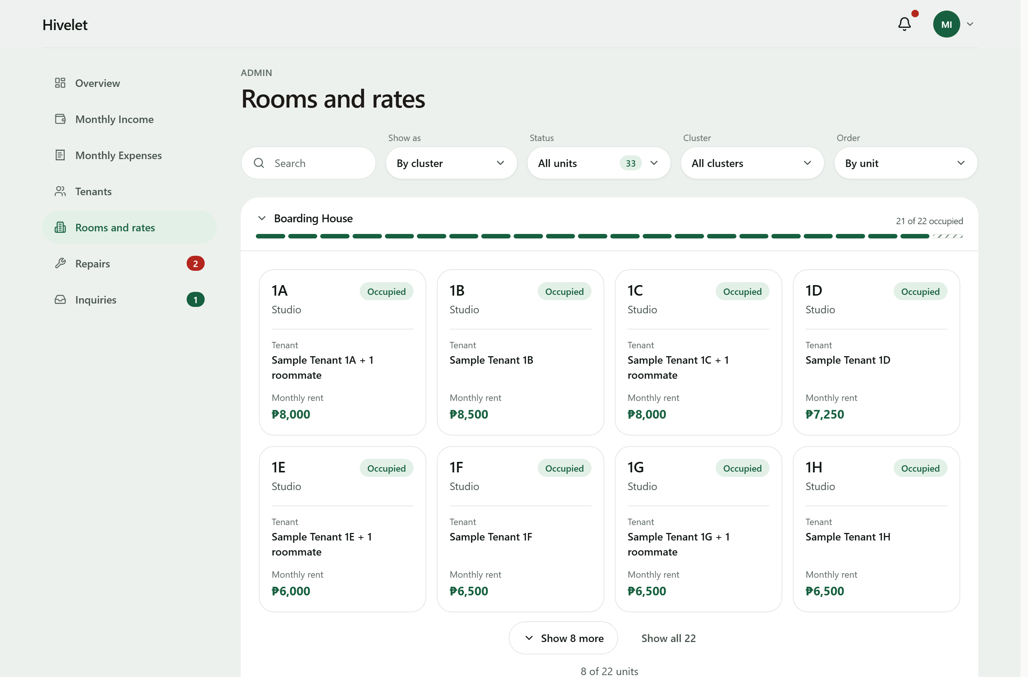

4.2.3 Booking and Reservation Management Module
Figure 4-8 presents the public unit catalogue and the inquiry form. A visitor sees each unit with its rate, read live from the database, and sends an inquiry about a specific unit without an account. On sending, the visitor receives a private link and a short reference code; either one (the code with the phone number given) opens the conversation, where the owner's answer appears and the visitor can write back. The link's secret is stored only in hashed form. An accepted inquiry becomes a tenancy linked to it, a reserved unit accepts no new inquiries, and the public site never shows a tenant's name, which is checked on every verification run against all 33 units.
Figure 4-8. Public unit catalogue (top) and inquiry form (bottom).
[IMAGE FILE: images/Figure 4-8 - Public unit catalogue (top) and inquiry form (bottom) (1).png]
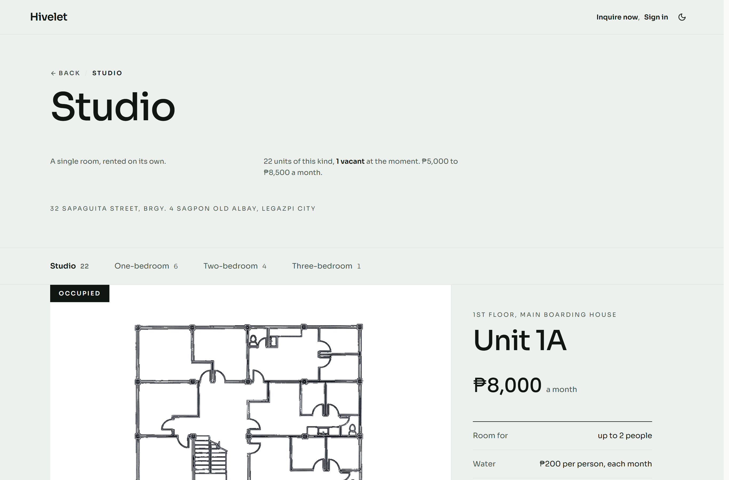
[IMAGE FILE: images/Figure 4-8 - Public unit catalogue (top) and inquiry form (bottom) (2).png]
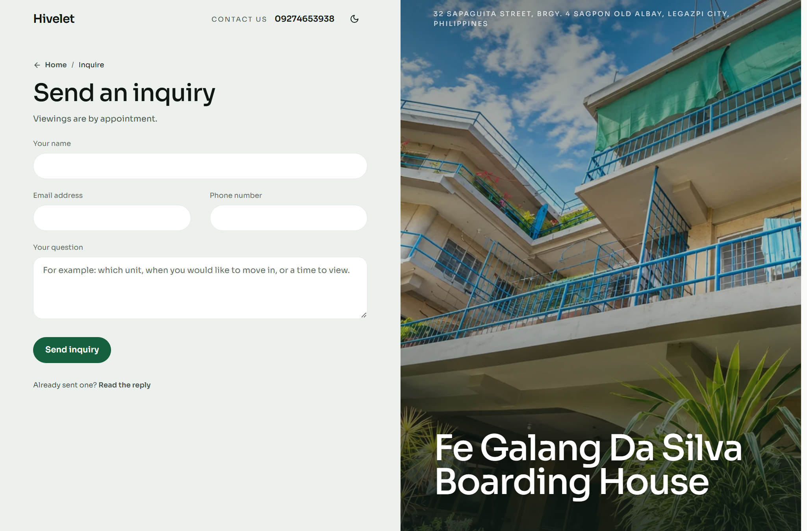

4.2.4 Financial Tracking and Payment Recording Module
Figure 4-9 presents the Monthly Income ledger. The owner records a cash payment with the number of the invoice she issued, or with none, since not every payment has one; the system never makes up an invoice number, and it warns her if the same tenant already has a payment for that month. The receipt is filed under the month the rent is for, not the day it was paid, and both ledgers keep her workbook's layout and download as Excel files in it. Online payments go through Adyen with GCash: a payment made this way enters Pending Verification and changes nothing on the tenant's bill until the owner verifies it. Tenants see the same record from their side, month by month, where only receipts the owner has verified count as paid and a month with no receipt is shown as "Not entered", never as owed, because the records alone cannot tell an unpaid month from one not yet entered. Electricity is outside the system: each unit has its own meter and the tenant pays the electric company directly.
Figure 4-9. The monthly income ledger.
[IMAGE FILE: images/Figure 4-9 - The monthly income ledger.png]
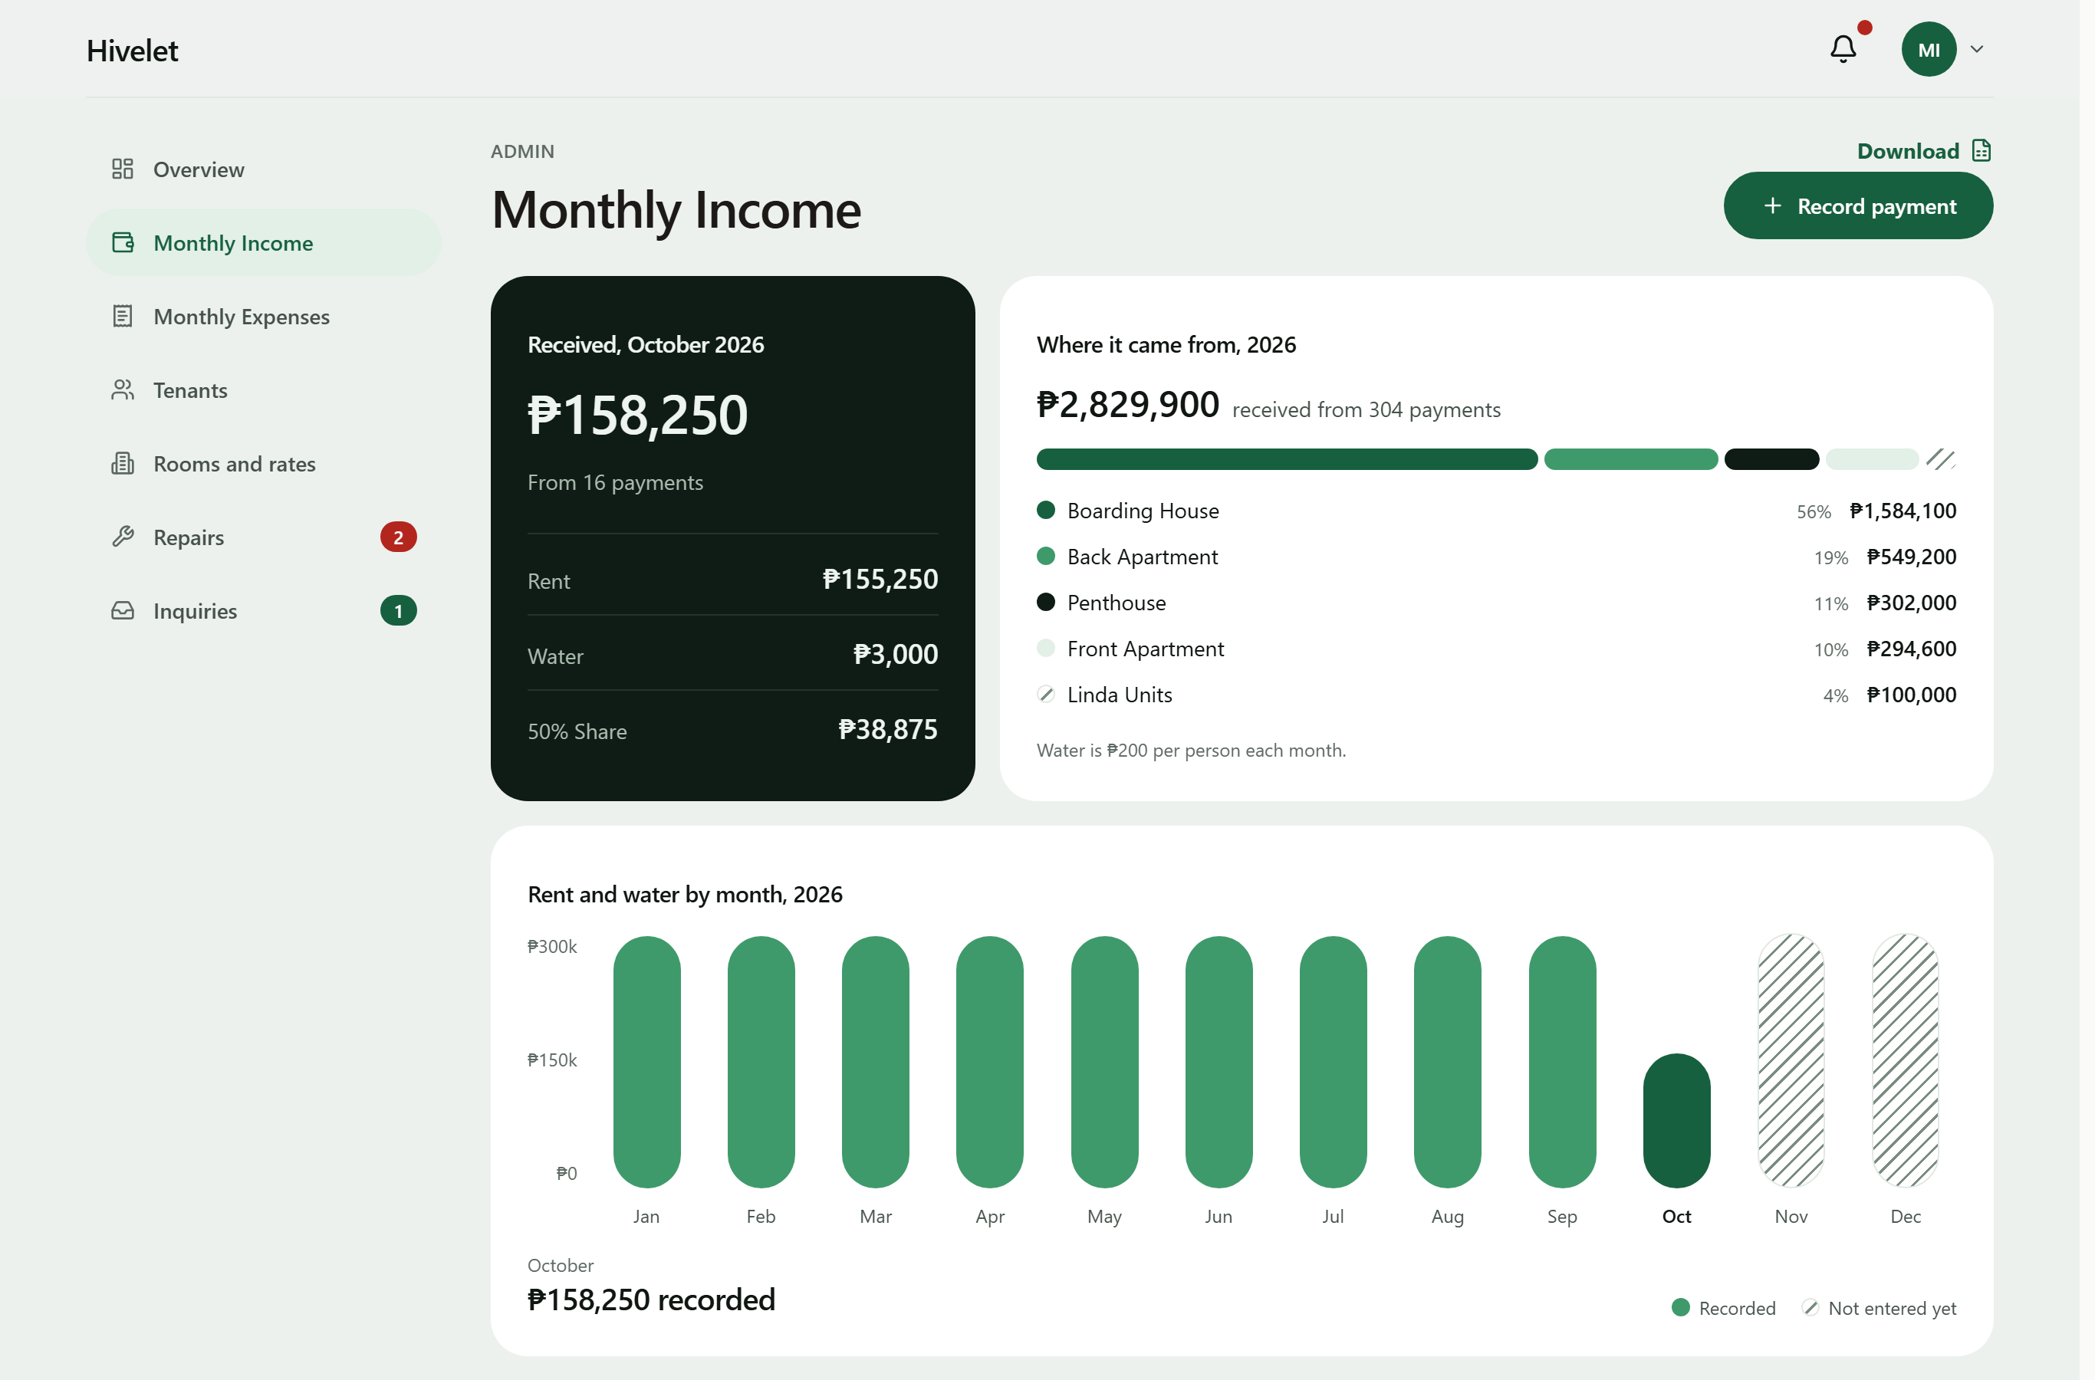
These results agree with Encarnacion et al. (2025) and Setty (2022), who found that one structured ledger improves oversight and reduces administrative errors, and add one observation: the consolidation also exposed errors already in the owner's records (Section 4.1.1). Every figure the owner reads is computed from the rules in Table 4-6 rather than typed, so the same inputs always give the same amount.
Table 4-6. Business rules for computed figures, with a worked example
Rule | What the system computes | Worked example
BR-014 Water fee | Water = number of occupants × ₱200 | Unit 2C with two occupants: 2 × ₱200 = ₱400
BR-038 Remitted amount | Remitted = Rent Amount + Water Payment | ₱8,500 + ₱400 = ₱8,900
BR-035 50% Share | A system-computed figure equal to half that row's Rent Amount, kept for ledger parity with the owner's historical spreadsheet | ₱8,500 ÷ 2 = ₱4,250
BR-033 Rent period | The period a payment covers, from the tenancy's anniversary date | Anniversary on the 13th: rent for 13 August to 12 September
BR-010, BR-011, BR-012 Due date and overdue | Due on the date the billing cycle sets; overdue from the next day, with no grace period | Due 13 September: overdue from 14 September
BR-039 Deposit | Equal to the rent in effect at move-in, set once | Moved in at ₱8,500: deposit ₱8,500
BR-040 Linda's units | Water at the same ₱200 per occupant, recorded separately and kept out of the remitted amount | Unit LF with two occupants: ₱400 recorded as Linda's water; remitted = rent only
BR-045 Expense total | An expense entry's total = the sum of its allocations to property areas | ₱6,000 to the Boarding House + ₱2,000 to the Main House = ₱8,000

4.2.5 Maintenance Ticketing and Notification Module
Figure 4-10 presents the repairs board. A tenant submits a request with a title, description and priority, follows it through to completion, and may cancel it before work starts. The owner can also log a repair she is told about in person, including one for an empty unit. Only the owner closes a request, and the tenant is notified when it is done. In-app notifications also tell a tenant when a payment is verified or declined, and the owner when a payment, inquiry or comment arrives; opening one opens the record it is about. This is the change Saputra et al. (2025) report, in which complaints turned into traceable requests improved accountability, and it bears on the responsiveness Jing and Lim (2021) found central to residents' satisfaction: a request now carries its status from submission to closing, where before it left no record (Figure 4-1).
Figure 4-10. Maintenance requests board.
[IMAGE FILE: images/Figure 4-10 - Maintenance requests board.png]
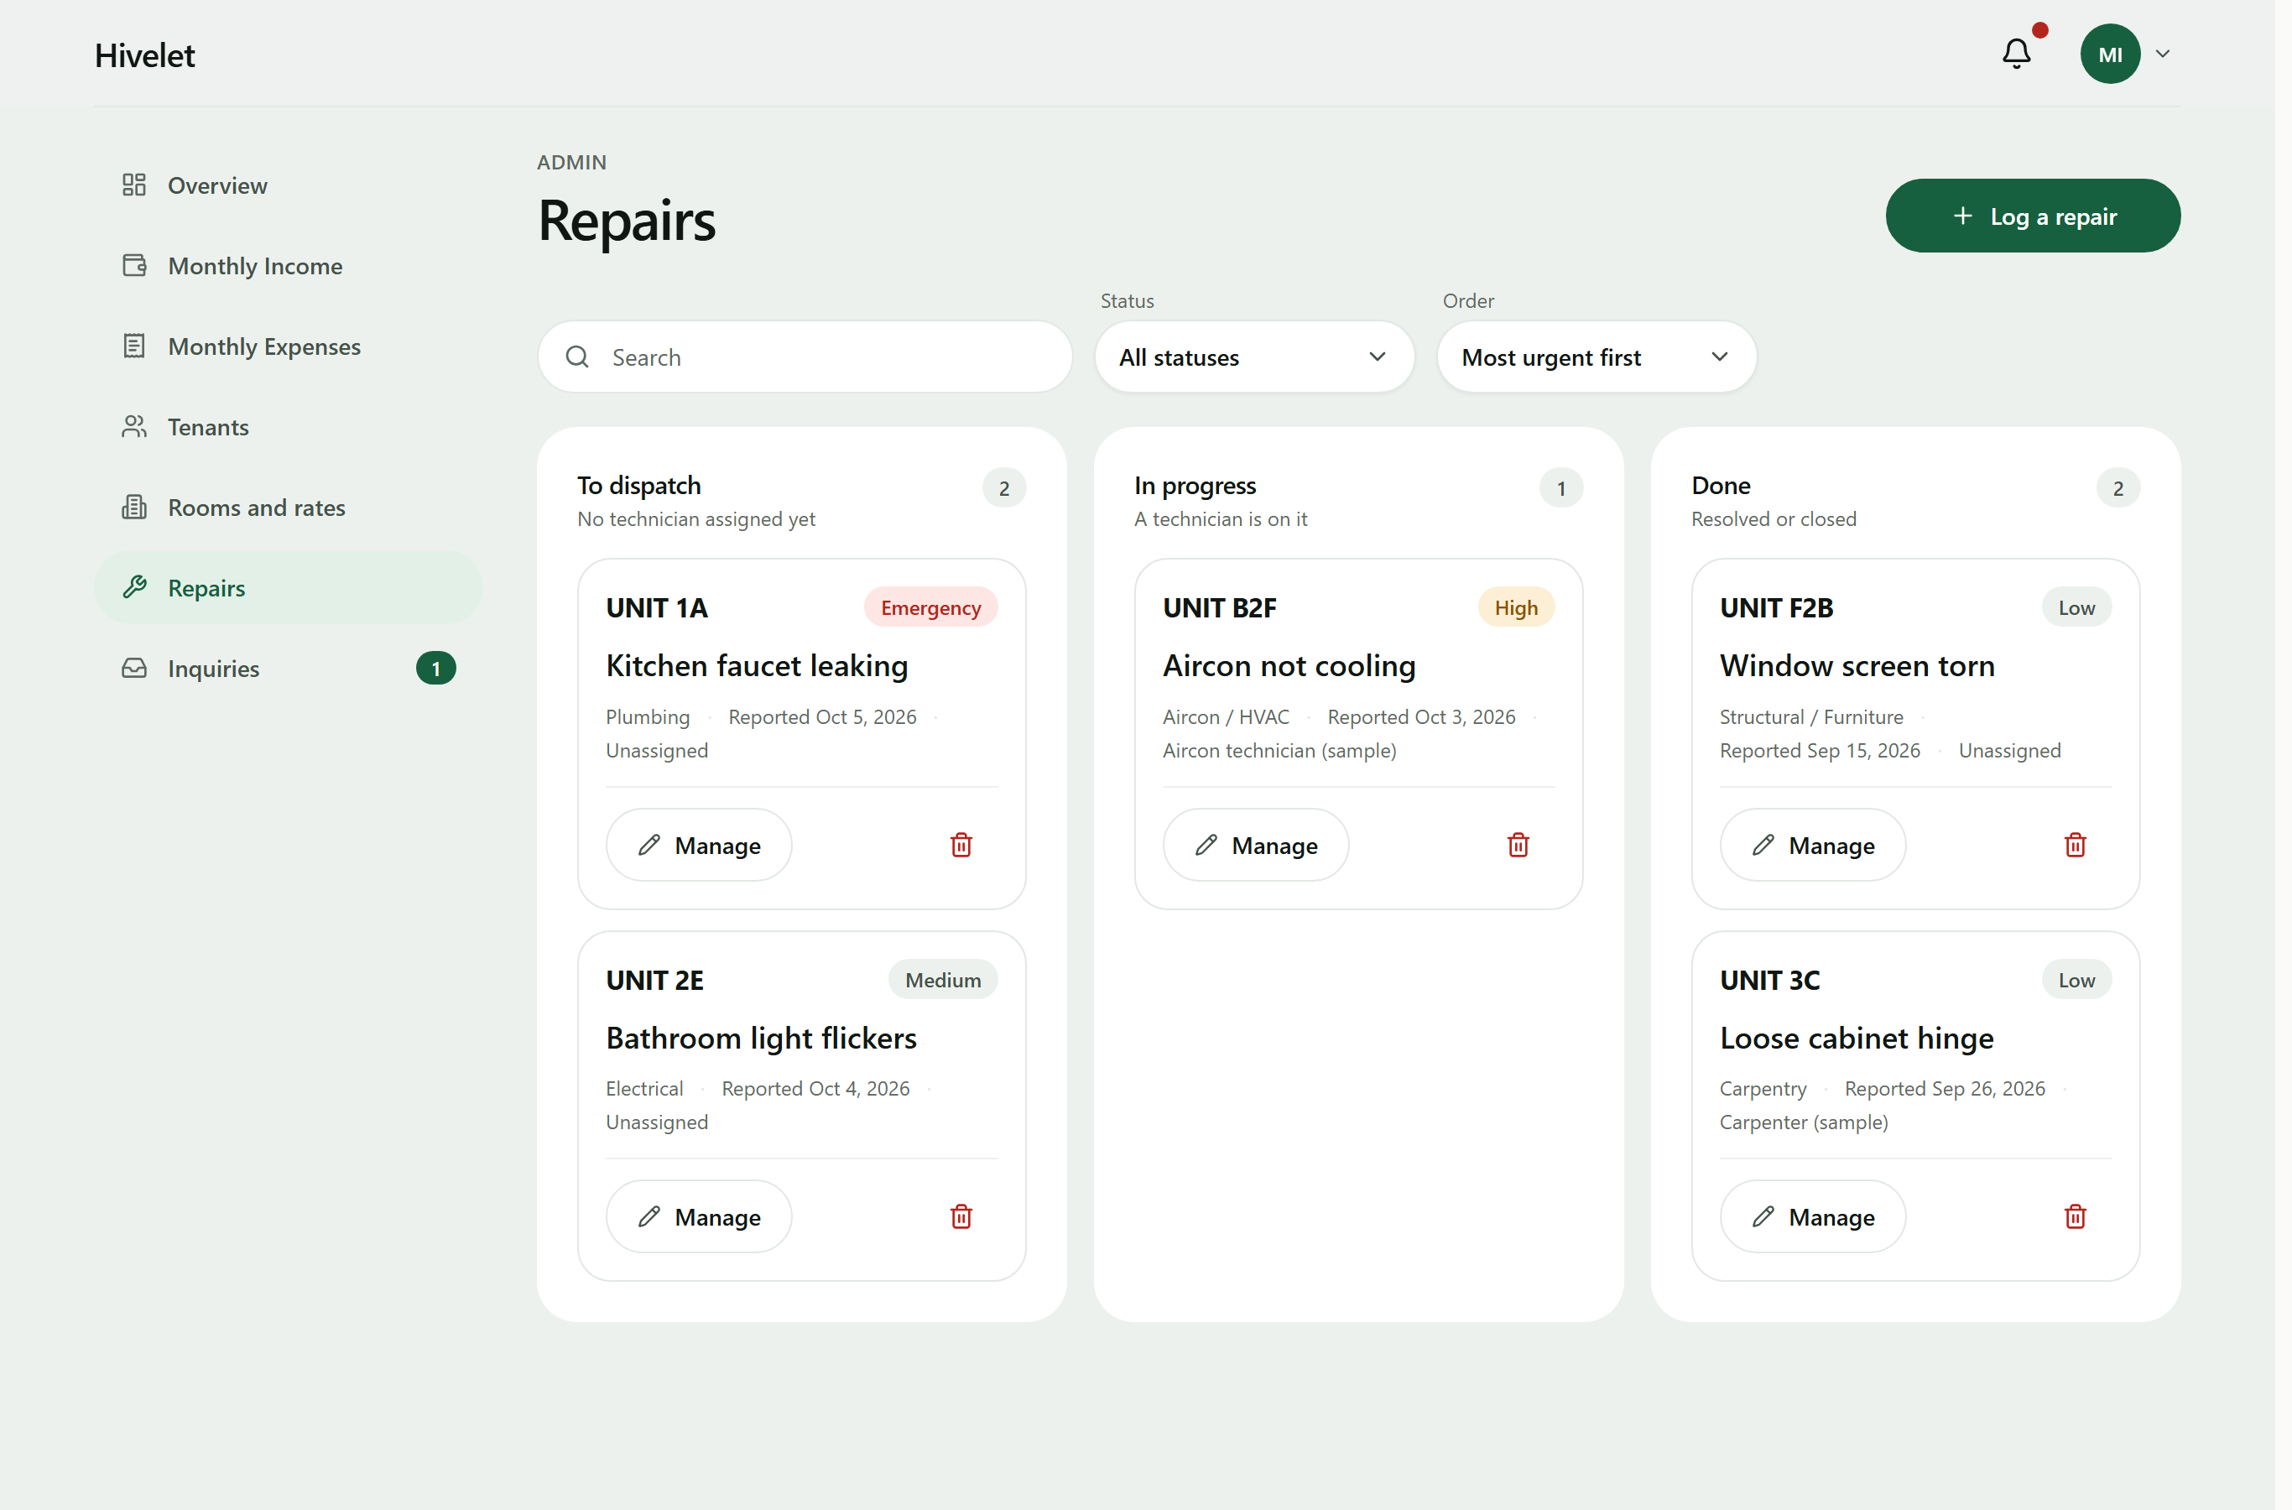

4.2.6 Role-Based Access Control
The system has the three kinds of user designed in Section 3.2.2, the public, tenants and the administrator, plus a record of each visitor who sends an inquiry (a prospect), who holds the public's rights. Every role's rights come from one permission matrix, against which each of the 55 administrator and tenant routes is checked on every verification run, and row-level security is on for every table. Table 4-7 sets out which role may use which function.
Table 4-7. Role and privilege matrix
Function | Visitor | Tenant | Administrator
View the public site, units and rates | Yes | Yes | Yes
Send an inquiry and read the reply (private link or reference code) | Yes | Yes | Yes
View and update their own details and password | No | Own | Own
View a unit, its bills, payments and receipts | No | Own | All
Pay a bill online with GCash | No | Own | No
Send, follow and cancel a repair request | No | Own | All, and dispatch or close
Receive notifications | No | Own | Own
Manage units and rates | No | No | Yes
Manage tenants: move in, move out, reset a password | No | No | Yes
Record, verify, correct and void payments | No | No | Yes
Income and expense ledgers, overview figures and workbook downloads | No | No | Yes
Answer, close and delete inquiries | No | No | Yes

Passwords are stored as bcrypt hashes with a per-password salt; a new one needs ten characters, a letter and a number, and is refused if it appears in a public list of breached passwords. An account locks after five failed sign-ins, a new account must change its password at first sign-in, and every administrator action is written to an audit trail the application cannot edit, delete or empty. The testing of these protections is reported in Section 4.4.4.

4.2.7 Progressive Web Application Implementation
Figure 4-11 presents the tenant portal on a phone. The client is a Progressive Web Application with a service worker and a manifest, so it installs on a phone or computer without an app store. Installing it means adding it to the home screen from the browser (Add to Home Screen in Safari, Install app or Add to Home screen in Chrome). Nothing is downloaded from a store, it opens in its own window like an application, and the application files it keeps on the device come to about 1.2 MB (as built on 13 October 2026). Since 1 and 2 October 2026 it keeps a read-only copy of the figures, names and notifications the signed-in person last loaded on that person's device. The installed application can therefore show them without a connection, under one notice giving the time they were saved; paying and recording still need the connection, and the copy is removed at sign-out. This stays within the delimitation in Section 1.4. Screens adapt to the device, and tables on a computer become cards on a phone. As Biørn-Hansen et al. (2017) describe, one code base served every device: the owner's laptop, an Android phone in Chrome and an iPhone in Safari (Section 4.3.7).
Figure 4-11. The tenant portal on a mobile phone.
[IMAGE FILE: images/Figure 4-11 - The tenant portal on a mobile phone.png]
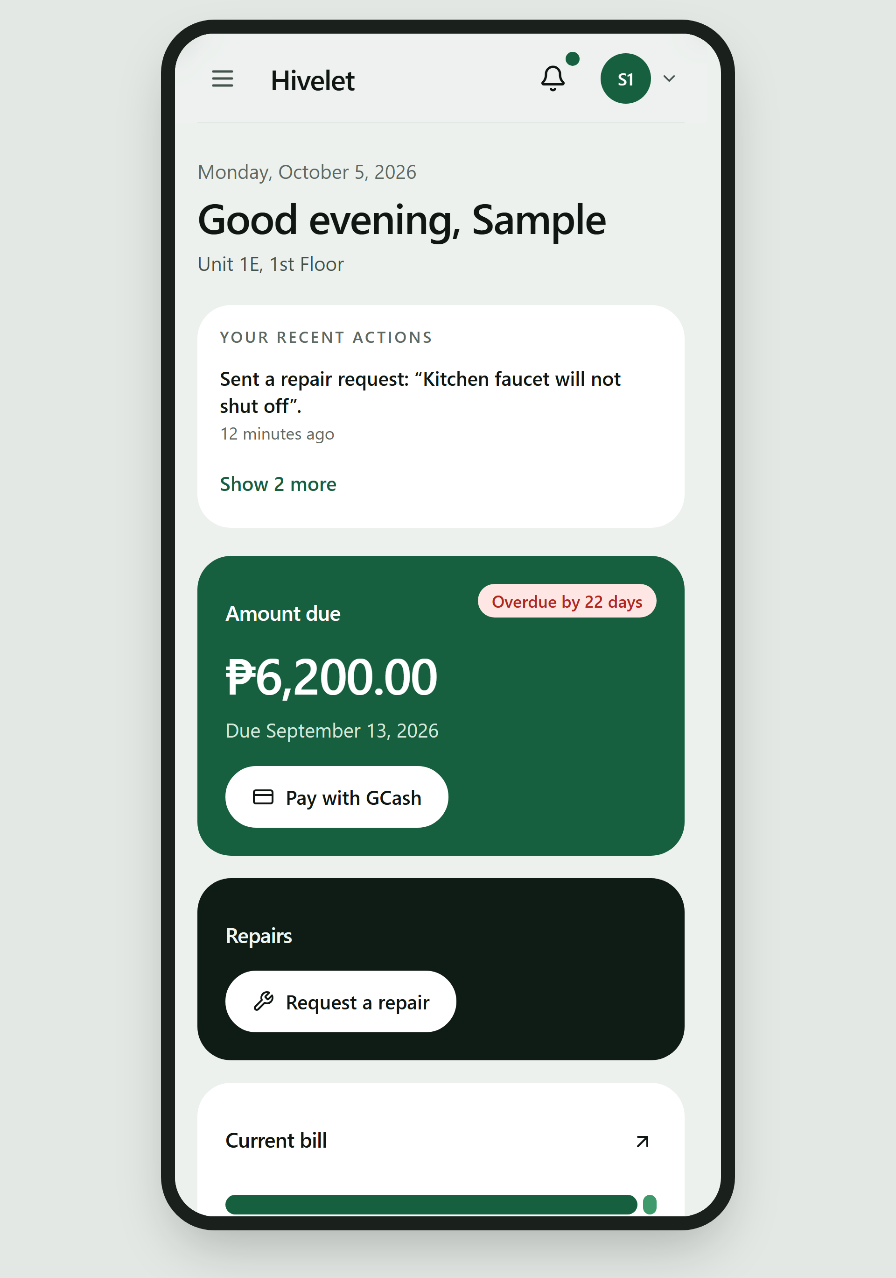

4.3 Pilot Testing of the Developed System
Answers Objective 3: functionality, responsiveness and operational performance.
The three qualities Objective 3 names are characteristics of ISO/IEC 25010:2011: functionality is Functional Suitability, responsiveness the time behavior of Performance Efficiency, and operational performance its capacity and Reliability. A test written for one quality often measures others, so each test was assigned in advance to the sub-characteristics it measures (Chapter 3, Table 3-6); Appendix M, Table M-23 lists them by test activity. The measures are brought together by characteristic in Section 4.4.

4.3.1 Automated Verification
Twenty automated check suites were written during development. They run against the live system and perform no writes, which is what makes them safe to run against the owner's real records. On 29 September 2026, the evening before the first test with real users, all 20 passed; Table 4-8 shows the principal results.
Table 4-8. Results of automated verification (29 September 2026)
Suite | What it checks | Result
Endpoint and access control | Every endpoint the client calls, the separation of roles, and the rejection of bad input | 78 of 78 passed
Ledger integrity | All 937 income rows against the business rules; room, tenant and occupancy agreement | Passed; 5 receipt anomalies reported for the owner
Report reconciliation | The exported Excel reports against the database, month by month | 490 of 490 passed
Payment gateway | Signature checking on gateway messages and how each kind of message is recorded | 73 of 73 passed
Record relations | That separate records agree with each other (payments with bills, tickets with units) | 30 of 30 passed
Billing arithmetic | Water, billing period and how a payment is split across bills | Passed
Data presentation | That no screen shows stored, sample or empty data as a live figure | 6 of 6 passed
Interface integrity | That every screen component exists, every input has a label, and every source file is used | Passed
Document consistency | That the requirements matrix and business rule register agree with themselves | Passed (44 requirements, 49 rules)

The checks also found problems in the records themselves: the five receipt anomalies of Section 4.1.1 came from the owner's records and are reported on every run rather than corrected, because only her invoice book can say what each should read. More important, the most serious defects found in development gave no error on screen. A cash payment could be confirmed while nothing was written to the ledger, and a partial payment could be recorded while the remaining debt was lost. Each was fixed and now has a check that fails if it returns, which is the case for automated verification in a system that holds real money: the most dangerous defects are the silent ones.

4.3.2 Use in the Live Environment
The system has run at a public address with the owner's real records since September 2026. On 22 September a checkout raised the first real bill, ₱8,200.00 for unit 1a, exactly as the rules compute it, and a test receipt voided four minutes after it was recorded returned the ledger to its 937 rows. On 23 September the owner found the system hard to use on her phone; the causes were measured (a table 518 pixels wide on a 301-pixel screen, edit buttons touch screens never showed) and fixed the same day. GCash payments were refused at first by a misconfigured acquirer account on Adyen's side, which Adyen support confirmed and replaced (Case 08657379); on 26 September a test payment passed end to end, from Adyen's authorization to the owner's verification queue. Every record the pilot tests created was then removed by one reviewed migration after a backup, leaving the owner's 937 income rows untouched.

4.3.3 Screen-versus-Database Audit
The suites prove each part correct on its own, not that a screen shows a person what the database holds for them. On 26 September 2026 a tenant's payment history read "Nothing recorded" although the tenant had seven receipts that year, while every suite passed. The team therefore compared every figure on every owner screen, and on the tenant screens on 29 September, with a read-only query of the live database for the same records. Table 4-9 shows the result.
Table 4-9. Results of the screen-versus-database audit (26 and 29 September 2026)
Screen | What was compared | Result
Owner overview | Collections for each month of 2026, the year's total, occupancy, rent per cluster, expected monthly income, operating and personal costs | Matched to the peso
Monthly Income | Totals for rent and water (and a garbage fee, removed on 30 September); collections by cluster | Matched after one defect was fixed
Monthly Expenses | Total spent, split by kind and by area | Matched; one layout defect fixed
Rooms and rates | Rent and number of occupants for each unit | Matched
Tenants | Number of tenants per cluster; move-in dates | Counts matched; one defect fixed
Activity (audit trail) | Each recent entry against the recorded action | One defect fixed
Repairs, inquiries | Number of open items | Matched
Tenant payments | A tenant's receipts for 2026 | Two defects fixed
Tenant overview, repairs and details (29 Sep 2026) | Unit, rate, occupants, monthly charge (rent plus ₱200 per occupant), the period the receipts reach, amount due, requests, contact details | Matched

The audit found six defects no automated check had caught, all fixed on 26 September. They were a tenant's payment history that read only online payments, rental and personal expenses in one column, a placeholder move-in date shown for every tenant, an opened checkout listed as a recorded payment, a voided receipt in a tenant's receipt list, and the Boarding House's remitted amount halved on the income screen. The lesson is the reverse side of Section 4.3.1: passing checks show that what was tested is correct, not that everything is. It qualifies Magno et al. (2024), who found that digitizing transaction tracking improves data accuracy. Here every record was already digital and in one database, yet six screens disagreed with it, so digitizing alone did not make the records agree.

4.3.4 Functional Walkthrough Testing
A 26-step walkthrough, 30 rows counting its sub-steps, exercises every function that writes data once, on the one unoccupied unit so that no real record is touched. The owner performed it herself on 30 September 2026 on her laptop, signed in to her own account, with a team member reading each step; the full results are in Appendix M, Table M-1. Of the 30 rows, 24 passed the first time, 1 failed and 5 were not performed as written. Every function a tenant uses passed, as did onboarding, the duplicate guards, voiding, inquiry replies, repairs, the Excel export and moving a tenant out. The one failure was step 23b: with the connection cut, the Overview showed ₱0 where the design requires "—", so that a missing figure is never read as a zero balance; re-tested on the owner's laptop on 13 October 2026, it passed (Table 4-20). A rate change and its reversal were skipped, and an expense split across two areas was entered as two expenses, so splitting, editing and deleting an expense were not exercised by the owner.

4.3.5 Responsiveness and Operational Performance
Response times were measured on 30 September 2026 on the live system, on a Dell XPS 15 laptop in Google Chrome 154 over the boarding house's Wi-Fi and on an iPhone 15 in Safari over mobile data, from the tap until the figures the user came for were on screen (Table 4-10).
Table 4-10. Page load and response times (30 September 2026, seconds)
Screen | Laptop (Dell XPS 15, Chrome 154, Wi-Fi) | Phone (iPhone 15, Safari, mobile data)
Public home page, first load | 1.85 | 2.42
Public home page, second load | 0.62 | 0.95
Sign-in to dashboard | 2.10 | 2.88
Income ledger, one full year | 1.45 | not measured
Excel export of one year | 2.30 | not measured
Tenant portal, first load | 2.15 | 3.05
Tenant payments page | 1.20 | 1.78
Sending a repair request | 1.65 | 2.10

Every screen was usable within about three seconds on the phone and a little over two on the laptop, the slowest being the tenant portal's first load (3.05 seconds on the phone). Google's PageSpeed Insights, emulating a mid-range phone on slow 4G, scored the public page 85 to 88, with its largest element at 3.4 to 3.6 seconds, and 100 for accessibility. On the owner's Overview, Lighthouse found the page moving as its figures arrived (a layout shift of 0.22) and 0.7 seconds of script work on the phone (Chapter 5, recommendation 5).

4.3.6 Offline Use, Installation, Weak Connections and Simultaneous Users
On 29 September 2026 the live system was measured with no connection, on a weak one, once installed, and with many requests at once, using an automated browser in phone emulation with every save blocked so that nothing was written to the owner's records. Without a connection, the installed application opened on all ten addresses tried, in about 1.5 seconds, showed no personal or financial data until sign-in, and said at once what could not be done offline; on a slow connection a returning visitor saw the units after 0.3 seconds instead of 4.6. In a load test a script played 12 simultaneous users on the public pages and 6 on the owner's records, each pausing between requests as a person reading does: none of the 1,085 and 285 requests failed. These were simulated users, not people (the owner and tenants together are reported in Section 4.3.7). Every result is in Appendix M, Tables M-24 and M-25.
The application opens without a connection and says plainly what it cannot do, and under loads several times the property's own no request failed and nineteen in twenty were answered in under a second. The tests found one weakness: on a weak signal a page could wait for minutes with no message. A limit was added that evening, so that a page stops after 25 seconds and says it could not reach the server, and a save stops after 45 seconds and says it cannot tell whether the save arrived, so the reader should check before sending it again. An accessibility scan of the public pages (axe-core 4, WCAG 2 A and AA) at phone and computer widths found no violation, nor did the same scan of the owner's eight screens.
Simultaneous saves. Reading at the same time tests capacity; saving at the same time tests correctness, because two requests that arrive together can each pass a check before either has been saved. This was tested by sending the same request several times in the same instant, which reproduces a double click, a retry after a timeout, or two people pressing Save together, with closer timing than people can produce by hand. Before the change, the same receipt sent twice or five times at once was saved every time, and two GCash checkouts could open on one bill; after it, one was saved and every other refused, and a checkout abandoned for more than 15 minutes no longer held the bill (Appendix M, Table M-26).
Neither fault showed an error, and neither could be fixed in the program alone, since a check followed by a save can always be outrun. Each fix is a rule in the database, which refuses the second save whatever order the requests arrive in, so ten requests arriving together meet the same refusal as two. Since 12 October 2026 a twenty-first suite repeats these tests on every run against the system's own request handlers; it passes 15 checks, and each of four deliberate faults made it fail. Two limits remain: the rule covers receipts with an invoice number, so two identical receipts without one, or two acknowledgement receipts, arriving at the same instant would both be saved, which the payment form's confirmation step makes unlikely without ruling out; and two people changing the same record in different ways at once was not tried.

4.3.7 User Acceptance Testing with the Owner and Tenants
[TO DO when the owner signs Appendix O: add "The owner's signed acceptance form is in Appendix O." after this section's first paragraph. If she does not accept it yet, say what she asked for instead.]
The owner and three tenants used the live system for their own tasks on 30 September 2026, each on their own device and account, after giving written consent, by the procedure in Section 3.3. Where an observer's sheet and the system's activity record disagreed, the activity record was used. Table 4-11 gives each task's result.
Table 4-11. Tenant task results (30 September 2026)
Task | Tenants attempting | Completed without help | Completed with help | Not completed | Median time (s) | Mean wrong turns | Completion without help
First sign-in and choosing a password (T-01, T-02) | 3 | 4 | 2 | 0 | 120 | 0.5 | 67%
Finding their unit, rent and balance (T-03, T-04) | 2 | 3 | 1 | 0 | 90 | 0.5 | 75%
Finding their payments (T-05, T-06) | 2 | 4 | 0 | 0 | 60 | 0.0 | 100%
Sending a repair request with a photo (T-07 to T-09) | 3 | 7 | 0 | 0 | 90 | 0.0 | 100%
Following up a request (T-10, T-11) | 2 | 3 | 0 | 0 | 120 | 0.0 | 100%
Checking their details and notifications (T-12, T-13) | 3 | 5 | 0 | 0 | 60 | 0.2 | 100%
Opening the GCash payment (T-14) | 2 | 2 | 0 | 0 | 120 | 0.0 | 100%
Staying out of the owner's pages; signing out (T-15, T-16) | 2 | 3 | 0 | 0 | 60 | 0.0 | 100%
All tasks | 3 | 31 | 3 | 0 | 60 | 0.2 | 91%

Every task the tenants attempted was completed, 31 of 34 attempts without help (91 percent). Help was needed only at the start: two of the three tenants were helped through their first sign-in and one to find their unit and rent; everything else, from finding payments to reporting a repair and opening the GCash payment, was done alone in one to two minutes. The repairs they sent reached the owner at once, and she acted on them the same evening. Mia et al. (2024) name limited technical capacity as a barrier when small Philippine enterprises adopt digital tools; these results place it precisely, in the first two things a new user does. The tests that needed several tenants saving at once were not performed, because only two attended together. In the session in which the owner and two tenants used the system at the same time, every screen loaded, each tenant saw only their own unit, the owner's full year of Monthly Income opened in about three seconds, and no session affected another (Appendix M, Table M-22). On two phones the offline behavior matched Appendix M, Table M-24, except that the Android phone showed the "cannot tell whether it was saved" message after 60 to 80 seconds instead of 45; corrected on 1 October, it was on time when re-tested on that phone on 13 October 2026 (Table 4-20).
Table 4-12 brings the testing together by the test levels of ISO/IEC/IEEE 29119 (Section 3.2.4).
Table 4-12. Summary of test execution by level
Level | Activity (source) | Executed | Passed | Failed | Not performed or not applicable | Pass rate
Unit and integration | Automated check suites, 29 September 2026 (Table 4-8) | 20 | 20 | 0 | 0 | 100%
System | Functional walkthrough by the owner, 30 September 2026 (Appendix M, Table M-1) | 25 | 24 | 1 | 5 | 96%
Acceptance | Tenant tasks, 30 September 2026 (Table 4-11) | 34 | 34 | 0 | 0 | 100% (91% without help)
Acceptance | Simultaneous use by the owner and tenants (Appendix M, Table M-22) | 4 | 4 | 0 | 3 | 100%
All levels |  | 83 | 82 | 1 | 8 | 98.8%

Every level passed at least 96 percent of the tests executed, against the course standard of 90 percent. The one failure, at the system level, was not critical, and no critical defect was found in any activity. Table 4-20, in Section 4.4.6, lists the defects by activity, severity and disposition.

4.4 Evaluation of the System Based on ISO/IEC 25010
Answers Objective 4.
The evaluation followed the five steps of ISO/IEC 25040 (Table 4-13), on the quality model of ISO/IEC 25010:2011. That edition was used because the approved proposal (Section 3.3) named its eight characteristics as the evaluation criteria, and the instrument was built on them; the same edition is used in Chapter 3 and here. Each characteristic was judged on measured quality, the results of Section 4.3 expressed as measures of its sub-characteristics in the manner of ISO/IEC 25023, and on rated quality, a survey in which each item belongs to one sub-characteristic (Chapter 3, Table 3-6). Each respondent group rated only what it can judge: tenants did not rate Security or Maintainability, prospective tenants rated neither, and only technical evaluators rated Maintainability, the group with the background to judge it.
Table 4-13. The evaluation process, following ISO/IEC 25040
Step | What it required | How it was carried out
1. Establish the evaluation requirements | The purpose, the product, the quality model and who judges it | Objective 4; the live system at its public address; ISO/IEC 25010:2011, eight characteristics; the owner, tenants and technical evaluators (Section 3.3)
2. Specify the evaluation | The measures for each sub-characteristic, and the criteria for judging them | Measures from the tests of Section 4.3 (Table M-23); survey items assigned to sub-characteristics (Chapter 3, Table 3-6); criteria: Chapter 3's Table 3-5 for every mean, and for tests the course standard of at least 90 percent passed with no critical defect open
3. Design the evaluation | The activities, their order and schedule | Measurements on 29 September 2026; the walkthrough and acceptance test on 30 September; the technical evaluators' review on 3 October; the survey after each group's use of the system
4. Execute the evaluation | Take the measures and apply the criteria | Section 4.3 (measured) and the survey (rated; Appendix M, Tables M-2 to M-17)
5. Conclude the evaluation | Review the results, report them, and act on them | Tables 4-17 and 4-18, and the changes made in response (Table 4-19)

ISO/IEC 25010 was revised in 2023, renaming Usability as Interaction Capability and Portability as Flexibility and adding Safety. The survey was built and answered on the 2011 characteristics, so its results are reported on them; Appendix M, Table M-21, shows where each falls in the revised model.

4.4.1 Respondents
Table 4-14 shows the respondents by group, and Table 4-15 how many forms were given out and returned.
Table 4-14. Distribution of respondents
Group | Number | Percent
Owner / administrator | 1 | 16.67%
Tenants | 3 | 50.00%
Technical evaluators | 1 | 16.67%
Prospective tenants | 1 | 16.67%
Total | 6 | 100%

Table 4-15. Instrument administration and response rate
Group | Distributed | Retrieved | Valid | Response rate
Owner / administrator | 1 | 1 | 1 | 100%
Tenants | 3 | 3 | 3 | 100%
Technical evaluators | 1 | 1 | 1 | 100%
Prospective tenants | 1 | 1 | 1 | 100%
Total | 6 | 6 | 6 | 100%

Six people answered, each after using the system and giving consent: the prospective tenant and the three tenants on 30 September 2026, after their tasks in Section 4.3.7, the owner that night after her walkthrough, and one technical evaluator on 4 October, the day after the evaluators' review. No member of the development team was among them. Three of the four groups have one respondent each, so for those groups a mean is one person's rating, and the results describe how these six people rated the system, not a sample from which a wider population can be inferred.

4.4.2 Interpretation of Scores
Each item was rated on the five-point scale in Table 3-4, and means are read using Chapter 3's Table 3-5. The composite of each characteristic is the mean of its group means, so that one owner is not outweighed by three tenants on functions only she uses, and the overall mean is the mean of the eight composites. Averaging every response together instead gives 4.55 rather than 4.53, with the same interpretation and ranking. Table 4-16 works one weighted mean in full, WM = Σ(f × w) / N.
Table 4-16. Worked computation of a weighted mean
Rating (w) | Meaning | Frequency (f) | f × w
5 | Strongly Agree | 3 | 15
4 | Agree | 0 | 0
3 | Neutral | 0 | 0
2 | Disagree | 0 | 0
1 | Strongly Disagree | 0 | 0
Total |  | N = 3 | Σ(f × w) = 15

Indicator: "I can see my own unit details, my bill, and what I still owe." (Functional Suitability, rated by tenants). WM = 15 / 3 = 5.00, which Table 3-5 reads as Very High Quality.

4.4.3 Results by Characteristic
Table 4-17 summarizes the result for each characteristic; the rating of every item by every group is in Appendix M (Tables M-2 to M-17, ratings and measured evidence for each characteristic).
Table 4-17. Summary of evaluation results
Characteristic | n | Composite mean | Interpretation | Rank
Functional Suitability | 6 | 4.86 | Very High Quality | 2
Performance Efficiency | 6 | 4.42 | Very High Quality | 6
Compatibility | 6 | 4.67 | Very High Quality | 4
Usability | 6 | 4.12 | High Quality | 7
Reliability | 6 | 4.62 | Very High Quality | 5
Security | 2 | 4.70 | Very High Quality | 3
Maintainability | 1 | 4.00 | High Quality | 8
Portability | 6 | 4.89 | Very High Quality | 1
Overall |  | 4.53 | Very High Quality

The six respondents rated the system Very High Quality overall (4.53), and no characteristic, and no group mean, fell below High Quality. This is the range Canlas et al. (2026) report for a Philippine dormitory system rated by the same kinds of respondents, tenants, administrators and IT professionals; here, each rating is also read beside the measured evidence for its characteristic (Section 4.4.5).
Portability was rated highest (4.89), as one code base installed on an Android phone and an iPhone without an app store. Functional Suitability followed (4.86): every feature the objective names is present, and 96 to 100 percent of the executed checks of correctness gave the right result. Security (4.70) is discussed in Section 4.4.4. Compatibility (4.67) agrees with the browser matrix, on which every combination tried worked. Reliability (4.62) agrees most closely with the testing: the technical evaluator's 3 for handling a failed request without presenting incorrect data names the one test that failed, the ₱0 of step 23b, since resolved. Performance Efficiency (4.42) matches the measurements: no failed request, but screens of two to three seconds on a phone.
The two lowest were rated High Quality. Usability (4.12) is the lowest of the characteristics all four groups rated. The prospective tenant gave every item 5 and the tenants 4.47, but the owner gave 3 to telling what each screen is for and to learning the system without help, and the technical evaluator gave 3 to all five items. The evaluator answered before the fourteen changes made for that evaluator's group, eleven of them about usability, and the owner learned the system with each step read to her (Section 4.3.4). Here the rating and the measurement disagree and both are right. Nine tasks in ten were done without help, and 76 accessibility scans of 19 screens found no violation once one defect on three screens was corrected. Those, however, measure whether a task can be done and whether a screen is built correctly, not how easily a first-time user finds the way. Maintainability (4.00) is the lowest composite and rests on one respondent, who gave every item 4 after reviewing the running system, without inspecting its source code, so here the measurement, read from the code itself, carries more weight than the rating. It points the same way as the rating: the system can be checked as a whole on every change, but three database calls in four are written inside the request handlers, so the rules for one record are spread across the handlers that touch it. Both are taken up in Chapter 5, recommendation 6.

4.4.4 Security
The owner gave every Security item 5. The technical evaluator gave 5 to role restriction, to a tenant being kept out of administrative data and to the audit trail. The evaluator gave 4 to authentication and session handling, which agrees with two low-risk session weaknesses the code review accepted, and 3 to the handling of credentials, for which the measured evidence gives no cause and the form gave no reason. Three passive external scans graded the site A+: Qualys SSL Labs, Mozilla HTTP Observatory (all 12 tests passed once the Content Security Policy was enforced) and securityheaders.com, on 29 and 30 September 2026. Twelve checks by hand passed, among them an account locking after five wrong passwords, no personal data behind the Back button after signing out, and another tenant's repair answering "not found". A review of all 71 request handlers on 2 October found no high-severity problem, and Supabase's security advisor raised no warning on 5 October. Two weaknesses remain by design. The sign-in token is kept in the browser's storage, where an injected script could read it, which the enforced Content Security Policy and the absence of any raw HTML on the screens stand against; and sign-in takes a password only, with no second factor even for the administrator. Both are left to Chapter 5, recommendation 3.

4.4.5 Measured and Rated Evidence Together
Table 4-18 sets the two kinds of evidence side by side. Of the thirty-one sub-characteristics of ISO/IEC 25010:2011, twenty-seven have a measured result and twenty-five are rated by at least one survey item; two, user interface aesthetics and reusability, have neither, and no conclusion is drawn about them.
Table 4-18. Measured and rated evidence by characteristic
Characteristic | Sub-characteristics | Measured | Rated | Measured result (Appendix M) | Composite mean (Table 4-17)
Functional Suitability | 3 | 3 | 3 | All six features present; 96 to 100 percent of correctness checks passed | 4.86
Performance Efficiency | 3 | 3 | 3 | No request failed under load; every screen usable within 3.05 s on a phone | 4.42
Compatibility | 2 | 1 | 2 | 5 of 5 device and browser combinations; gateway and spreadsheet exchange correct | 4.67
Usability | 6 | 5 | 4 | 91 percent of tasks without help; 0 accessibility violations in 76 scans | 4.12
Reliability | 4 | 3 | 4 | No critical defect; the two offline defects found on real devices, a ₱0 shown for a figure that could not load and a late message, both passed on re-test, 13 October | 4.62
Security | 5 | 5 | 3 | Every protection tried held; A+ from all three outside scanners | 4.70
Maintainability | 5 | 4 | 4 | 20 of 20 suites pass without writing to the records; every change a numbered migration; but 154 of 204 database calls inside the request handlers | 4.00
Portability | 3 | 3 | 2 | No screen wider than its window at four widths; installed on two phones without an app store | 4.89
All | 31 | 27 | 25 |  | 4.53

For seven of the eight characteristics the two kinds of evidence agree, and they disagree on Usability for the reason given in Section 4.4.3: passing measures show what was measured. Quality in use, which ISO/IEC 25010:2011 defines as the quality experienced by users in their own context, was measured by the acceptance test of Section 4.3.7 in the manner of ISO/IEC 25022 (Appendix M, Table M-20). For effectiveness, all 34 attempted tasks were completed, 31 of them without help. For efficiency, the median was 60 seconds a task with 0.2 wrong turns. For context coverage, the system was used on the owner's laptop, an Android phone and an iPhone.

4.4.6 Optimization in Response to the Evaluation
Objective 4 asks for the system to be evaluated and optimized. Table 4-19 groups the 51 changes made in response to feedback and testing by where each finding came from; every change, with its finding and the characteristic it serves, is in Appendix M, Table M-18. Most were made the day the finding arrived, and each of the technical evaluators' fourteen comments of 3 October 2026 was addressed on the live system by 5 October.
Table 4-19. Optimizations made in response to evaluation, by source
Source | Changes | Characteristics served | Examples of what was found
The owner's review on a phone, 23 Sep 2026 | 4 | Usability, Portability | Edit buttons that touch screens never showed; a tenant register wider than the phone
Screen-versus-database audit, 26 Sep 2026 | 7 | Functional Suitability, Reliability, Usability, Security | A payment history showing no payments; a placeholder move-in date for every tenant
Development reviews, 26 to 28 Sep 2026 (performance, requirements, team, client, mobile, checks, final review) | 11 | Usability, Functional Suitability, Reliability, Performance Efficiency, Portability | Repairs for an empty unit; page names that differed between menu, tab and heading
Pre-testing audit and Lighthouse, 29 and 30 Sep 2026 | 5 | Usability, Security, Performance Efficiency, Reliability | One shared starting password for every tenant; no way back for a forgotten password
Testing day, 30 Sep 2026 (owner's use, walkthrough, Android phone) | 3 | Reliability, Usability | Changes not reaching the other person until a refresh; ₱0 shown with no connection
Evaluation account and security reviews, 2 and 7 Oct 2026 | 3 | Security, Functional Suitability, Reliability | A request from another website answered with a server error; breached passwords accepted
Technical evaluators' review, 3 Oct 2026 (all addressed by 5 Oct) | 14 | Usability, Functional Suitability, Security, Reliability | Filters in a pop-up with an Apply button; no way for a tenant to withdraw a request
The survey, 30 Sep to 4 Oct 2026 | 4 | Usability, Reliability, Functional Suitability | Usability items rated 3 before the evaluators' changes; a tenant asking to see the deposit
All | 51

Table 4-20 counts the defects found by each activity in Sections 4.3 and 4.4, by their highest severity and what became of them. The severities are critical, a wrong amount in the records or lost data; high, a wrong amount shown, a core task blocked, or an exploitable weakness; medium, a misleading display or a weakness with a workaround; and low, usability, appearance or hardening.
Table 4-20. Defects found, by activity, severity and disposition
Activity | Found | Highest severity | Resolved | Open or accepted
Screen-versus-database audit, 26 and 29 September (Table 4-9) | 6 | High: a tenant's payments not shown; a voided receipt shown as paid | 6 | None
Functional walkthrough, 30 September (Appendix M, Table M-1) | 1 | Medium: ₱0 instead of "—" with the connection cut | 1 | None: passed when re-tested on the owner's laptop, 13 October
Testing day on phones, 30 September | 1 | Medium: the "cannot tell whether it was saved" message late on Android | 1 | None: on time when re-tested on the same phone, 13 October
Check of the evaluation account, 2 October | 1 | High: online payment refused for an amount owed | 1 | None
Security review and outside probe, 2 October | 12 | High, operational: the hosting provider's visitor challenge could block payment notifications | 9 | 3 accepted as low risk: sign-in attempt limits counted per server instance, signing out not revoking a token, a wide connection policy
Technical evaluators, 3 October | 14 | Medium: phone, email and photo validation | 14 | None
All activities | 35 |  | 32 | 3 accepted

No defect found was critical. The three accepted items are low-risk session weaknesses recorded in the security audit with the reason each was accepted.
One further defect, of high severity, was found after these activities, in an audit of the live records on 13 October 2026, and corrected the same day: two tenants were shown as owing a month they had already paid. It is outside the counts above, which are the testing activities' own; Appendix M, Table M-27, describes it, its cause and its correction.

4.5 Deployment Plan and Strategies
The system is hosted on Vercel at a public web address, with the database on Supabase and the payment gateway on Adyen. Every approved change is deployed automatically from the project's main code branch. Table 4-21 lists what is needed to use the system, and Table 4-22 the deployment plan.
Table 4-21. Software and hardware requirements for deployment
Side | Requirement | Used in testing, 30 September 2026
Owner | A current web browser on a computer, and an internet connection | The administrator's laptop, an Acer Nitro V 15 with Chrome; the team's laptop, a Dell XPS 15 on Windows 11 with Chrome 154, Edge and Firefox 157 (Table 4-10, Section 4.4.3)
Tenants and visitors | A current web browser (Chrome, Edge, Firefox or Safari) on a phone or computer, and an internet connection | Infinix GT20 with Android and Chrome 154; iPhone 15 and iPhone 13 with Safari; the three tenants' own phones, models not recorded
Hosting | Vercel (application), Supabase (PostgreSQL database), Adyen merchant account with GCash (optional online payment) | Vercel; PostgreSQL 17.6 on Supabase; Adyen Web Drop-in 6.44 and API Library 32.0 (Table 4-4)
Administration | A computer that can run Node.js, used only for backups and verification runs | Node.js 22.16 on the team's Windows 11 computer

Table 4-22. Deployment plan and strategies
Stage | Activity | Status
1. Environment preparation | Hosting, database and gateway set up; security settings applied | Done
2. Record transfer | The owner's workbook transferred: 937 income rows and 1,327 expense allocations | Done
3. Pilot use | The system used alongside the owner's existing records; differences investigated | In progress
4. Training and hand-over | The owner and tenants shown how to use the system; user manual (Appendix K) handed over; accounts issued | Done: every tenant account prepared with its own starting password on 29 September 2026; the owner guided through the system, and the owner and three tenants using it on their own accounts, on 30 September 2026 (Section 4.3.7); the first change taken from the owner's own practice, acknowledgement receipts for payments with no invoice number, made on 1 October 2026
5. Full transition | The system becomes the owner's main record once both records agree | Not yet: as of 13 October 2026 the system has not become the owner's main record and runs beside her own records

Three risks are managed deliberately:
• The records are the owner's real financial records. A backup is taken before any change to the data, and every change is a numbered migration that can be reviewed before it runs.
• Gateway and database credentials are kept outside the code, passed between team members separately, and never written in any document. A check for committed credentials runs before every commit.
• The five historical receipt anomalies are kept exactly as the owner wrote them and reported on every verification run, so they are never mistaken for errors made by the system.

5 SUMMARY, CONCLUSIONS, AND RECOMMENDATIONS
This chapter summarizes the study, states the conclusions drawn from its results, and gives recommendations for the owner, for the continued development of the system, and for future researchers.

5.1 Summary
Small boarding houses that run on spreadsheets, paper receipts and messages are not served by the property management systems on the market, which assume larger operations. This study designed, developed and evaluated Hivelet, a web-based apartment management system delivered as a Progressive Web Application, for the Fe Galang Da Silva Boarding House, a 33-unit property in Legazpi City. The system was built in three Agile iterations with Vue, Express and PostgreSQL, pilot tested at the unit and integration, system and acceptance levels, and evaluated on the eight characteristics of ISO/IEC 25010:2011 by the owner, three tenants, a prospective tenant and a technical evaluator. The results are summarized below in the order of the specific objectives.
1. The existing practices were analyzed. The owner kept a two-sheet workbook on a USB flash drive and a paper invoice book, collected rent in cash, and received requests by message or in person. Transferring her records, 937 income rows and 1,327 expense allocations, showed that 43% of the income rows lacked an anniversary date and deposit and that five invoice numbers had each been used for two payments. The analysis produced 44 functional requirements and 49 business rules; graded against the code, 25 were implemented as worded, 15 in part, 1 in the interface only and 3 not as worded.
2. The system was developed with the six features the objective names: tenant and room management, booking and reservation management, financial tracking with optional online payment through Adyen with GCash, maintenance ticketing and notification, role-based access control, and Progressive Web Application support. It holds the owner's real records.
3. The system was pilot tested. Twenty automated check suites, run against the live system on 29 September 2026, all passed, including 490 report reconciliation checks, and a screen-by-screen comparison with the live records found six defects the checks had missed, all corrected the same day. The owner performed the walkthrough herself: 24 of its 30 rows passed the first time, one failed and five were not performed as written. Three tenants completed every task they attempted, 31 of 34 attempts without help. Of the 83 tests executed across the three levels, 82 passed (98.8 percent), and no critical defect was found. Every screen measured was usable within about three seconds on a phone, and no request failed under twelve simulated simultaneous visitors or six simulated readers of the owner's records.
4. The system was evaluated by the five steps of ISO/IEC 25040: twenty-seven of the model's thirty-one sub-characteristics had a measured result and twenty-five were rated. The six respondents rated the system 4.53 overall: Functional Suitability 4.86, Performance Efficiency 4.42, Compatibility 4.67, Usability 4.12, Reliability 4.62, Security 4.70, Maintainability 4.00 and Portability 4.89. In response to feedback and testing, 51 changes were made, among them each of the technical evaluators' fourteen comments of 3 October 2026.

5.2 Conclusions
Based on the results of the study, the following conclusions were drawn:
1. The first objective was achieved. The existing practices were analyzed in all four areas the objective names, and every gap found was traced to a requirement and to the module that meets it (Chapter 4, Table 4-2). The main problem at the property was not the lack of a digital tool but the lack of connection between its records.
2. The second objective was achieved. All six features the objective names were developed and are in use on the owner's real records (Chapter 4, Sections 4.2.2 to 4.2.7). They keep her own report layout, invoice numbers and cash as the main way to pay, so using the system requires no change to how she keeps her accounts.
3. The third objective was achieved. The system was pilot tested for functionality, responsiveness and operational performance, and 82 of the 83 tests executed passed (98.8 percent), above the course standard of 90 percent, with no critical defect (Chapter 4, Tables 4-12 and 4-20). The one failure, a ₱0 shown without a connection, appeared only on a real device in its user's hands, and it passed when re-tested on the owner's laptop.
4. The fourth objective was achieved. The system was evaluated on all eight characteristics of ISO/IEC 25010:2011 by the process of ISO/IEC 25040 and optimized in response. Its users rated it Very High Quality overall (4.53), with every characteristic at least High Quality on the scale of Chapter 3's Table 3-5 (Chapter 4, Tables 4-17 and 4-19). The ratings agree with the measured evidence on every characteristic but Usability, and they describe how six people rated the system over one week, three of the four groups with one respondent each.

5.3 Recommendations
Based on the summary and conclusions of the study, the following are recommended:
For the owner of the Fe Galang Da Silva Boarding House
1. Keep the system's receipts up to date with her receipt book, entering each on Monthly Income, which also settles any bill it covers (Appendix M, Table M-27); the system can become her main record only once the two agree (Chapter 4, Table 4-22).
2. Keep taking a backup before any change to the records, as the team did throughout, and read the five flagged invoice numbers as history: they stay as she wrote them, and the system lists them on every verification run (Section 4.1.1).
For the continued development of the system
3. Before real money moves through the system, move the Adyen account from test to live and let the system refund a GCash payment the owner rejects; refunds were excluded from this study by its delimitation (Sections 1.4 and 4.3.2). Keep the sign-in token in a cookie that no script can read, and add a second sign-in factor for the administrator, the two weaknesses Chapter 4 names (Section 4.4.4).
4. Add automated browser tests that sign in and perform each of the 26 walkthrough steps, so that every function that writes data is tested on every change rather than once by a person. Extend the rule that refuses a second copy of a receipt to receipts with no invoice number and to acknowledgement receipts (Sections 4.3.3, 4.3.4 and 4.3.6). Keep a deleted repair request or inquiry as an archived record, as a voided receipt or expense already is, and let the owner list finished repairs by the dates they were resolved and closed.
5. Make the pages appear faster on phones, where the public page's largest element was drawn at 3.4 to 3.6 seconds and the owner's Overview moved as its figures arrived (a layout shift of 0.22), by pre-rendering the public page, serving the typefaces from the site itself and reserving the space each figure takes (Section 4.3.5). Keep the figures already loaded on the Overview, Monthly Income and the tenant's dashboard, so that returning to a page does not wait for them again.
6. Strengthen the two characteristics rated lowest (Section 4.4.3). Raise Maintainability (4.00) by moving the database work now written inside the request handlers, three calls in four, into service modules, one per kind of record, with the result reviewed by more than one developer. Raise Usability (4.12) by taking the owner through each screen with the user manual (Appendix K) before she uses the system alone, and by showing each new tenant first how to sign in and find their unit and rent, where the tenants needed help.
For future researchers
7. Check a system against its own real data, not only against test cases: the most important defects in this study passed every automated check and were found only by comparing each screen with the records it claimed to show (Section 4.3.3).
8. Evaluate over a longer period of real use with every tenant, including two people changing the same record at once, which this study did not test. Measure availability over months, the owner's time on record-keeping, and the two sub-characteristics no instrument here covered, user interface aesthetics and reusability. Build the instrument on ISO/IEC 25010:2023 (Chapter 4, Appendix M, Table M-21), and ask tenants what they find missing, as the survey did when one asked to see the deposit, which the system now shows (Sections 4.2.2, 4.3.6 and 4.4.5).

REFERENCES
Altinay, Z., Arslan, R. U., & Sharma, R. C. (2024). Assessing student satisfaction and institutional efficiency in dormitory management: A qualitative analysis based on student perspectives. Sustainability, 16(20), 8823. https://doi.org/10.3390/su16208823
Anuar, N. N., & Othman, M. K. (2024). Development and validation of progressive web application usability heuristics (PWAUH). Universal Access in the Information Society, 23(1), 245–273. https://doi.org/10.1007/s10209-022-00925-4
Biørn-Hansen, A., Majchrzak, T. A., & Grønli, T. M. (2017). Progressive web apps: The possible web-native unifier for mobile development. In Proceedings of the 13th International Conference on Web Information Systems and Technologies (WEBIST 2017) (pp. 344–351). SciTePress. https://doi.org/10.5220/0006353703440351
Burke, D. (2026). Property management challenges in residential multifamily apartment complexes. American Journal of Industrial and Business Management, 16(1), 1–19. https://doi.org/10.4236/ajibm.2026.161001
Canlas, W. J. R., Andres, I. V., Kato, K. C., Vinuya, L. V., & Rivera, M. G. (2026). FixHub: A community-based maintenance reporting system. International Journal for Multidisciplinary Research, 8(3). https://doi.org/10.36948/ijfmr.2026.v08i03.79323
Caparos, E., Gabriel, C., Prudente, R., & Romero, R. (2025). Cloud based property management system: Enhancing real estate operation and tenant experience. International Journal of Innovative Science and Research Technology, 10(5), 1782–1791. https://doi.org/10.38124/ijisrt/25may851
Encarnacion, R. E., Laulita, F. A. G., Cruiz, H. J. B., & Quinte, J. L. E. (2025). Design and evaluation of an online payment monitoring system for student boarding houses near a university campus in the Philippines. Proceedings of International Exchange and Innovation Conference on Engineering & Sciences (IEICES), 11, 1225–1231. https://hdl.handle.net/2324/7395667
Etikan, I., Musa, S. A., & Alkassim, R. S. (2016). Comparison of convenience sampling and purposive sampling. American Journal of Theoretical and Applied Statistics, 5(1), 1–4. https://doi.org/10.11648/j.ajtas.20160501.11
Ghasemaghaei, M., Ebrahimi, S., & Hassanein, K. (2018). Data analytics competency for improving firm decision making performance. Journal of Strategic Information Systems, 27(1), 101–113. https://doi.org/10.1016/j.jsis.2017.10.001
International Organization for Standardization & International Electrotechnical Commission. (2011a). Systems and software engineering: Systems and software Quality Requirements and Evaluation (SQuaRE): System and software quality models (ISO/IEC Standard No. 25010:2011).
International Organization for Standardization & International Electrotechnical Commission. (2011b). Systems and software engineering: Systems and software Quality Requirements and Evaluation (SQuaRE): Evaluation process (ISO/IEC Standard No. 25040:2011).
International Organization for Standardization & International Electrotechnical Commission. (2016a). Systems and software engineering: Systems and software Quality Requirements and Evaluation (SQuaRE): Measurement of quality in use (ISO/IEC Standard No. 25022:2016).
International Organization for Standardization & International Electrotechnical Commission. (2016b). Systems and software engineering: Systems and software Quality Requirements and Evaluation (SQuaRE): Measurement of system and software product quality (ISO/IEC Standard No. 25023:2016).
International Organization for Standardization & International Electrotechnical Commission. (2023). Systems and software engineering: Systems and software Quality Requirements and Evaluation (SQuaRE): Product quality model (ISO/IEC Standard No. 25010:2023).
International Organization for Standardization, International Electrotechnical Commission, & Institute of Electrical and Electronics Engineers. (2022). Software and systems engineering: Software testing: Part 1: General concepts (ISO/IEC/IEEE Standard No. 29119-1:2022).
Jing, F., & Lim, C.-K. (2021). An effect of management service quality on residential satisfaction and recommended intention of high-rise apartments. Turkish Journal of Computer and Mathematics Education, 12(4), 201–211. https://doi.org/10.17762/turcomat.v12i4.492
Kotkar, A. R., Kaldate, V. N., Kandekar, R. B., Andhale, S. A., & Wamane, S. J. (2026). Revolutionizing student accommodation: A MERN based rental system for seamless property management. International Journal of Engineering Research & Technology, 15(2). https://doi.org/10.5281/zenodo.18641825
Laudon, K. C., Laudon, J. P., & Traver, C. G. (2026). Management information systems: Managing the digital firm (18th ed.). Pearson.
Likert, R. (1932). A technique for the measurement of attitudes. Archives of Psychology, 22(140), 1–55.
Magno, J. M., Pelayo, R. S., & Soberano, K. T. (2024). Apartment rental management system for real-time transaction and task organization. International Journal of Multidisciplinary Research and Analysis, 7(7), 3287–3294. https://doi.org/10.47191/ijmra/v7-i07-29
Mangca, D. C. (2023a). Assessment of a web-based boarding house booking system with notification capability. International Research Journal of Advanced Engineering and Science, 8(2), 59–62. http://irjaes.com/wp-content/uploads/2023/04/IRJAES-V8N2P48Y23.pdf
Mangca, D. C. (2023b). Boarding house booking system: Design and development using Laravel framework with SMS notification. International Journal of Innovative Science and Research Technology, 8(7), 1887–1892. https://ijisrt.com/assets/upload/files/IJISRT23JUL1243.pdf
Mia, I. B., Jimenez, S., Habaradas, R., Ranieses, J. J., Javier, C., & Enriquez, J. (2024). Digital technology adoption among Philippine micro-, small-, and medium-sized enterprises: Barriers, enablers & challenges during COVID-19. Journal of Business, Ethics and Society, 4(1), 1–17. https://doi.org/10.61781/4-1i2024/1bmlm
Muawwal, A. (2024). The implementation of PWA (progressive web app) technology in enhancing website performance & mobile accessibility. Buletin Pos dan Telekomunikasi, 22(1). https://doi.org/10.17933/bpostel.v22i1.395
Nielsen, J., & Landauer, T. K. (1993). A mathematical model of the finding of usability problems. In Proceedings of the INTERACT '93 and CHI '93 Conference on Human Factors in Computing Systems (pp. 206–213). ACM Press. https://doi.org/10.1145/169059.169166
Pavia, J. F., Bonilla, K. M. J., Cordovilla, W. J. B., Pama, J. R. N., Baula, C. L., & Bermejo, E. O. (2022). Bicol College property management system for Bachelor of Science in Hospitality Management students: Mock hotel operation. JPAIR Multidisciplinary Research, 50(1), 52–66. https://doi.org/10.7719/jpair.v50i1.820
Pernate, W. J. A., Rosales, D. R. E., Aya-ay, L. A. S., & Artigas, A. L. (2025). BH Niyo App: A smart mobile solution for boarding house room rentals in Ormoc City. Business, Education, Social Sciences, and Technology, 1(2), 83–90. https://doi.org/10.69478/BEST2025v1n2a013
Pressman, R. S., & Maxim, B. R. (2020). Software engineering: A practitioner's approach (9th ed.). McGraw-Hill Education.
Puspasari, B. D., Irawan, J. D., Wicaksono, R. A., Pratama, D. R., & Ilmi, A. B. (2025). Development of information system for boarding houses. International Journal of Computer Science and Information Technology, 2(1), 8–12. https://doi.org/10.36040/ijcomit.v2i1.13659
Republic Act No. 10173. (2012). Data Privacy Act of 2012. National Privacy Commission. https://www.privacy.gov.ph/data-privacy-act/
Saputra, R. G., Susanto, R., & Pradana, A. I. (2025). Implementation of web-based room management system for boarding house operations. Bit-Tech (Binary Digital - Technology), 8(1), 830–839. https://doi.org/10.32877/bt.v8i1.2738
Setty, Y. (2022). Management system for an apartment [Master's capstone project, Governors State University]. OPUS Open Portal to University Scholarship. https://opus.govst.edu/cgi/viewcontent.cgi?article=1542&context=capstones
Thevaraju, D. P., Zakaria, Z., Sukri, K. A. M., & Kasim, S. (2019). Vista Angkasa Apartment Management System. International Journal of Advanced Science Computing and Engineering, 1(2), 76–84. https://doi.org/10.62527/ijasce.1.2.4
Ullah, F., Sepasgozar, S. M. E., & Wang, C. (2018). A systematic review of smart real estate technology: Drivers of, and barriers to, the use of digital disruptive technologies and online platforms. Sustainability, 10(9), 3142. https://doi.org/10.3390/su10093142
World Wide Web Consortium. (2023). Web Content Accessibility Guidelines (WCAG) 2.2 (W3C Recommendation). https://www.w3.org/TR/WCAG22/

APPENDICES

APPENDIX A: LETTER OF REQUEST
[TO DO: scan of the signed letter of request to the owner]

APPENDIX B: APPOINTMENTS
[TO DO: scans of the adviser appointment papers]

APPENDIX C: GANTT CHART
The schedule as it ran, taken from the project's version history (Appendix M, Table M-19). Each iteration passed through every phase of the Agile cycle of Section 3.2; the second iteration had no deployment work, since the system ran as before. The dashed block is the preparation and submission of the Module 01 documents, between the first and second iterations.
Figure C-1. Development schedule, July to October 2026.
[IMAGE FILE: images/Figure C-1 - Development schedule, July to October 2026.png]
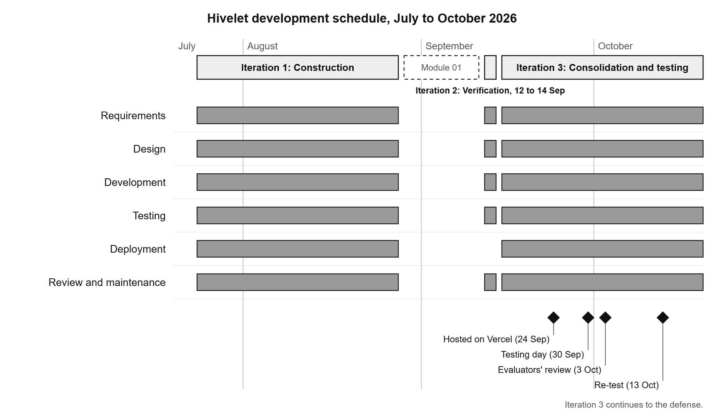

APPENDIX D: CONTEXT DIAGRAM
Figure D-1. Context diagram, as built (the same diagram as Figure 4-3).
[IMAGE FILE: images/Figure D-1 - Context diagram, as built (the same diagram as Figure 4-3).png]

APPENDIX E: LEVEL 1 DATA FLOW DIAGRAM
Figure E-1. Level 1 data flow diagram, as built (the same diagram as Figure 4-4).
[IMAGE FILE: images/Figure E-1 - Level 1 data flow diagram, as built (the same diagram as Figure 4-4).png]

APPENDIX F: DATA FLOW DIAGRAMS (CHILD DIAGRAMS)
Figures F-1 to F-4 open four of the eight processes of the level 1 diagram (Figure 4-4) into their steps. Each step is one operation the system's screens perform, and the stores and external entities keep the names of Figure 4-4. Processes 2.0 (manage units and rates), 6.0 (record expenses), 7.0 (produce reports) and 8.0 (sign in and manage one's own account) each perform a single operation and are not opened further.
Figure F-1. Diagram 1.0, handle inquiries.
[IMAGE FILE: images/Figure F-1 - Diagram 1.0, handle inquiries.png]
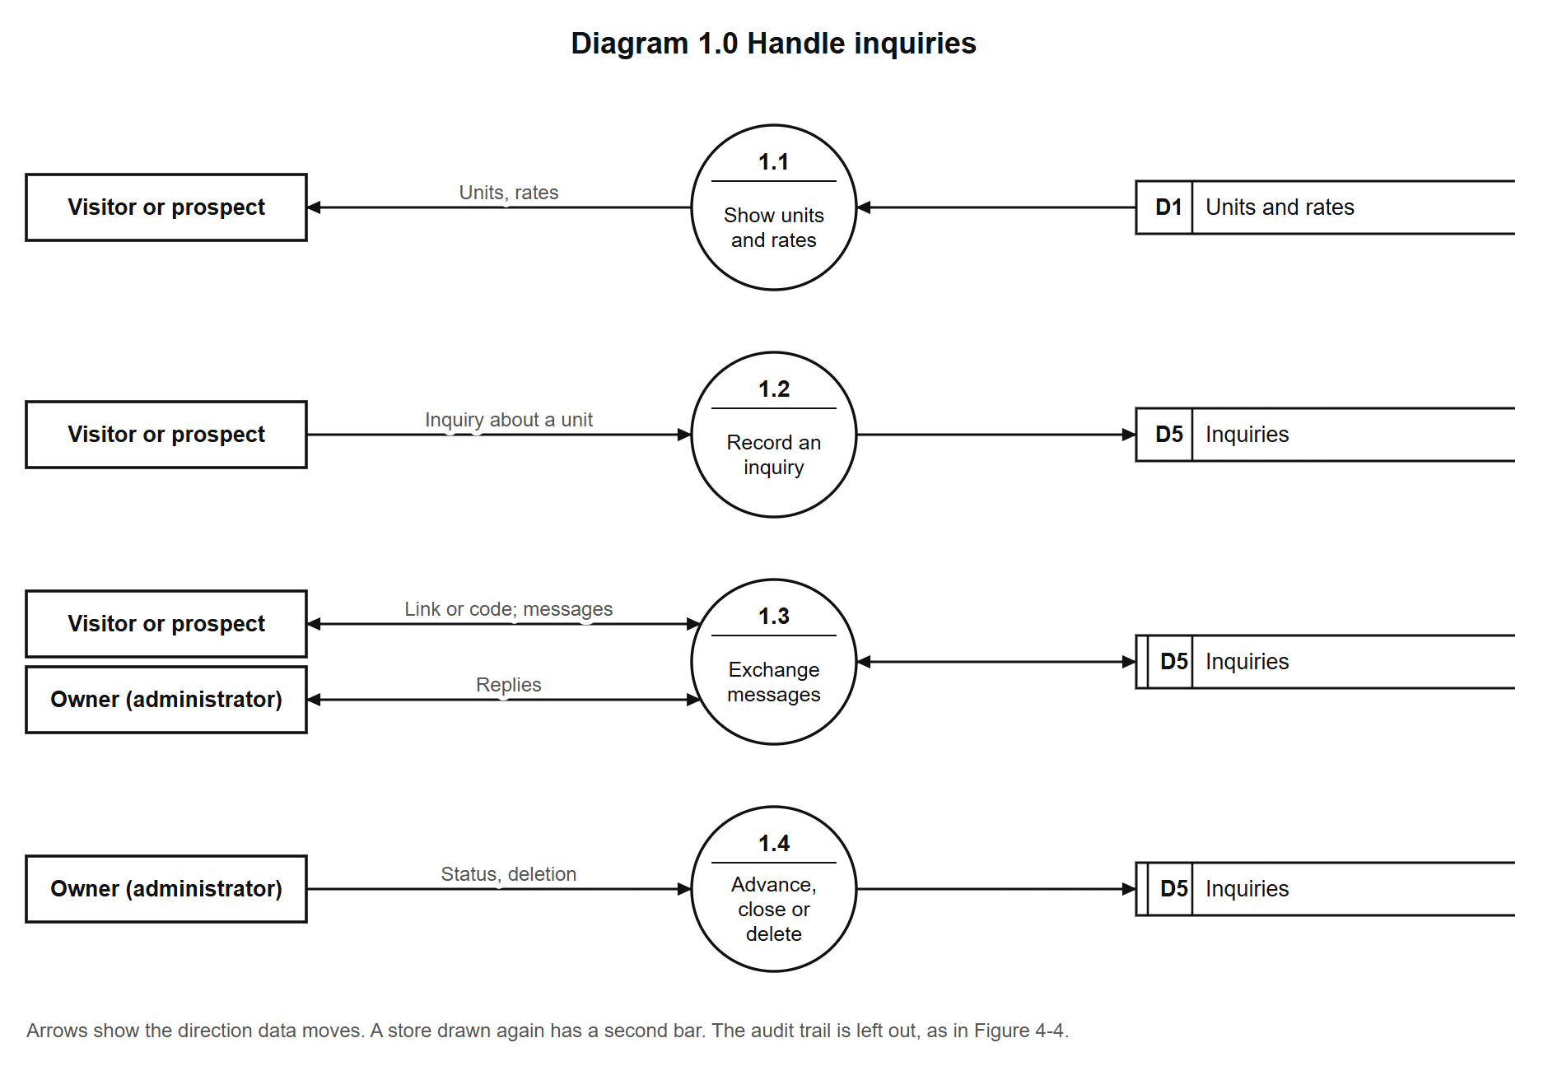
Figure F-2. Diagram 3.0, manage tenants and tenancies.
[IMAGE FILE: images/Figure F-2 - Diagram 3.0, manage tenants and tenancies.png]
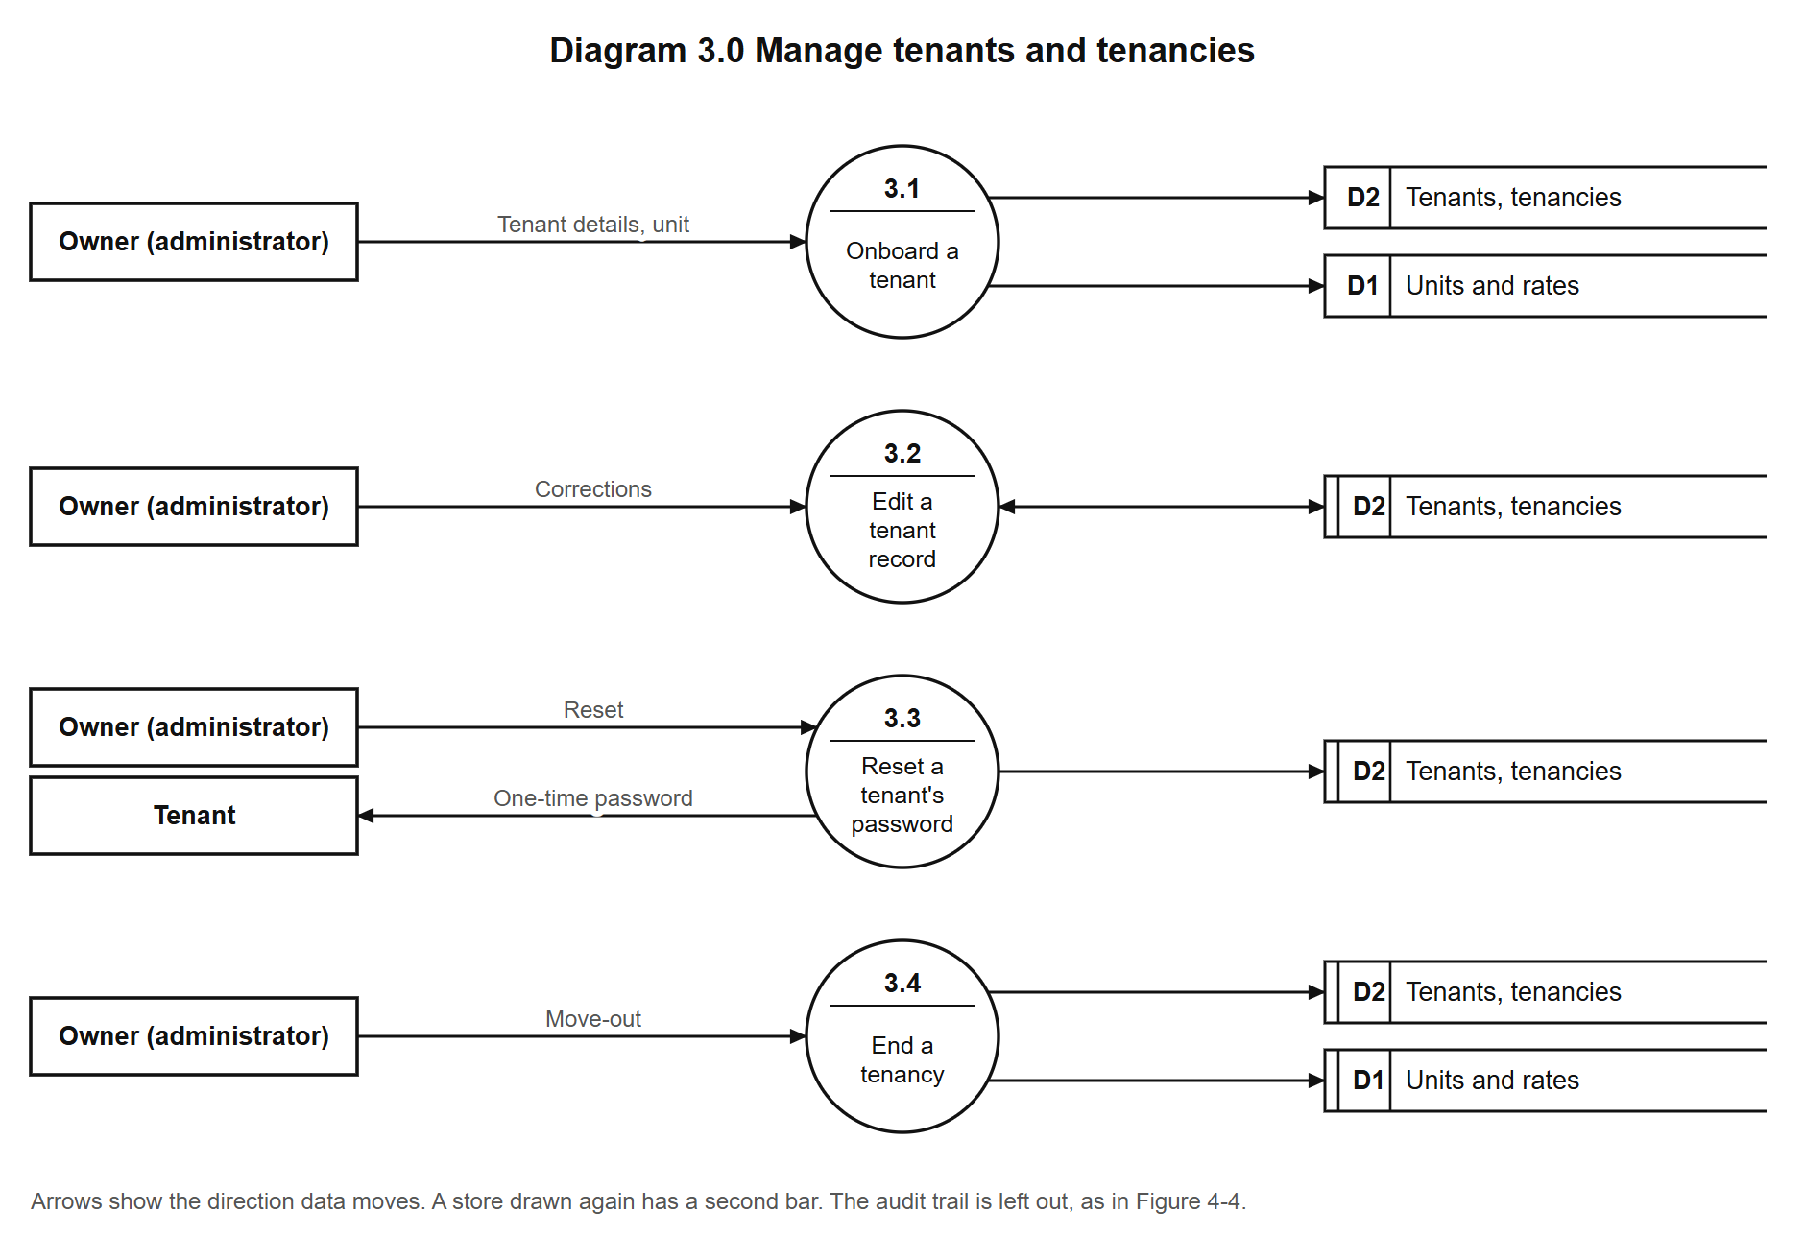
Figure F-3. Diagram 4.0, bill and record payments.
[IMAGE FILE: images/Figure F-3 - Diagram 4.0, bill and record payments.png]
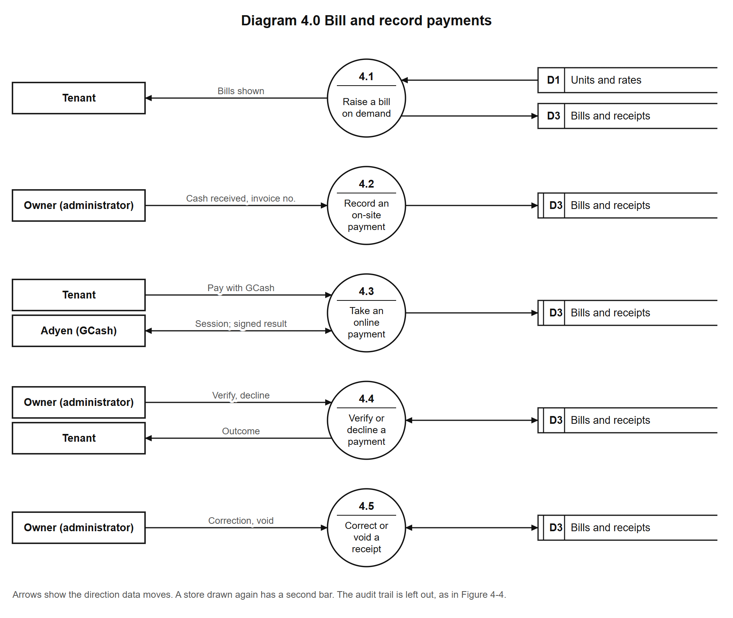
Figure F-4. Diagram 5.0, manage repair requests.
[IMAGE FILE: images/Figure F-4 - Diagram 5.0, manage repair requests.png]
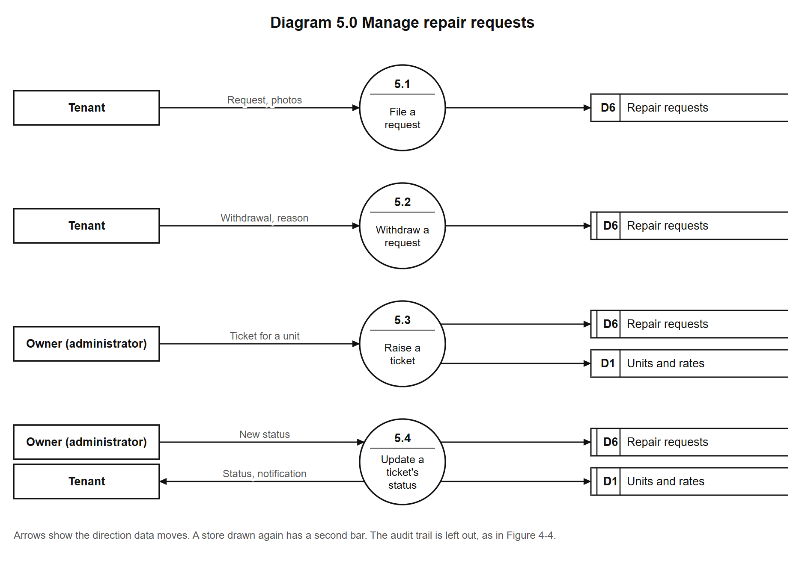

APPENDIX G: USE CASE DIAGRAM
Figure G-1. Use case diagram, as built (the same diagram as Figure 4-5).
[IMAGE FILE: images/Figure G-1 - Use case diagram, as built (the same diagram as Figure 4-5).png]

APPENDIX H: ENTITY-RELATIONSHIP DIAGRAM
Figure H-1. Entity-relationship diagram, as built (the same diagram as Figure 4-6).
[IMAGE FILE: images/Figure H-1 - Entity-relationship diagram, as built (the same diagram as Figure 4-6).png]

APPENDIX I: INITIAL DESIGN
The interface was prototyped directly in code (Section 3.1.1), so the initial design is the first working version of the system, as it stood at the end of the first iteration on 28 August 2026. Figures I-1 to I-4 show four of its screens, with sample tenants. They differ from the system as built (Figures 4-4 to 4-8): the second iteration removed the automatic rent increase marked beside each tenant, which the owner does not apply, and corrected the number of units on the public page (Appendix M, Table M-19). The owner's financial screens of that version are not shown, because they carry figures from her records.
Figure I-1. Public landing page, 28 August 2026.
[IMAGE FILE: images/Figure I-1 - Public landing page, 28 August 2026.png]
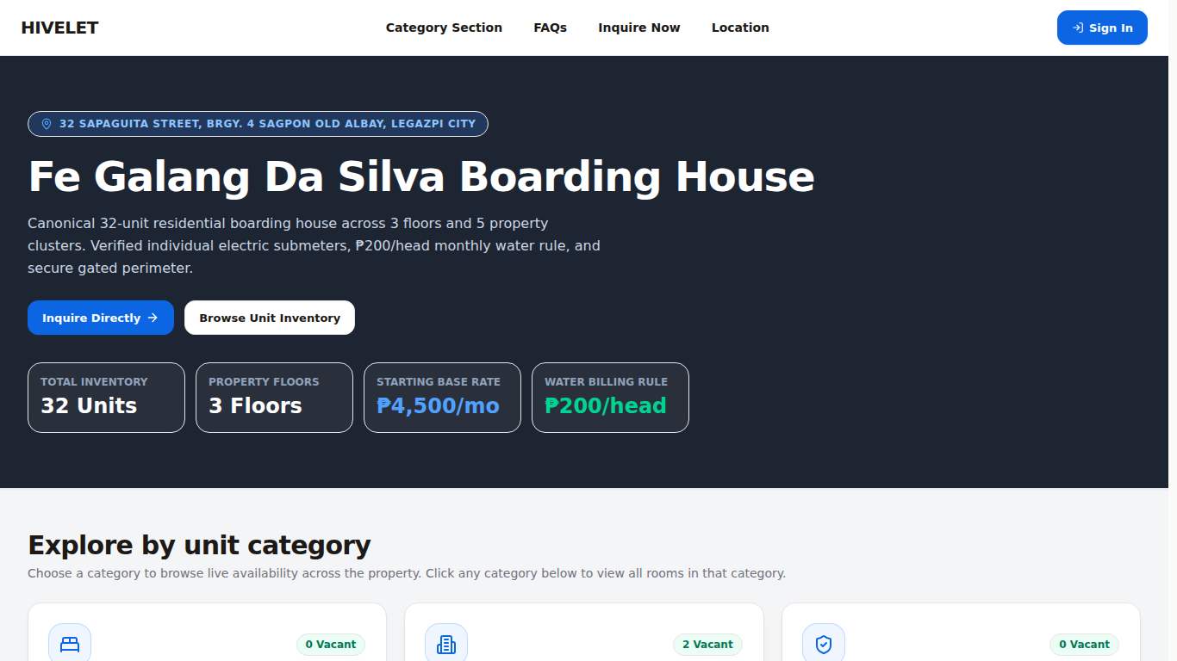
Figure I-2. A unit category on the public site, 28 August 2026.
[IMAGE FILE: images/Figure I-2 - A unit category on the public site, 28 August 2026.png]
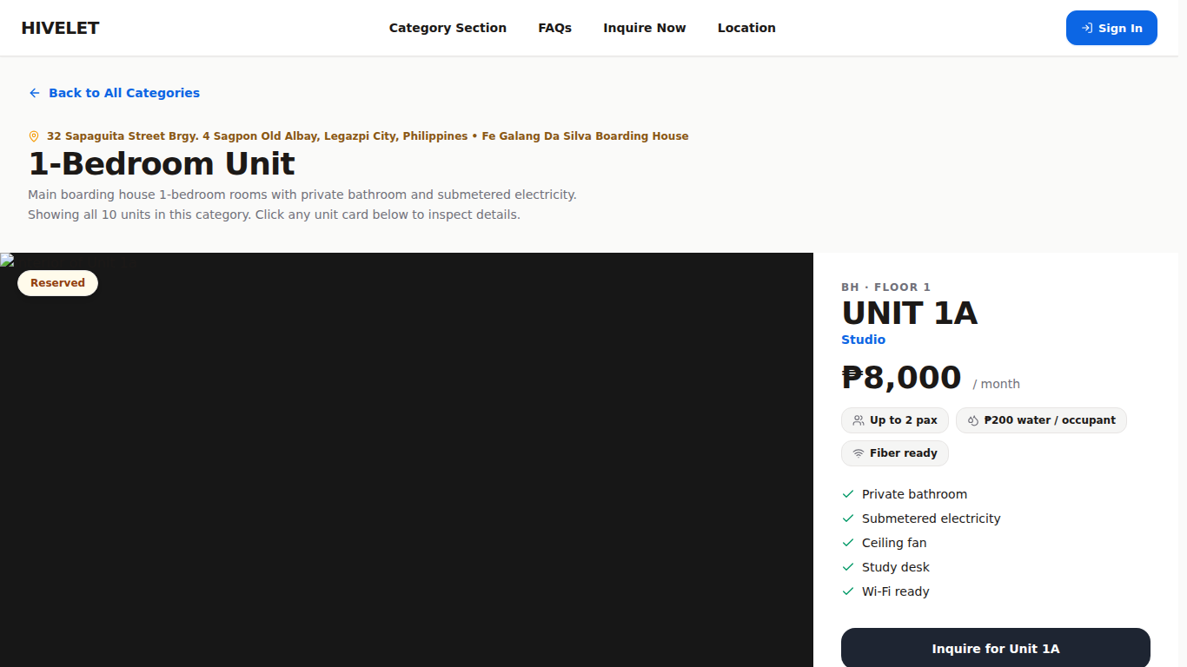
Figure I-3. Tenant directory, with sample tenants, 28 August 2026.
[IMAGE FILE: images/Figure I-3 - Tenant directory, with sample tenants, 28 August 2026.png]
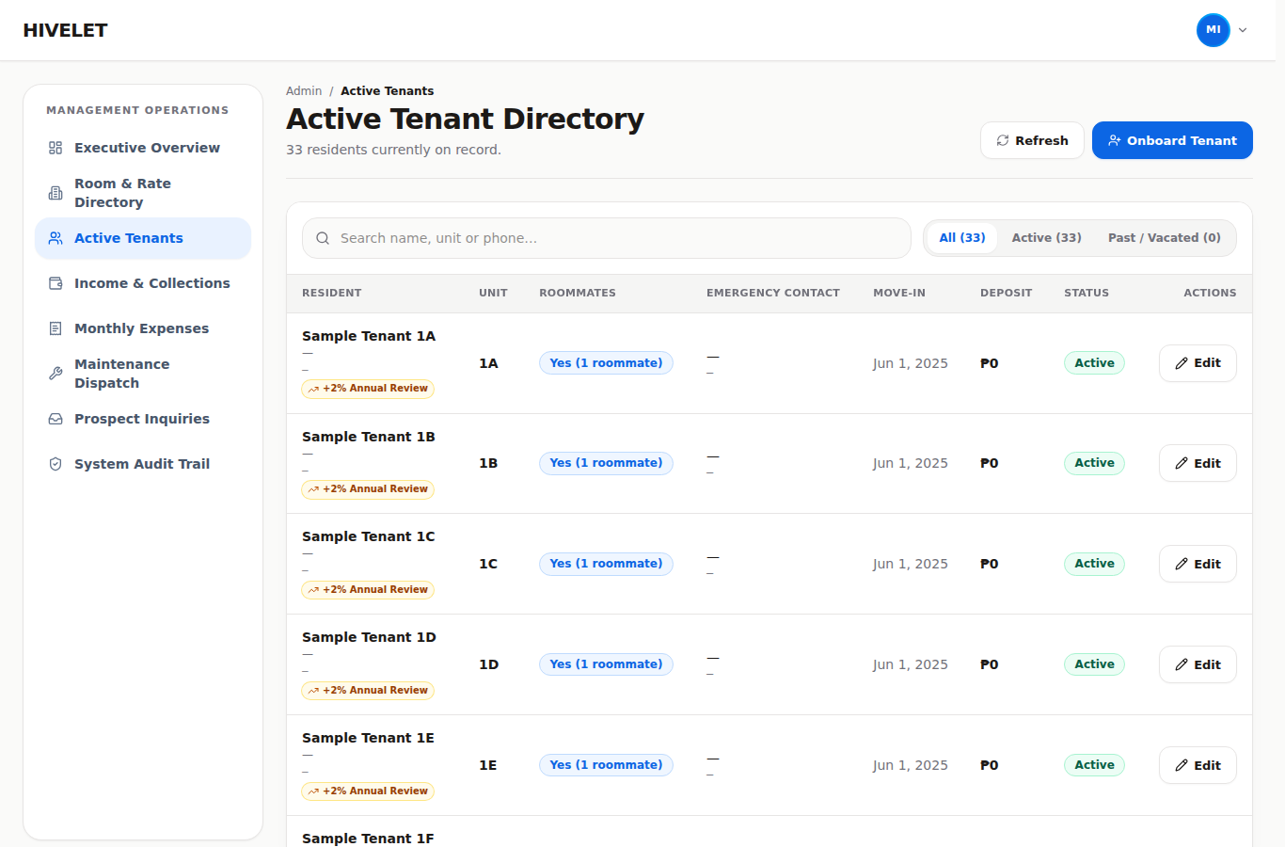
Figure I-4. Tenant overview on a phone, 28 August 2026.
[IMAGE FILE: images/Figure I-4 - Tenant overview on a phone, 28 August 2026.png]
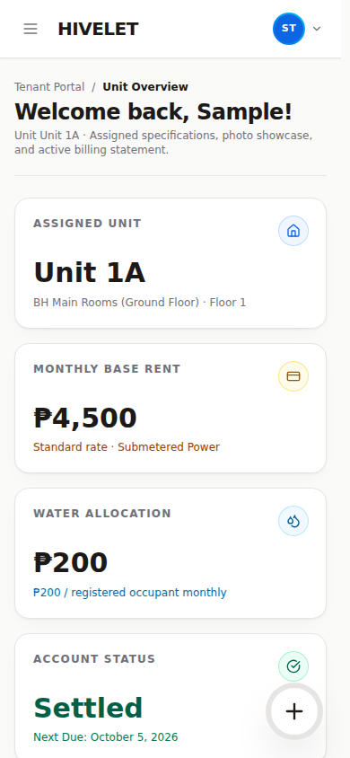

APPENDIX J: EVALUATION INSTRUMENT
The ISO/IEC 25010 questionnaire, as respondents saw it in a Google Form, from 30 September to 4 October 2026. Each respondent answered Section 1, which sent them to the one section for their group; the item numbers are those of Chapter 3, Table 3-6. Rated items: owner and administrator 28, tenants 18, technical evaluators 33, prospective tenants 12.
Hivelet System Evaluation: ISO/IEC 25010 Software Quality Assessment
Thank you for helping us evaluate Hivelet, a web-based apartment management system developed for the Fe Galang Da Silva Boarding House by Group 4, BS Information Technology, Bicol University College of Science.
This survey measures the quality of the system using the ISO/IEC 25010 international standard for software product quality. It takes about 5 to 10 minutes.
Please answer based on your own experience of using the system. There are no right or wrong answers, and an honest low rating is more useful to us than a polite high one.
Your responses are used only for this academic study. Your name is not required and individual answers are not shown to anyone outside the research team.
Salamat sa pagtulong sa amin na suriin ang Hivelet, isang web-based na sistema para sa pamamahala ng apartment na ginawa para sa Fe Galang Da Silva Boarding House ng Group 4, BS Information Technology, Bicol University College of Science.
Sinusukat ng survey na ito ang kalidad ng sistema gamit ang pamantayang ISO/IEC 25010. Aabutin ito ng humigit-kumulang 5 hanggang 10 minuto.
Sagutin po batay sa sarili ninyong karanasan sa paggamit ng sistema. Walang tama o maling sagot, at mas nakakatulong sa amin ang tapat na mababang marka kaysa sa magalang na mataas na marka.
Ang inyong mga sagot ay gagamitin lamang para sa pag-aaral na ito. Hindi kinakailangan ang inyong pangalan at hindi ipinapakita ang indibidwal na sagot sa sinumang wala sa pangkat ng mananaliksik.

Section 1: About you
Q1. Which best describes you? / Alin ang naglalarawan sa inyo?
• Property owner or administrator / May-ari o administrador ng apartment
• Tenant of the boarding house / Nangungupahan sa boarding house
• Technical evaluator (IT professional, developer, or IT faculty) / Technical evaluator
• Looking for a room (not living here yet) / Naghahanap ng kwarto (hindi pa nakatira dito)
Q2. How long have you been using or reviewing the system? / Gaano na kayo katagal gumagamit o sumusuri sa sistema?
• Less than one week / Wala pang isang linggo
• One to two weeks / Isa hanggang dalawang linggo
• More than two weeks / Higit sa dalawang linggo
Q3. Which device did you mainly use? / Anong device ang pangunahin ninyong ginamit?
• Desktop or laptop computer / Desktop o laptop
• Mobile phone / Cellphone
• Tablet / Tablet
• Both computer and mobile phone / Parehong computer at cellphone

Section 2: Owner and administrator
Rate each statement: 5 Strongly Agree, 4 Agree, 3 Neutral, 2 Disagree, 1 Strongly Disagree.
No. | Statement | 5 | 4 | 3 | 2 | 1
 | Functional Suitability
1 | The system lets me manage tenant records, units, and the number of occupants in each unit.
2 | The system computes rent and water charges correctly, without me doing the arithmetic myself.
3 | Payments I receive in person are recorded accurately against the correct unit and month.
4 | Online payments made by tenants appear correctly for me to verify before they are settled.
5 | Maintenance requests can be submitted, followed, and closed within the system.
6 | The financial reports the system produces match the records I keep.
 | Performance Efficiency
7 | The system responds quickly when I move between screens.
8 | Financial reports are produced without a long wait.
9 | The system stays responsive even when many records are shown at once.
 | Compatibility
10 | The system works correctly in the browser I normally use.
11 | Reports exported from the system open correctly in my spreadsheet program.
12 | I can use the system at the same time as the other applications on my device.
 | Usability
13 | I can tell what each screen is for without being taught.
14 | The words and labels used match the way I actually talk about my property.
15 | Before anything is changed or deleted, the system asks me to confirm and tells me what will happen.
16 | When something goes wrong, the message tells me what to do about it.
17 | I was able to learn the system without technical help.
 | Reliability
18 | The system is available whenever I need it during the day.
19 | Records I enter are still there when I come back to them.
20 | When information cannot be loaded, the system says so instead of showing a wrong amount.
21 | After an interruption, nothing I had already recorded was lost.
 | Security
22 | Only I can reach the financial records.
23 | A tenant can see only their own information.
24 | I can see a record of the actions taken in the system and who took them.
25 | I can change my password myself when I need to.
 | Portability
26 | The system works on the devices I already own.
27 | I can install the system on my phone without going to an app store.
28 | I did not need to install any other software to use the system.

Open questions (optional)
1. What worked best for you in the system?
2. What was difficult, confusing, or missing? Please be specific — this is the most useful answer you can give us.

Section 3: Tenants
Rate each statement: 5 Strongly Agree, 4 Agree, 3 Neutral, 2 Disagree, 1 Strongly Disagree. 5 Lubos na Sumasang-ayon, 4 Sumasang-ayon, 3 Walang Kinikilingan, 2 Hindi Sumasang-ayon, 1 Lubos na Hindi Sumasang-ayon.
No. | Statement | 5 | 4 | 3 | 2 | 1
 | Functional Suitability
1 | I can see my own unit details, my bill, and what I still owe. Nakikita ko ang detalye ng aking unit, ang aking bill, at kung magkano pa ang dapat kong bayaran.
2 | I can submit a maintenance request and follow what happens to it. Nakakapagpasa ako ng request para sa pagpapakumpuni at nasusubaybayan ko kung ano ang nangyayari dito.
3 | I can see a record of the payments I have made. Nakikita ko ang talaan ng mga bayad na naibigay ko na.
 | Usability
4 | I can tell what each screen is for without being taught. Nauunawaan ko kung para saan ang bawat screen kahit walang nagturo sa akin.
5 | The words used in the system are easy to understand. Madaling maintindihan ang mga salitang ginamit sa sistema.
6 | It is clear how much I owe and what the amount is made up of. Malinaw kung magkano ang dapat kong bayaran at kung paano ito nabuo.
7 | When something goes wrong, the message tells me what to do about it. Kapag may mali, sinasabi ng mensahe kung ano ang dapat kong gawin.
8 | I was able to use the system without anyone explaining it to me. Nagamit ko ang sistema kahit walang nagpaliwanag sa akin.
 | Performance Efficiency
9 | The system opens quickly. Mabilis magbukas ang sistema.
10 | The system responds without delay when I move between screens. Mabilis tumugon ang sistema kapag lumilipat ako ng screen.
 | Reliability
11 | The system is available whenever I try to use it. Magagamit ang sistema sa tuwing kailangan ko ito.
12 | The information shown to me is correct and up to date. Tama at napapanahon ang mga impormasyong ipinapakita sa akin.
13 | When something cannot be loaded, the system says so instead of showing a wrong amount. Kapag may hindi mabuksan o ma-load, sinasabi ito ng sistema sa halip na magpakita ng maling halaga.
 | Compatibility
14 | The system works correctly in the browser I normally use. Gumagana nang maayos ang sistema sa browser na karaniwan kong ginagamit.
15 | I can use the system at the same time as my other apps. Nagagamit ko ang sistema kasabay ng iba kong mga app.
 | Portability
16 | The system works on my own phone or computer. Gumagana ang sistema sa sarili kong cellphone o computer.
17 | I can open the system on more than one device. Nabubuksan ko ang sistema sa higit sa isang device.
18 | I did not need to install anything extra to use it. Hindi ako kinailangang mag-install ng kahit anong karagdagang app para magamit ito.

Open questions (optional)
1. What did you find most useful? Ano ang pinakanakatulong sa iyo?
2. What was difficult, confusing, or missing? Ano ang nahirapan kang gawin, nakalito sa iyo, o kulang sa sistema?

Section 4: Technical evaluators
Rate each statement: 5 Strongly Agree, 4 Agree, 3 Neutral, 2 Disagree, 1 Strongly Disagree. The form asked evaluators to review the repository and documentation before answering.
No. | Statement | 5 | 4 | 3 | 2 | 1
 | Functional Suitability
1 | The system provides the functions required for tenant, unit, and occupancy management.
2 | Rent and water charges are computed correctly and consistently.
3 | Payment recording and verification behave correctly for both in-person and online payments.
4 | The maintenance ticketing workflow supports submission, tracking, and closure.
5 | Generated reports agree with the records held in the database.
 | Performance Efficiency
6 | Response times are acceptable for the expected number of users and records.
7 | Report generation completes within a reasonable time.
8 | The system uses client and server resources efficiently.
 | Compatibility
9 | The system operates correctly across current mainstream browsers.
10 | Exported files conform to formats that other applications can read.
11 | The system coexists with other applications without interference.
 | Usability
12 | The interface is understandable without prior training.
13 | Terminology is consistent across the system and appropriate to the users.
14 | Destructive actions require confirmation and state their consequence.
15 | Error messages are actionable rather than technical.
16 | The interface is operable for users with limited technical background.
 | Reliability
17 | The system handles failure of a request without presenting incorrect data.
18 | Recorded data is retained reliably.
19 | The system distinguishes clearly between "no data" and "data could not be loaded".
20 | The system recovers from interruption without data loss.
 | Security
21 | Access to functions and records is correctly restricted by role.
22 | A tenant account cannot reach administrative data.
23 | Administrative actions are recorded in an auditable trail.
24 | Credentials are handled and stored appropriately.
25 | Authentication and session handling follow accepted practice.
 | Maintainability
26 | The codebase is organized so that a change can be located and made confidently.
27 | The system is documented sufficiently for another developer to maintain it.
28 | Changes to configurable values do not require code changes.
29 | Automated checks exist that would catch a regression.
30 | A change in one part of the system is unlikely to disturb unrelated parts.
 | Portability
31 | The system can be deployed to another environment without modification.
32 | The client installs on a mobile device without an application store.
33 | The system does not depend on software the target environment is unlikely to have.

Open questions (optional)
1. Which aspect of the system is strongest, from a technical standpoint?
2. Which aspect most needs improvement, and what would you change?

Section 5: Prospective tenants
Rate each statement: 5 Strongly Agree, 4 Agree, 3 Neutral, 2 Disagree, 1 Strongly Disagree. 5 Lubos na Sumasang-ayon, 4 Sumasang-ayon, 3 Walang Kinikilingan, 2 Hindi Sumasang-ayon, 1 Lubos na Hindi Sumasang-ayon.
No. | Statement | 5 | 4 | 3 | 2 | 1
 | Functional Suitability
1 | I could find which kinds of units the boarding house has and how much they cost. Nakita ko kung anong mga uri ng unit ang mayroon at kung magkano ang mga ito.
2 | I could see enough about a unit (its floor, how many people can stay, its floor plan) to decide whether to ask about it. Nakita ko ang sapat na detalye ng isang unit (palapag, ilang tao ang puwede, floor plan) para magpasya kung magtatanong ako.
3 | I could send an inquiry about a unit without difficulty. Nakapagpadala ako ng tanong tungkol sa isang unit nang walang hirap.
 | Usability
4 | I could tell what each part of the website is for without being taught. Nauunawaan ko kung para saan ang bawat bahagi ng website kahit walang nagturo sa akin.
5 | The words used on the website are easy to understand. Madaling maintindihan ang mga salitang ginamit sa website.
6 | When I made a mistake in the inquiry form, the message told me what to fix. Kapag nagkamali ako sa inquiry form, sinabi ng mensahe kung ano ang dapat ayusin.
 | Performance Efficiency
7 | The website opens quickly. Mabilis magbukas ang website.
8 | The pages respond without delay when I move around the website. Mabilis tumugon ang mga pahina kapag lumilipat ako sa website.
 | Reliability
9 | The information shown (units, rates, availability) looks correct and up to date. Mukhang tama at napapanahon ang impormasyong ipinapakita (mga unit, presyo, bakante).
 | Compatibility
10 | The website works correctly in the browser I normally use. Gumagana nang maayos ang website sa browser na karaniwan kong ginagamit.
 | Portability
11 | The website works on my own phone. Gumagana ang website sa sarili kong cellphone.
12 | I did not need to install anything to use it. Hindi ko kinailangang mag-install ng kahit ano para magamit ito.

Open questions (optional)
1. What did you find most useful on the website? Ano ang pinakanakatulong sa iyo sa website?
2. What was difficult, confusing, or missing? Ano ang nahirapan kang gawin, nakalito sa iyo, o kulang sa website?

APPENDIX K: USER'S MANUAL
For the owner and the tenants of the Fe Galang Da Silva Boarding House. Written 2026-09-29 against the system as deployed that night; every button and screen name below is the one the system shows. Chapter 4, §4.5 (Table 4-22, stage 4) names this manual as the hand-over document.
Hivelet is at https://hivelet.vercel.app. It works in any current browser on a phone or a computer, and it can be installed on a phone's home screen (Part 1, step 6).

Part 1. For tenants / Para sa mga nangungupahan

1. Signing in for the first time / Unang pag-sign in
1. Open hivelet.vercel.app and tap Sign in. Buksan ang hivelet.vercel.app at pindutin ang Sign in.
2. Type your login ID (for example HV-48213) and the starting password the landlady gave you. I-type ang inyong login ID at ang starting password na ibinigay ng landlady.
3. A window asks for your own email, your own mobile number and your own password. Type the starting password again, then your new one twice. It must have at least 10 characters, a letter and a number. Your name stays as the landlady recorded it. Ilagay ang sariling email, numero at password: hindi bababa sa 10 character, may letra at numero.
4. Keep your password to yourself. The slip stops working once you have your own. Huwag ibahagi ang password.
Forgot your password? Ask the landlady. She can give you a new starting password from her screen. Nakalimutan ang password? Lumapit sa landlady; bibigyan niya kayo ng bagong starting password.
Five wrong passwords lock the account for 15 minutes; then it opens again by itself.

2. Overview / Pangunahing pahina
Your unit, your rent, and Amount due. The amount due counts only the payments the landlady has recorded, up to the date it shows ("Your recorded payments cover rent up to…"). If you have paid and it is not there yet, it appears once she records your receipt. Ang "Amount due" ay batay lang sa mga bayad na naitala na ng landlady.
Your recent actions lists the last three things you did here (a repair request sent, a GCash payment started, your details updated), newest first. On a computer it is in the menu on the left, under the sections, on every page, headed Recently. On a phone the latest one is under the greeting: Recently, with the date and time you did it at the right, and what you did on the line below. It is there to be read, not clicked. Only you see your own actions. Ang huling tatlong ginawa ninyo dito.

3. Payments and billing / Bayad at singil
• Your rent: the monthly rent, plus water at ₱200 per occupant per month. Tubig: ₱200 bawat nakatira bawat buwan.
• Your rent, month by month: your bills over time, up to the last 12 months. Ang inyong upa, buwan-buwan: hanggang sa huling 12 buwan.
• One sentence says where you stand, for example "Paid up to August 12, 2026. You are up to date." or how many months are due and how much in all. Isang pangungusap ang nagsasabi kung hanggang kailan kayo bayad at kung may dapat pang bayaran.
• A bar for each month: Paid, Due (Due soon or Due today), Not entered (no payment entered for that month yet), or Not due yet. Bawat buwan: Paid (bayad), Due (dapat bayaran), Not entered (wala pang naitalang bayad), Not due yet (hindi pa dapat bayaran).
• Months paid, Paid in these months and Due now. Only receipts the landlady has verified count; a cancelled (voided) receipt never counts. A GCash payment you sent shows as waiting until she verifies it. Ang mga resibong na-verify lang ng landlady ang binibilang.
• "Not entered" does not mean you owe that month: the landlady may not have entered your payment yet. If you paid, it appears once she enters it, or ask her to check her records. Kung "Not entered" pero nagbayad kayo, lalabas ito kapag naitala na ng landlady.
• Show each month as a list gives the same months as a table, with the receipt for each.
• Payment record: every payment recorded for your unit, newest first. Search it, or pick another Year or Order in the dropdowns above it (on a phone, tap Filters first). The list changes as soon as you pick.
• Pay with GCash: online payment. Until the landlady announces it, online payments do not charge real money; pay her in person. Sa ngayon, sa landlady pa rin po magbayad nang personal.

4. Repairs / Pagpapaayos
1. Open Repairs. Say what needs fixing, choose the kind of problem and How urgent, add the details. Isulat kung ano ang sira at gaano kaapurahan.
2. Add a photo if you can, as a JPG or PNG (a phone camera's photos are). It is made smaller before sending.
3. Press Send request. It goes straight to the landlady and appears in Your requests.
4. Open a request to follow it and to add a note. You get a notification when it is done. The Show dropdown above your requests shows only Open or Done ones (on a phone, under Filters).
5. Changed your mind? Open the request and press Cancel request while it is still Submitted. You may give a reason. You can cancel one request an hour, and not once the landlady has started on it; send her a note instead. A cancelled request stays in your list, marked Cancelled. Puwedeng i-cancel habang hindi pa sinisimulan ng landlady.

5. My details / Aking detalye
Keep your email, phone number and the person to call If something happens to you up to date, then press Save. After your first sign-in you can sign in with your login ID, phone number or email. Your name can only be changed by the landlady. A phone number is spaced as you type it (0917 123 4567), and an email is checked as soon as you leave its box. Both your number and the number of the person to call must be Philippine mobile numbers; if one is not, a note under the box says so and nothing is saved until it is corrected.

6. Install it on your phone / I-install sa cellphone
• Android (Chrome): menu ⋮ > Install app (or Add to Home screen).
• iPhone (Safari): Share > Add to Home Screen.
It then opens from its own icon. Pull down from the top of a page to reload it: the green hexagon turns until your figures are back, and the page stays where it is. Hilahin pababa mula sa itaas para i-reload.
Without signal, it still opens, with a thin bar at the top: "No connection · Transactions unavailable". Overview, Payments and billing, Repairs, My details and the bell show your rent, balance, payments, requests, details and notifications as last loaded. Pay with GCash is hidden and Send request, Save and marking notifications read wait until the signal returns. When it does, the pages reload by themselves. These essential figures, names and notifications are kept on your phone for your account only, and signing out removes them. If sending stalls on a weak signal, wait: after about 45 seconds it tells you whether to check before sending again. Kapag walang signal, makikita pa rin ang huling na-load na upa, balanse, bayad, request at notification, pero hindi makakapagpadala o makakabayad.
Light or dark: tap your initials at the top right > Appearance > System, Light or Dark. System follows your phone's own setting. Piliin ang Light o Dark sa Appearance.

7. Signing out / Pag-sign out
Tap your initials at the top right > Sign out. Always sign out on a phone that is not yours: it also removes the figures, names and notifications kept on the phone for viewing without signal.

Part 2. For the landlady (administrator)
The administrator account is Michelle's; the business keeps the name Fe Galang Da Silva Boarding House. The greeting at the top follows the time of day.
Every list (Rooms and rates, Tenants, Monthly Income, Monthly Expenses, Repairs, Inquiries) has the same bar at the top:
• Search narrows the list as you type.
• The filters are dropdowns beside the search, each named above it: cluster, month, year, status, kind, whichever that list has. Where a list can be drawn two ways, Show as picks By cluster or As a list. Order arranges the list: By unit, By name (A to Z), Newest first or Oldest first (Repairs also has Most urgent first). The list changes the moment you pick. On a phone, tap Filters to open them under the bar, and tap it again to close them. The filters in use are named under the bar; Clear removes them.
• Show more and Show all under a long list open more of it; Show fewer closes it again.
Also on every screen: a short ping means something was saved, or someone else's change has arrived. Tap a message at the top of the screen to close it. The phone's Back button goes back a page and closes any window that was open on it. In the installed app, pull down from the top of a page to reload it: the green hexagon turns until the figures are back, and grey outlines stand in for them meanwhile; the page does not go blank. Light or dark: your initials > Appearance > System, Light or Dark (System follows the phone or computer). On the public pages it is the sun/moon button at the top of the page. The green hexagon turns in the middle of the screen the first time the site opens on a phone or computer, when it is opened again after half an hour or more away, and when the public pages or the sign-in page are reloaded. Reloading one of your own screens during a visit shows grey outlines of the page instead while the figures load.
Downloads. Where the browser offers a Save window (Chrome or Edge on a computer), the message "Report downloaded" appears only once the file is saved; cancelling the window says nothing and saves nothing. On a phone the message is "Download started". The cluster of 22 main rooms is called Boarding House on every screen and in every downloaded workbook.

1. Signing in and your password
Sign in with your phone number and your password. To change it: your initials at the top right > Change password. Only you should know it; the system's record of who did what is only as good as that.

2. Overview
The first screen: Needs your attention (how many payments wait to be verified, and how many urgent repairs are open), Rent and water for this month, Occupancy (32 of 33 today), Rent and water by month, Units by cluster, Net income and Open repair requests. Personal spending is shown beside operating costs and is not deducted from rental income. If a figure cannot be loaded, the tile shows "—", never ₱0.00: refresh when the connection is back.
Your recent actions lists the last three things you did (a payment recorded, a GCash payment approved, a repair marked done), newest first. On a computer it is in the menu on the left, under the sections, on every page, headed Recently. On a phone the latest one is under the greeting: Recently, with the date and time you did it at the right, and what you did on the line below. It is there to be read, not clicked. It shows only your own actions, never anyone else's.
• Record payment, Record expense and Move someone in/out are the green buttons at the top. On a phone, tap the green + at the bottom right to show them; tap it again to hide them.
• Another year: tap the year beside the date (for example 2026 ⌄) and choose one. Back to 2026 returns to this year.
The bell at the top shows a dot when you have unread notifications; open it to read them. The filter icon beside the title shows only Unread, Payments, Repairs or Inquiries (or All); the refresh icon checks for new ones; X closes. Mark all read is at the bottom. The numbers beside Inquiries and Repairs in the side menu count what you have not looked at yet (new inquiries, and urgent repairs). They clear once you open that page, and come back if something changes: a visitor writes back, or a repair is made more urgent. They are remembered on this device only, so another phone or computer shows its own count.

3. Recording a payment (Monthly Income)
1. Monthly Income > Record payment.
2. Choose the Unit, the Date received, How they paid, and the period it covers (Covering from, Covering to, or Months covered for more than one month at once). Covering from starts on the day after that tenant's last recorded period, so payments entered oldest first need no change. Change it if this payment is for a different period.
3. Occupants starts at the number on record. Change it if more or fewer people live there now: Water is worked out from it (₱200 a person) and cannot be typed. Rent fills in from the unit's rate.
4. Invoice or acknowledgement receipt (if any): type the number on the invoice you issued, or pick Acknowledgement receipt from the list when you gave a slip with no number. Leave it blank if there was neither. "4726" or "INV 4726" is saved as INV#4726.
5. Save, and check the summary that appears: the months, rent, water, total, and, if you changed the occupants, that the tenant's record now shows the new number (their water from then on). See it in Monthly Income opens that month with the payment marked.
The system never makes up an invoice number: it records yours, or none. The same invoice number cannot be recorded twice for the same unit and month.
To correct a payment: open it with Edit > change > Save changes. To remove one recorded by mistake: Edit > Delete payment. It leaves the ledger and totals at once; the system's own record (section 9) keeps that it existed and who removed it.
Online (GCash) payments appear under To verify / Payments to verify. Check the money arrived, then verify it, or reject it. A payment is only counted once you verify it. Until online payment goes live it runs on Adyen's test account and no real money arrives, so reject these.
The month and the year. The dark card at the top is one month: what was received this month (for example "Received, October 2026"), with its rent, water and 50% Share. Beside it, Where it came from is the year: the year's total and how it divides across the clusters, and below that the year month by month. Monthly Expenses is laid out the same way ("Spent, October 2026" with utilities and repairs; Where it went is the year by area). Filters > Month shows another month in the dark card; Filters > Year picks another year, or All years for everything since the records began. Filters > Group by gathers the payments by Cluster (the usual view), by Unit, or by Tenant (A to Z).
Download asks what the file should cover: Month (pick the month and year), Year (pick the year) or All. It opens on what the screen is showing, so pressing Download again gets that. The workbook is in your own layout (month blocks, cluster subtotals, Linda separate) and is named for what it holds: "Monthly Income March 2026" for one month, "Monthly Income 2025" for a year (this year's too), and for All the years it covers, such as "Monthly Income 2024-2026". In the workbook each cluster's subtotal is on a light-blue row and each GRAND SUBTOTAL is red with white letters; an acknowledgement receipt shows as ACK. The Monthly Expenses workbook uses the same colors for each month's TOTAL and the YEAR TOTAL.

4. Recording an expense (Monthly Expenses)
1. Monthly Expenses > Record expense.
2. The date, the invoice or supplier, amount, category, and the property area it was for.
3. One expense for several areas: Split across another area. The parts must add up to the expense; the total is worked out for you. Choose an area for each new part; each area can be given once, so two amounts for the same area go in as one.
4. Add another expense records the next one without closing the form.
5. A kind of expense that is not in the list: open Kind of expense, choose Add a new kind… at the bottom, type its name and press Add kind. It is added after your 13, numbered 11, 12 and so on, and chosen for that expense; it is also in Filters > Kind of expense and in the workbook's category summary. Your 13 stay as they are. A kind you add cannot be renamed or removed, so check the spelling.
Editing and Delete expense work as for payments. Monthly Expenses also opens on this year, with All years in Filters > Year. Download asks Month, Year or All, as for income; a single month's file ends in "only" ("Monthly Expenses March 2026 only - ME032026").

5. Tenants
• Move someone in: name, unit, move-in date, occupants, emergency contact. No phone or email: the tenant gives their own. Press Move them in. Their login ID and a one-time password are shown: write both down and give them to the tenant in person (the password is shown only once). At first sign-in they choose their own password and add their own email and phone.
• Edit (pencil on a tenant): change their details, unit or number of occupants, then Save changes. The water charge follows the number of occupants.
• Reset password (in the same window): for a tenant who forgot theirs or lost the slip. Confirm, and their login ID and a new one-time password are shown. Their old password stops working and their phone is signed out. The login ID is also on their record (Edit), under Login ID.
• Move them out: type the unit code to confirm, and add a reason if you like (kept with the move-out; the tenant does not see it). The tenant loses access at once, the unit becomes free to let, and their records stay.
• Who lived where before: choose a Year (and a Month if you like) in the filters. The list then shows who paid for each unit then, read from your receipts: the months they paid, or for one month what the receipt covered, when it was paid and its number. A name you wrote two ways in the same unit is shown once, with the other spelling under it; a tenant who moved units says which other unit they rented. Download asks Month, Year or All and saves the list as a workbook, named like "Tenant History June 2025 - TH062025". Clear (under the search) goes back to your current tenants.

6. Rooms and rates
Every unit, by cluster or as one list (Filters > Show as); Filters also narrows them by status or cluster. Edit (the pencil) a unit to change its rate, status, description or picture. A unit with no photograph shows its Floor plan, the same one visitors see on the public pages; Replace photo uploads one, and once saved the public page shows that photograph instead. Every rate change is kept in the unit's price history automatically; the system never raises a rate by itself.

7. Repairs
New requests from tenants appear here, marked by urgency. Open one (Manage this repair) to reply, Send technician, move it to In Progress, or Mark resolved (the tenant is notified). Log a repair records one you were told about in person, or one for an empty unit. Delete repair (in Manage this repair, or the bin icon beside Manage on each card) removes a request for good after you confirm it. Status in the filters shows one stage only. A request the tenant cancelled (they can, until work starts) is marked Cancelled by the tenant, with their reason as a note if they gave one.

8. Inquiries
Messages from people asking about a unit. Type a reply and press the arrow (Send reply), Close inquiry when settled, or Move them in to start a tenancy with the details already filled in. Delete (on any inquiry) asks "Delete this inquiry?" and then removes it and its conversation for good; it cannot be undone. Filters > Status shows only those Waiting for an answer, Answered, Moved in or Closed.
The person who asked reads your reply on their inquiry's own page, and can write back there: when they send an inquiry they are given a link and a reference code for it (the code is shown beside your reply box). Their answers appear in the same conversation, and a notification tells you. No text or email is sent, so call them if it is urgent. Inquiries from before 30 September 2026 have no such page: call or text those people as before.

9. The record of who did what
The system writes every payment, correction, tenant change, repair, sign-in and download to a permanent record: who did it, when, and what changed. Nobody can change or delete an entry. Since 1 October 2026 this record is kept in the database for the developers and is not shown in the app. Ask the team if you need to know who changed something.

10. When the connection is weak or gone
The system opens without a connection, with a thin bar at the top ("No connection · Transactions unavailable"), and shows what each screen last loaded on this device: the Overview's figures, the tenants, both ledgers, repairs, inquiries and the notifications. Nothing can be recorded, moved or marked read until the connection returns, so Record payment, Record expense, Move someone in, the buttons in Manage this repair and Log a repair, and Send reply and Close inquiry are greyed out ("Needs a connection"), and the Overview's actions are hidden; when it returns, every screen reloads by itself. An inquiry's conversation (the replies) is not saved for offline viewing: its first message is shown, with a note that the replies could not be loaded. These essential figures, names and notifications stay on your own device only, and signing out removes them. A screen you have not opened since signing in has nothing saved yet. If a save takes too long it stops after about 45 seconds and says "we cannot tell whether it was saved": look at the list before recording it again, so it is not recorded twice.

11. Looking after the records
• The team takes a backup of every record before any change to the data, and whenever asked.
• Record receipts as you collect them: tenants see their balance from what is recorded.
• Five receipts from before the system are known to contain slips in the old book (for example a year typed wrongly). They stay exactly as written, and the checks list them so that nobody mistakes them for the system's errors.

12. Quick answers
Question | Answer
A tenant says their balance is wrong | Check that their receipts since the date shown are recorded (Monthly Income, their unit)
A tenant cannot sign in | They sign in with the login ID on their record (Tenants > Edit). Five wrong tries lock it for 15 minutes. If they forgot the password: Reset password
A figure shows "—" | It could not be loaded. Refresh when the connection is back
"Too many attempts from this connection" | Everyone on the house wifi shares one counter; wait 15 minutes or use mobile data
A GCash payment appeared | Until online payment goes live no real money arrives: reject it under To verify
Something looks wrong | Take a screenshot and tell the team. Do not try to correct the numbers directly

APPENDIX L: TEST CASES
The test cases run on 30 September 2026 on the live system, with their results, as summarized in Chapter 4, Sections 4.3.4 to 4.3.7. Each case names the ISO/IEC 25010 characteristic it tests (FS Functional Suitability, PE Performance Efficiency, CO Compatibility, US Usability, RE Reliability, SE Security, MA Maintainability, PO Portability) and the requirement it traces to. Results: Pass; Fail; Pass after fix; NT, not tested. The prospective tenant's task cards (Part PR) were not recorded on the day and are not shown.

Part A. Owner and administrator (A-05 to A-32 are the 26-step walkthrough)
ID | ISO | Req | Do | Should see | Result
A-01 | US | FR-001 | Sign in with her own password | Lands on Overview | Pass
A-02 | FS | FR-019 | Read the Overview. Ask her: "is this month's collection what you expect?" | Money tiles show figures; occupancy 32 of 33 | Pass
A-03 | US | NFR-002 | Ask her to find, without help, where she would record a payment | Finds Monthly Income within about a minute | Pass
A-04 | FS | FR-027 | Open the notification bell | Notifications list opens; unread count matches | Pass
A-05 | FS | FR-003 | (Walkthrough 1) Open the public site signed out, browse units | 33 units, no resident names | Pass
A-06 | SE | FR-003 | (2) Open LB and LF details | Rate, floor, cluster; no resident name | Pass
A-07 | FS | FR-004 | (3) Send one inquiry from a unit page | "Thank you" confirmation | Pass
A-08 | US, SE | FR-001 | (4) Change Password, wrong current password first | "That is not your current password", still signed in | Pass
A-09 | SE | FR-001 | (5) Change it for real | "Password changed", still signed in | Pass
A-10 | SE | FR-001 | (6) Sign out, sign in with the new password | Works | Pass
A-11 | FS, SE | FR-007, FR-008 | (7) Rooms and rates, edit PH to ₱30,500 | Saved; history row written | NT
A-12 | FS | FR-009 | (8) Tenants: onboard "REHEARSAL Test" into PH | Created; PH Occupied; a one-time password is shown to hand over | Pass
A-13 | FS | FR-009 | (9) Onboard a second tenant with the same phone | Refused, names the reason | Pass
A-14 | FS | FR-033 | (10) Edit the rehearsal tenant: occupants to 2 | Saved | Pass
A-15 | FS | FR-001 | (11) Sign in as the rehearsal tenant (private window) | Forced to choose a password, then Overview shows PH, rate, occupants | Pass
A-16 | FS | FR-021, FR-022 | (12) As that tenant: repair request with a phone photo | Sent; if the photo is too big, it says so plainly | Pass
A-17 | FS | FR-026 | (13) Post a message on it | Appears in the thread | Pass
A-18 | FS | FR-010 | (14) My details: change the emergency contact | Saved | Pass
A-19 | FS | FR-015 | (15) Start a GCash payment; do not pay | Adyen box with a GCash button, inside the window | Pass
A-20 | FS | FR-011 | (15b) Pay this period when no bill exists | A bill is raised: rate + ₱200 per occupant | Pass
A-21 | FS | FR-027 | (16) Mark a notification read | Badge drops by one | Pass
A-22 | SE | FR-002 | (17) Change a ticket id in the address bar to someone else's | Not found (404), never "forbidden" | Pass
A-23 | FS | FR-014, FR-032, FR-034 | (18) Monthly Income: record a collection for PH, receipt REHEARSAL-001, type a wrong water figure first | Warns about water; saved; bill settled | Pass
A-24 | RE | FR-017 | (19) Record the same receipt again | Refused: already recorded | Pass
A-25 | RE, FS | FR-017, FR-029 | (19b) Open Monthly Income in a second tab. In the first, Edit REHEARSAL-001 > Delete payment; then do the same in the second tab without refreshing it (the screen calls a void "Delete payment", and the row leaves the first tab's list) | First works; second refused: "That income record was already voided on …" | Pass
A-26 | FS | FR-005 | (20) Inquiries: reply to A-07's inquiry, close it | Message posted; Closed | Pass
A-27 | FS | FR-025, FR-027 | (21) Repairs: In Progress, Resolved, delete | Each saves; tenant gets "repair is done" | Pass
A-28 | FS | FR-018, FR-038, FR-039 | (22, 22b) Monthly Expenses: ₱100 REHEARSAL, edit, split 60/40, delete | Saves; total stays ₱100 when split | NT
A-29 | FS, CO | FR-044, FR-028 | (23) Download the Monthly Income and Monthly Expenses workbooks, open in Excel. They save as "Monthly Income September 2026 - MI092026.xlsx" and "Monthly Expenses September 2026 - ME092026.xlsx" | Open correctly; her layout | Pass
A-30 | RE | NFR-006 | (23b) With Overview open, disconnect the laptop's internet, reload | Money tiles show "—", never ₱0.00 | Fail
A-31 | FS | FR-009 | (24) Vacate the rehearsal tenant | PH Available; account inactive | Pass
A-32 | FS | FR-007 | (26) Set PH back to ₱30,000 | Saved | NT
A-33 | FS | FR-029, NFR-009 | Open Activity | Today's actions listed with who and when | Pass
A-34 | FS | FR-016 | Monthly Income: the payment verification queue | Opens; shows pending items or says there are none | Pass
A-35 | US | NFR-002 | Ask: "What would you use first tomorrow morning?" Write the answer |  | Pass
A-36 | SE, FS | FR-009 | Before A-31, on the REHEARSAL tenant only: Tenants > Edit > Reset password > confirm; sign in as that tenant with the new password (private window) | Confirmation says their phone is signed out; the password is shown once; signing in forces a new password; the old one is refused; Activity shows the reset without the password | Pass

Part T. Tenant tasks (testers coded T1 to T3; P done alone, PH done with help, F not done, NT not tried)
ID | ISO | Req | T1 Time | T1 Result | T1 Errors | T2 Time | T2 Result | T2 Errors | T3 Time | T3 Result | T3 Errors
T-01 | SE, US | FR-001 | 7:28 – 7:31 | PH | 2 | 8:08 – 8:10 | PH | 1 | 8:12 (log) | P | 0
T-02 | SE, US | FR-001 | 7:31 – 7:32 | P | 0 | 8:10 – 8:12 | P | 0 | 8:12 (log) | P | 0
T-03 | FS | FR-003 | 7:32 – 7:33 | P | 1 | 8:12 – 8:14 | PH | 1 |  | NT
T-04 | FS, US | FR-011, FR-013 | 7:34 – 7:36 | P | 0 | 8:14 – 8:15 | P | 0 |  | NT
T-05 | FS | FR-014 | 7:37 – 7:40 | P | 0 | 8:15 – 8:16 | P | 0 |  | NT
T-06 | US | FR-011 | 7:40 – 7:41 | P | 0 | 8:16 – 8:17 | P | 0 |  | NT
T-07 | US | NFR-002 | 7:32 – 7:35 | P | 0 | 8:13 – 8:15 | P | 0 |  | NT
T-08 | FS | FR-021, FR-023 | 7:34 (log) | P | 0 | 8:17 (log) | P | 0 | 8:15 (log) | P | 0
T-09 | FS | FR-022 | 7:43 – 7:44 | P | 0 | 8:16 – 8:17 | P | 0 |  | NT
T-10 | FS | FR-026 |  | NT |  | 8:18 – 8:20 | P | 0 |  | NT
T-11 | FS | FR-024 | 7:45 – 7:46 | P | 0 | 8:18 – 8:20 | P | 0 |  | NT
T-12 | FS | FR-010 | 7:46 – 7:47 | P | 0 | 8:18 (log) | P | 0 | 8:20 (log) | P | 0
T-13 | FS | FR-027 | 7:35 – 7:36 | P | 1 | 8:21 – 8:22 | P | 0 |  | NT
T-14 | FS | FR-015 | 7:35 (log) | P | 0 | 8:14 – 8:16 | P | 0 |  | NT
T-15 | SE | FR-002 | 7:48 – 7:49 | P | 0 | 8:22 – 8:23 | P | 0 |  | NT
T-16 | SE | FR-001 | 7:36 (log) | P | 0 |  | NT |  |  | NT
T-17 | SE | FR-001 | 7:36 – 7:38 | P | 0 |  | NT |  |  | NT
T-18 | US | NFR-002 | 7:50 – 7:52 | — | 0 | 8:25 – 8:27 | — | 0 | not timed | — | 0

Part P. Public site
ID | ISO | Req | Do | Should see | Result
P-01 | FS | FR-003 | Open hivelet.vercel.app on a phone | Landing page, building photo, "Inquire now" | Pass
P-02 | FS | FR-003 | Browse the categories and units | 33 units in five clusters; only PH available | Pass
P-03 | SE | FR-003 | Open any occupied unit | No tenant name, phone or email anywhere | Pass
P-04 | US | FR-004 | Inquiry form: press Send with everything empty | Each missing field says what it needs | Pass
P-05 | US | FR-004 | Type a bad email and a short phone number | Plain messages under the fields; nothing sent | Pass
P-06 | FS | FR-004 | Send one real-looking inquiry (a team member's own details) | Confirmation with Open your conversation, Copy the link and a reference code; the owner sees it in Inquiries (A-26) | Pass
P-06b | FS | FR-004 | After the owner replies to P-06: open the link on the same phone, then on another phone open /inquiry and type the reference code and the phone number used | Her reply shows in both; write back once and it appears in her conversation, with a notification. A wrong code or wrong phone says only "No inquiry matches that" | Pass
P-07 | US | none | Open /privacy and /terms | Both readable on a phone | Pass
P-08 | RE | none | Open a made-up address, /this-does-not-exist | A friendly "not found" page with a way back | Pass

Part C. Simultaneous use
ID | ISO | Req | Do (at the same moment) | Should see | Result
C-01 | PE, RE | NFR-004 | All tenants refresh Overview together | Every screen loads; note the slowest (seconds) | Pass
C-02 | SE | FR-002 | Everyone checks the unit and name on screen | Each sees only their own unit. Any other name: STOP (guide §9) | Pass
C-03 | FS, RE | FR-026 | Every tenant posts a note on their request within the same minute | Every note saved once, none lost, none doubled | NT
C-04 | FS | FR-025 | Owner opens Repairs while C-03 happens, then refreshes | All new notes visible, each on the right request | NT
C-05 | FS | FR-027 | Owner moves two requests to In Progress | Those two tenants get a notification; the others do not | NT
C-06 | RE | NFR-006 | Two tenants double-tap Send on a note | Only one copy saved (the button disables while sending) | NT
C-07 | PE | NFR-004 | Owner opens Monthly Income for the whole year while tenants are active | Loads; note the time | Pass
C-08 | CO | NFR-005 | Owner uses the laptop, tenants use phones, at once | No one's session affects another's | Pass

Part O. Offline, weak signal and installing
ID | ISO | Req | Do | Should see | Android | iPhone
O-01 | PO | FR-030 | Android Chrome: menu ⋮ > Install app (or Add to Home screen) | Hivelet icon on the home screen | Pass | n/a
O-02 | PO | FR-030 | iPhone Safari: Share > Add to Home Screen | Hivelet icon on the home screen | n/a | Pass
O-03 | PO | FR-030 | Open it from the icon | Opens full screen, no address bar, green top bar | Pass | Pass
O-04 | RE | FR-030 | Sign in, open Overview, then switch on airplane mode | Banner: "No connection. You can read what is already loaded, but nothing can be saved or paid until it is back." | Pass | Pass
O-05 | RE | FR-030 | Still offline: move between the tenant pages | The app still opens each page, and says it cannot load data; never shows ₱0.00 or an empty list as if true | Pass | Pass
O-06 | RE | FR-021 | Still offline: try to send a note on a request | A message that it could not reach the server; the typed text is kept | Pass | Pass
O-07 | RE | FR-030 | Switch airplane mode off | "Back online" notice; send the note again: it works, once | Pass | Pass
O-08 | RE, SE | FR-030 | Close the app fully, airplane mode on, open it from the icon | App opens; the tenant is not signed out; banner shows | Pass | Pass
O-09 | SE | FR-030 | Sign out, airplane mode on, open the app | No personal data visible anywhere | Pass | Pass
O-10 | RE | FR-003 | Offline: open the public units page | Units shown from memory, or a notice that availability cannot be shown (never a made-up list) | Pass | Pass
O-11 | RE | NFR-006 | Weak signal: on the laptop, DevTools > Network > Slow 3G; open Repairs and send a note | It gets there, slowly; the button shows "Sending…" and cannot be pressed twice | Pass (laptop) | n/a
O-12 | RE | NFR-006 | Weak signal that stops answering (walk to a dead spot, or on the laptop DevTools > Network > throttling > Add a custom profile with 60000 ms latency, select it, then send) | Within 45 seconds a message says it cannot tell whether it was saved and to check before sending again | Fail | Pass

Part S. Security
ID | ISO | Req | Do | Should see | Result
S-01 | SE | NFR-003 | Mozilla HTTP Observatory, hivelet.vercel.app | Grade (write it). The 30 Sep 00:04 run gave B, 75/100, 11 of 12, its one failure the Content Security Policy being report-only; the policy was switched to enforcing later that morning, and a scan at about 10:07 gave A+, 115/100, 12 of 12. Write the grade you get and the time | Pass
S-02 | SE | NFR-003 | securityheaders.com | Grade. Expect A+ (30 Sep 10:05) | Pass
S-03 | SE | NFR-003 | SSL Labs, hivelet.vercel.app | Grade. Expect A+ (run 30 Sep 00:10; one of two addresses A) | Pass
S-04 | SE | FR-001 | Rehearsal tenant only: 5 wrong passwords | Locked for 15 minutes with a clear message. Never on a real account | Pass
S-05 | SE | FR-002 | Tenant opens /admin (T-15) | Refused | Pass
S-06 | SE | FR-002 | Signed out, open /tenant | Sent to sign-in | Pass
S-07 | SE | FR-001 | Tenant signs out; Back button (T-16) | No data | Pass
S-08 | SE | FR-001 | Slip password after the tenant changed it (T-17) | Refused | Pass
S-09 | SE | FR-029 | Activity shows today's password changes and admin actions, without any password in it | As described | Pass
S-10 | SE | FR-003 | Public pages and unit details: no tenant names (P-03) | As described | Pass
S-11 | SE | FR-002 | Foreign ticket id (A-22) | Not found | Pass
S-12 | SE | NFR-003 | Ask the owner: "Who else knows your password?" | Only she does (after A-09) | Pass

Part CO. Browsers and devices
ID | Device and browser | Sign-in | Tenant pages | Admin pages | Install
CO-01 | Android, Chrome | Pass | Pass | n/a | Pass
CO-02 | Android, Samsung Internet (if a tenant has it) | NT | NT | NT | NT
CO-03 | iPhone, Safari | Pass | Pass | n/a | Pass
CO-04 | Windows laptop, Chrome | Pass | Pass | Pass | Pass
CO-05 | Windows laptop, Edge | Pass | Pass | Pass | Pass
CO-06 | Any, Firefox | Pass | Pass | Pass | n/a

Part PF. Performance timings (seconds)
ID | Screen | Table 4-10 row | How | Laptop (s) | Phone (s)
PF-01 | Public home, first load | Public home page, first load | Cache cleared | 1.85 | 2.42
PF-02 | Public home, second load | (supporting) | Normal reload | 0.62 | 0.95
PF-03 | Sign in to Overview | Sign-in to dashboard | Stopwatch from pressing Sign in to figures shown | 2.10 | 2.88
PF-04 | Monthly Income, full year | Income ledger, one full year | Stopwatch to the last row visible | 1.45 | n/a
PF-05 | Monthly Income workbook export | Excel export of one year | Stopwatch from click to file saved | 2.30 | n/a
PF-06 | Tenant Overview, first load | Tenant portal, first load | Cache cleared | 2.15 | 3.05
PF-07 | Tenant Payments | (supporting) | Stopwatch | 1.20 | 1.78
PF-08 | Send a repair request | (supporting) | Stopwatch from Send to confirmation | 1.65 | 2.10
PF-09 | PageSpeed Insights, mobile, hivelet.vercel.app | (supporting) | pagespeed.web.dev, note the four scores and LCP. Expect about 86 / 100 / 100 / 100, LCP about 3.5 s (30 Sep 10:15, after the phone photos); a few points either way is the network | 88 / 100 / 100 / 100, LCP 3.4 s | 85 / 100 / 100 / 100, LCP 3.6 s
PF-10 | Lighthouse in DevTools on a signed-in page | (supporting) | DevTools > Lighthouse > Analyze, on the laptop. Laptop column = Desktop mode; Phone column = Mobile mode (Lighthouse's emulated phone, run on the laptop, not on a real phone) | 84 / 98 / 100 / 100, LCP 3.2 s | 82 / 96 / 100 / 100, LCP 3.7 s

Part N. Changes shipped on 30 September
ID | ISO | Req | Do | Should see | Result
N-01 | FS, US | FR-011, FR-013 | On a tenant's own account (a testing tenant, with their permission, or during T-05): Payments > Your rent, month by month | A sentence "Paid up to …" with Up to date / Due soon / Overdue; a bar per month (Paid, Due, Nothing recorded, Not due yet); Months paid, Paid in these months, Due now; Show each month as a list. The months and amounts agree with the tenant's own receipts (ask them) | NT
N-02 | FS, RE | FR-003 | /category/studio (then one-bedroom, two-bedroom): tap units quickly one after another, across floors and on the same floor, then stop | The floor plan is always shown for the last unit tapped, never a blank box, without refreshing | Automated test, 30 Sep 14:36, headless Chrome on the live site, 390 px and 1280 px, all four categories (33 units): every unit tapped 60 ms apart, two units alternated 40 ms apart, first then last at once; plan visible and loaded after all 20 rounds (20/20). Real phone: pending
N-03 | FS, RE | FR-003 | Open hivelet.vercel.app/public; read the pop-up | "1 unit is vacant right now" (only PH is vacant), then "Viewings are by appointment…" and Inquire now. With no signal: the old text, never a number | Automated test, 30 Sep: the live pop-up said "1 unit is vacant right now", matching /api/public/rooms (32 Occupied, 1 Available, PH). Real phone: pending

APPENDIX M: SUPPORTING EVIDENCE FOR CHAPTER 4
This appendix holds the detailed results that Chapter 4 summarizes: the full functional walkthrough, the rating of every survey item by every group, the measured evidence for each quality characteristic, and every change made in response to the evaluation.
Table M-1. Results of the functional walkthrough (30 September 2026) (summarized in Chapter 4, Section 4.3.4)
Step | Function tested | Expected result | Actual result | Pass or fail
1 | Public unit catalogue browsing | 33 units listed without resident names or sensitive details | As expected. | Pass
2 | Public unit detail inspection | Correct rate, floor, and cluster; resident names omitted (LB and LF verified) | As expected. | Pass
3 | Public booking inquiry submission | Confirmation message displayed; rate limiter guards abuse | As expected. | Pass
4 | Authentication negative test | Wrong current password rejected with inline message; session stays active | As expected. | Pass
5 | Administrator password rotation | Password updated successfully; active session maintained | As expected. | Pass
6 | Re-authentication with new credential | Successful sign-in using updated administrator password | As expected. | Pass
7 | Unit rate update and audit trigger | Rate updated; database trigger writes immutable price history row | Not performed: the system's activity record shows no rate change that day, and the unit kept its ₱30,000 rate. | Not done
8 | Tenant onboarding to vacant unit (PH) | Tenancy created; unit status transitions to Occupied | As expected. | Pass
9 | Duplicate credential guard | Duplicate phone number registration rejected with validation message | As expected. | Pass
10 | Tenancy details modification | Occupant count updated and persisted in database | As expected. | Pass
11 | Tenant portal authentication | Tenant dashboard displays correct unit details, rate, and occupancy | Signed in after one mistyped password; the system required a new password, then showed the unit, rate and occupants. | Pass
12 | Maintenance ticket creation with attachment | Ticket submitted with photo; size guard informs user if file is too large | As expected. | Pass
13 | Ticket communication thread | Follow-up message posted and displayed within ticket conversation | As expected. | Pass
14 | Tenant emergency contact update | Updated emergency contact saved and reflected in profile | As expected. | Pass
15 | Online payment checkout initialization | Adyen Web Drop-in mounts inside modal and displays GCash button | The payment window opened with the GCash button; the attempt was not paid and was rejected, so nothing reached the ledger. | Pass
15b | On-demand billing generation | Bill generated on demand matching unit rate plus ₱200/occupant water | A bill of ₱30,200 was raised (₱30,000 rent and ₱200 water for one occupant); removed after the test. | Pass
16 | Notification state management | Notification marked as read; unread badge counter decrements | As expected. | Pass
17 | Cross-tenant authorization perimeter | Accessing foreign ticket ID returns HTTP 404 (Not Found), not 403 | As expected. | Pass
18 | On-site cash collection recording | Collection recorded against invoice REHEARSAL-001; bill marked settled | The collection of ₱30,200 was recorded and the bill settled. Water is worked out from the number of occupants and cannot be typed, so a wrong water amount could not be entered. | Pass
19 | Duplicate invoice prevention | Re-submitting an identical invoice number is blocked with an explicit alert | As expected. | Pass
19b | Receipt voiding and double-void guard | First void reverses ledger entry; second void attempt is rejected | The first void worked. The second window refreshed itself and no longer showed the receipt, so a second void could not be attempted; the refusal message was therefore not seen. | Pass
20 | Inquiry processing and resolution | Administrator reply sent; inquiry status marked Closed | As expected. | Pass
21 | Maintenance resolution and notification | Ticket advanced to Resolved; tenant receives resolution notification | Moved to In Progress, then Resolved; the tenant was notified that the repair was done. | Pass
22 | Expense recording and allocation | ₱100 expense logged with property allocation; edits/deletion verified | Not performed as written: two separate expenses (₱60 and ₱40) were recorded instead of one ₱100 expense split 60/40, and neither was edited or deleted. | Not done
22b | Expense allocation split derivation | Expense split across areas; total derived automatically via trigger | Not performed as written: two separate expenses (₱60 and ₱40) were recorded instead of one ₱100 expense split 60/40, and neither was edited or deleted. | Not done
23 | Financial workbook export | income.xlsx and expenses.xlsx downloaded matching owner layout | As expected. | Pass
23b | Fail-safe presentation on API interruption | Backend stopped; money tiles display "—" instead of misleading ₱0.00 | With the connection cut, the money tiles showed ₱0 and "Try again" instead of "—". | Fail
24 | Tenant vacating and tenancy termination | Tenancy ended; unit returns to Available; end_date recorded | The test tenant was moved out and the unit showed Available. | Pass
25 | Ledger baseline verification | Rehearsal records removed; ledger restored to exact 937 baseline rows | Done by the team after the session rather than on screen: the test tenant's bill, payments, voided receipt and repair were removed; the two test expenses of step 22 were voided on 1 October. | Not done
26 | Unit rate restoration | PH rate restored to confirmed ₱30,000 rate card baseline | Not needed, because step 7 was not performed; the rate reads ₱30,000. | Not done

Table M-2. Evaluation results for Functional Suitability, by item and group (summarized in Chapter 4, Section 4.4.3, Table 4-17)
Indicator | Rated by | Mean | SD | Interpretation
The system lets me manage tenant records, units, and the number of occupants in each unit. | Owner | 5.00 |  | Very High Quality
The system computes rent and water charges correctly, without me doing the arithmetic myself. | Owner | 5.00 |  | Very High Quality
Payments I receive in person are recorded accurately against the correct unit and month. | Owner | 5.00 |  | Very High Quality
Online payments made by tenants appear correctly for me to verify before they are settled. | Owner | 5.00 |  | Very High Quality
Maintenance requests can be submitted, followed, and closed within the system. | Owner | 5.00 |  | Very High Quality
The financial reports the system produces match the records I keep. | Owner | 4.00 |  | High Quality
Owner mean |  | 4.83 |  | Very High Quality
I can see my own unit details, my bill, and what I still owe. | Tenants | 5.00 | 0.00 | Very High Quality
I can submit a maintenance request and follow what happens to it. | Tenants | 5.00 | 0.00 | Very High Quality
I can see a record of the payments I have made. | Tenants | 5.00 | 0.00 | Very High Quality
Tenant mean |  | 5.00 |  | Very High Quality
The system provides the functions required for tenant, unit, and occupancy management. | Technical | 5.00 |  | Very High Quality
Rent and water charges are computed correctly and consistently. | Technical | 5.00 |  | Very High Quality
Payment recording and verification behave correctly for both in-person and online payments. | Technical | 5.00 |  | Very High Quality
The maintenance ticketing workflow supports submission, tracking, and closure. | Technical | 3.00 |  | Moderate Quality
Generated reports agree with the records held in the database. | Technical | 5.00 |  | Very High Quality
Technical evaluator mean |  | 4.60 |  | Very High Quality
I could find which kinds of units the boarding house has and how much they cost. | Prospects | 5.00 |  | Very High Quality
I could see enough about a unit (its floor, how many people can stay, its floor plan) to decide whether to ask about it. | Prospects | 5.00 |  | Very High Quality
I could send an inquiry about a unit without difficulty. | Prospects | 5.00 |  | Very High Quality
Prospective tenant mean |  | 5.00 |  | Very High Quality
Composite mean |  | 4.86 |  | Very High Quality

Table M-3. Measured evidence for Functional Suitability (summarized in Chapter 4, Section 4.4.5, Table 4-18)
Sub-characteristic | Measure | Result | Source
Functional completeness | Features named in Objective 2 that were implemented, X = A / B | 6 / 6 = 1.00 | Sections 4.2.2 to 4.2.7
Functional completeness | Functional requirements implemented in full or in part, X = A / B | 41 / 44 = 0.93 (25 as worded); the other 3 reach the owner in another form | Section 4.1.2
Functional correctness | Report reconciliation checks that agreed with the database, X = A / B | 490 / 490 = 1.00 | Table 4-8
Functional correctness | Executed walkthrough steps that gave the expected result, X = A / B | 24 / 25 = 0.96 | Table M-1
Functional correctness | Screens whose figures matched the database, after correction | 9 / 9, after 6 defects were corrected | Table 4-9
Functional appropriateness | Tenant tasks completed, X = A / B | 34 / 34 = 1.00 | Table 4-11

Table M-4. Evaluation results for Performance Efficiency, by item and group (summarized in Chapter 4, Section 4.4.3, Table 4-17)
Indicator | Rated by | Mean | SD | Interpretation
The system responds quickly when I move between screens. | Owner | 5.00 |  | Very High Quality
Financial reports are produced without a long wait. | Owner | 4.00 |  | High Quality
The system stays responsive even when many records are shown at once. | Owner | 5.00 |  | Very High Quality
Owner mean |  | 4.67 |  | Very High Quality
The system opens quickly. | Tenants | 5.00 | 0.00 | Very High Quality
The system responds without delay when I move between screens. | Tenants | 5.00 | 0.00 | Very High Quality
Tenant mean |  | 5.00 |  | Very High Quality
Response times are acceptable for the expected number of users and records. | Technical | 4.00 |  | High Quality
Report generation completes within a reasonable time. | Technical | 4.00 |  | High Quality
The system uses client and server resources efficiently. | Technical | 4.00 |  | High Quality
Technical evaluator mean |  | 4.00 |  | High Quality
The website opens quickly. | Prospects | 4.00 |  | High Quality
The pages respond without delay when I move around the website. | Prospects | 4.00 |  | High Quality
Prospective tenant mean |  | 4.00 |  | High Quality
Composite mean |  | 4.42 |  | Very High Quality

Table M-5. Measured evidence for Performance Efficiency (summarized in Chapter 4, Section 4.4.5, Table 4-18)
Sub-characteristic | Measure | Result | Source
Time behavior | Longest time until a screen was usable, real devices | 3.05 s on a phone (tenant portal, first load); 2.30 s on a laptop (a year exported to Excel) | Table 4-10
Time behavior | Time within which 95 percent of requests were answered under load | 0.52 s (public pages); 0.80 s (the owner's data) | Table M-25
Resource utilization | Code a visitor's browser downloads for the payments page | About 20 kB; the 194 kB payment library only when a payment starts | Table 4-19
Resource utilization | Script work on an emulated mid-range phone, the owner's Overview | 0.7 s | Section 4.3.5
Capacity | Failed requests with 12 simulated simultaneous users, X = A / B | 0 / 1,085 = 0.00 | Table M-25
Capacity | Failed requests with 6 simulated simultaneous readers of the owner's records, X = A / B | 0 / 285 = 0.00 | Table M-25

Table M-6. Evaluation results for Compatibility, by item and group (summarized in Chapter 4, Section 4.4.3, Table 4-17)
Indicator | Rated by | Mean | SD | Interpretation
The system works correctly in the browser I normally use. | Owner | 5.00 |  | Very High Quality
Reports exported from the system open correctly in my spreadsheet program. | Owner | 5.00 |  | Very High Quality
I can use the system at the same time as the other applications on my device. | Owner | 5.00 |  | Very High Quality
Owner mean |  | 5.00 |  | Very High Quality
The system works correctly in the browser I normally use. | Tenants | 4.67 | 0.58 | Very High Quality
I can use the system at the same time as my other apps. | Tenants | 4.67 | 0.58 | Very High Quality
Tenant mean |  | 4.67 |  | Very High Quality
The system operates correctly across current mainstream browsers. | Technical | 5.00 |  | Very High Quality
Exported files conform to formats that other applications can read. | Technical | 5.00 |  | Very High Quality
The system coexists with other applications without interference. | Technical | 5.00 |  | Very High Quality
Technical evaluator mean |  | 5.00 |  | Very High Quality
The website works correctly in the browser I normally use. | Prospects | 4.00 |  | High Quality
Prospective tenant mean |  | 4.00 |  | High Quality
Composite mean |  | 4.67 |  | Very High Quality

Table M-7. Measured evidence for Compatibility (summarized in Chapter 4, Section 4.4.5, Table 4-18)
Sub-characteristic | Measure | Result | Source
Co-existence | Not measured by a test; rated in the survey only
Interoperability | Device and browser combinations on which sign-in, the pages and installation worked, X = A / B | 5 / 5 = 1.00 (Android Chrome 154, iPhone Safari, Windows Chrome 154, Edge and Firefox 157); Samsung Internet not tried | Compatibility matrix, 30 September 2026
Interoperability | Payment gateway message checks passed, X = A / B | 73 / 73 = 1.00 | Table 4-8
Interoperability | Exported workbooks opened in a spreadsheet program in the owner's layout | Opened (walkthrough step 23); 490 / 490 month-by-month checks against the database | Tables 4-8 and M-1

Table M-8. Evaluation results for Usability, by item and group (summarized in Chapter 4, Section 4.4.3, Table 4-17)
Indicator | Rated by | Mean | SD | Interpretation
I can tell what each screen is for without being taught. | Owner | 3.00 |  | Moderate Quality
The words and labels used match the way I actually talk about my property. | Owner | 4.00 |  | High Quality
Before anything is changed or deleted, the system asks me to confirm and tells me what will happen. | Owner | 5.00 |  | Very High Quality
When something goes wrong, the message tells me what to do about it. | Owner | 5.00 |  | Very High Quality
I was able to learn the system without technical help. | Owner | 3.00 |  | Moderate Quality
Owner mean |  | 4.00 |  | High Quality
I can tell what each screen is for without being taught. | Tenants | 4.00 | 0.00 | High Quality
The words used in the system are easy to understand. | Tenants | 5.00 | 0.00 | Very High Quality
It is clear how much I owe and what the amount is made up of. | Tenants | 4.33 | 0.58 | Very High Quality
When something goes wrong, the message tells me what to do about it. | Tenants | 4.67 | 0.58 | Very High Quality
I was able to use the system without anyone explaining it to me. | Tenants | 4.33 | 0.58 | Very High Quality
Tenant mean |  | 4.47 |  | Very High Quality
The interface is understandable without prior training. | Technical | 3.00 |  | Moderate Quality
Terminology is consistent across the system and appropriate to the users. | Technical | 3.00 |  | Moderate Quality
Destructive actions require confirmation and state their consequence. | Technical | 3.00 |  | Moderate Quality
Error messages are actionable rather than technical. | Technical | 3.00 |  | Moderate Quality
The interface is operable for users with limited technical background. | Technical | 3.00 |  | Moderate Quality
Technical evaluator mean |  | 3.00 |  | Moderate Quality
I could tell what each part of the website is for without being taught. | Prospects | 5.00 |  | Very High Quality
The words used on the website are easy to understand. | Prospects | 5.00 |  | Very High Quality
When I made a mistake in the inquiry form, the message told me what to fix. | Prospects | 5.00 |  | Very High Quality
Prospective tenant mean |  | 5.00 |  | Very High Quality
Composite mean |  | 4.12 |  | High Quality

Table M-9. Measured evidence for Usability (summarized in Chapter 4, Section 4.4.5, Table 4-18)
Sub-characteristic | Measure | Result | Source
Appropriateness recognizability | Tenant tasks completed without help, X = A / B | 31 / 34 = 0.91 | Table 4-11
Learnability | Tasks that needed help after the first sign-in and finding the unit | 0; all 3 tasks that needed help were among those first two | Table 4-11
Operability | Mean wrong turns per task; median time per task | 0.2; 60 s | Table 4-11
User error protection | Wrong inputs the system refused when tried, X = A / B | 3 / 3 (a duplicate phone number, a duplicate invoice number, a typed water amount); the double-void guard could not be reached from the screen | Table M-1, steps 9, 18, 19 and 19b
User interface aesthetics | Not measured and not rated
Accessibility | Automated scans with a WCAG 2.2 level A or AA violation, X = A / B | 0 / 76 after the correction of 5 October 2026; Lighthouse accessibility score 100 | Sections 4.3.5 and 4.4.6

Table M-10. Evaluation results for Reliability, by item and group (summarized in Chapter 4, Section 4.4.3, Table 4-17)
Indicator | Rated by | Mean | SD | Interpretation
The system is available whenever I need it during the day. | Owner | 5.00 |  | Very High Quality
Records I enter are still there when I come back to them. | Owner | 5.00 |  | Very High Quality
When information cannot be loaded, the system says so instead of showing a wrong amount. | Owner | 5.00 |  | Very High Quality
After an interruption, nothing I had already recorded was lost. | Owner | 5.00 |  | Very High Quality
Owner mean |  | 5.00 |  | Very High Quality
The system is available whenever I try to use it. | Tenants | 4.33 | 1.15 | Very High Quality
The information shown to me is correct and up to date. | Tenants | 4.33 | 0.58 | Very High Quality
When something cannot be loaded, the system says so instead of showing a wrong amount. | Tenants | 4.00 | 1.00 | High Quality
Tenant mean |  | 4.22 |  | Very High Quality
The system handles failure of a request without presenting incorrect data. | Technical | 3.00 |  | Moderate Quality
Recorded data is retained reliably. | Technical | 5.00 |  | Very High Quality
The system distinguishes clearly between "no data" and "data could not be loaded". | Technical | 5.00 |  | Very High Quality
The system recovers from interruption without data loss. | Technical | 4.00 |  | High Quality
Technical evaluator mean |  | 4.25 |  | Very High Quality
The information shown (units, rates, availability) looks correct and up to date. | Prospects | 5.00 |  | Very High Quality
Prospective tenant mean |  | 5.00 |  | Very High Quality
Composite mean |  | 4.62 |  | Very High Quality

Table M-11. Measured evidence for Reliability (summarized in Chapter 4, Section 4.4.5, Table 4-18)
Sub-characteristic | Measure | Result | Source
Maturity | Critical defects among those found in testing, X = A / B | 0 / 35; 31 resolved, 1 open, 3 accepted | Table 4-20
Availability | Not measured as a share of time over a period; rated in the survey only
Fault tolerance | Addresses that opened with no connection, X = A / B | 10 / 10 = 1.00 | Table M-24
Fault tolerance | A figure that could not be loaded shown as unavailable, not as ₱0 | Failed once on the testing day (step 23b); passed when re-tested on the owner's laptop, 13 October 2026 | Tables M-1 and 4-20
Fault tolerance | A stalled save reports within the 45 seconds designed | iPhone within 45 s; Android after 60 to 80 s, corrected and on time when re-tested, 13 October 2026 | Section 4.3.7
Recoverability | Ledger after a receipt was recorded and voided | Returned to its 937 rows and its previous total | Section 4.3.2
Recoverability | Typed text kept when a send failed | Kept on both phones; sent once the connection returned on one | Section 4.3.7

Table M-12. Evaluation results for Security, by item and group (summarized in Chapter 4, Section 4.4.3, Table 4-17)
Indicator | Rated by | Mean | SD | Interpretation
Only I can reach the financial records. | Owner | 5.00 |  | Very High Quality
A tenant can see only their own information. | Owner | 5.00 |  | Very High Quality
I can see a record of the actions taken in the system and who took them. | Owner | 5.00 |  | Very High Quality
I can change my password myself when I need to. | Owner | 5.00 |  | Very High Quality
Owner mean |  | 5.00 |  | Very High Quality
Access to functions and records is correctly restricted by role. | Technical | 5.00 |  | Very High Quality
A tenant account cannot reach administrative data. | Technical | 5.00 |  | Very High Quality
Administrative actions are recorded in an auditable trail. | Technical | 5.00 |  | Very High Quality
Credentials are handled and stored appropriately. | Technical | 3.00 |  | Moderate Quality
Authentication and session handling follow accepted practice. | Technical | 4.00 |  | High Quality
Technical evaluator mean |  | 4.40 |  | Very High Quality
Composite mean |  | 4.70 |  | Very High Quality

Table M-13. Measured evidence for Security (summarized in Chapter 4, Section 4.4.5, Table 4-18)
Sub-characteristic | Measure | Result | Source
Confidentiality | Another tenant's record requested by its number | Answered "not found" (walkthrough step 17); each tenant saw only their own unit (C-02) | Tables M-1 and M-22
Confidentiality | Protections a user meets that held when tried by hand, X = A / B | 12 / 12 = 1.00 | Later in this section
Confidentiality | Tables with row-level security and no rule opening them to a browser | Every table; no warning from the database's security advisor | Sections 4.2.6 and 4.4.4
Integrity | Payment gateway messages accepted only with a valid signature: checks passed, X = A / B | 73 / 73 = 1.00 | Table 4-8
Integrity | Requests that change data checked against a schema before use | Every one, in all 71 request handlers read | Later in this section
Non-repudiation, accountability | Administrator actions written to an audit trail the application cannot edit or delete | Every administrator action | Section 4.2.6
Authenticity | Account after five wrong passwords | Locked for 15 minutes | Later in this section
Authenticity | Grades from three passive external scans | SSL Labs A+; Mozilla HTTP Observatory A+ (115, 12 of 12 tests); securityheaders.com A+ | Later in this section
All | High-severity problems found by the code review | 0 | Later in this section

Table M-14. Evaluation results for Maintainability, by item and group (summarized in Chapter 4, Section 4.4.3, Table 4-17)
Indicator | Rated by | Mean | SD | Interpretation
The codebase is organized so that a change can be located and made confidently. | Technical | 4.00 |  | High Quality
The system is documented sufficiently for another developer to maintain it. | Technical | 4.00 |  | High Quality
Changes to configurable values do not require code changes. | Technical | 4.00 |  | High Quality
Automated checks exist that would catch a regression. | Technical | 4.00 |  | High Quality
A change in one part of the system is unlikely to disturb unrelated parts. | Technical | 4.00 |  | High Quality
Technical evaluator mean |  | 4.00 |  | High Quality
Composite mean |  | 4.00 |  | High Quality

Table M-15. Measured evidence for Maintainability (summarized in Chapter 4, Section 4.4.5, Table 4-18)
Sub-characteristic | Measure | Result | Source
Modularity | Routes whose access comes from the one permission matrix, checked on every run, X = A / B | 55 / 55 = 1.00 | Section 4.2.6
Modularity | Database calls made through service modules rather than inside the request handlers, X = A / B | 50 / 204 = 0.25; the owner's handlers are one file of 5,120 lines | The server's code, counted 7 October 2026
Reusability | Not measured and not rated
Analysability | Changes to the database kept as numbered, reviewable migrations | Every change; more than 70 by 5 October 2026 | Section 4.2.1
Modifiability | The water rate changed without a change to the code | Changed in the settings | Section 4.2.4
Testability | Automated suites that run against the live system without writing to it, passing, X = A / B | 20 / 20 = 1.00 | Table 4-8

Table M-16. Evaluation results for Portability, by item and group (summarized in Chapter 4, Section 4.4.3, Table 4-17)
Indicator | Rated by | Mean | SD | Interpretation
The system works on the devices I already own. | Owner | 5.00 |  | Very High Quality
I can install the system on my phone without going to an app store. | Owner | 5.00 |  | Very High Quality
I did not need to install any other software to use the system. | Owner | 5.00 |  | Very High Quality
Owner mean |  | 5.00 |  | Very High Quality
The system works on my own phone or computer. | Tenants | 5.00 | 0.00 | Very High Quality
I can open the system on more than one device. | Tenants | 4.67 | 0.58 | Very High Quality
I did not need to install anything extra to use it. | Tenants | 5.00 | 0.00 | Very High Quality
Tenant mean |  | 4.89 |  | Very High Quality
The system can be deployed to another environment without modification. | Technical | 4.00 |  | High Quality
The client installs on a mobile device without an application store. | Technical | 5.00 |  | Very High Quality
The system does not depend on software the target environment is unlikely to have. | Technical | 5.00 |  | Very High Quality
Technical evaluator mean |  | 4.67 |  | Very High Quality
The website works on my own phone. | Prospects | 5.00 |  | Very High Quality
I did not need to install anything to use it. | Prospects | 5.00 |  | Very High Quality
Prospective tenant mean |  | 5.00 |  | Very High Quality
Composite mean |  | 4.89 |  | Very High Quality

Table M-17. Measured evidence for Portability (summarized in Chapter 4, Section 4.4.5, Table 4-18)
Sub-characteristic | Measure | Result | Source
Adaptability | Screens wider than the window at 360, 390, 768 and 1,366 pixels | 0 (seven public pages and the owner's eight screens) | Section 4.3.6
Adaptability | Kinds of device on which the same code ran | 3: a laptop in Chrome, an Android phone in Chrome, an iPhone in Safari | Section 4.2.7
Installability | Installation requirements of a Progressive Web Application | Met; installed from the browser on an Android phone and an iPhone, with no app store | Table M-24 and Section 4.3.7
Replaceability | The owner's workbook reproduced by the system | Monthly Income and Monthly Expenses, exported in her layout and checked against the database month by month (490 / 490); she has not yet made it her main record | Section 4.2.4, Tables 4-8 and 4-22

Table M-18. Every optimization made in response to evaluation, with its finding (summarized in Chapter 4, Section 4.4.6, Table 4-19)
Source | Finding | Change made | Characteristic
Client review on a phone, 23 Sep 2026 | Edit buttons appeared only on mouse hover, so they did not exist on a touch screen | Buttons show on touch screens and stay hover-only on computers | Usability
Client review on a phone, 23 Sep 2026 | The tenant register was wider than the phone screen | Tables become cards on small screens | Usability, Portability
Client review on a phone, 23 Sep 2026 | The payment form's buttons were hidden below the screen | Form height limited on phones so the buttons stay visible | Usability
Client review on a phone, 23 Sep 2026 | Forms with typed input had no close button | Every form can be closed; only the required first password change cannot | Usability
Performance review, 26 Sep 2026 | The payments page loaded the whole payment gateway library for every visitor | The library (about 194 kB) now loads only when a tenant starts an online payment; the page's own code is about 20 kB, measured on the live site on 28 Sep 2026 | Performance Efficiency
Final review, 26 Sep 2026 | A refused refund could be announced as successful; a receipt could be credited to the wrong tenant | Both corrected, with checks added | Reliability, Functional Suitability
Screen audit, 26 Sep 2026 | A tenant's payment history showed no payments | Receipts from the ledger now shown with online payments | Functional Suitability
Screen audit, 26 Sep 2026 | Rental and personal expenses shared one column | Separate columns, as in the owner's workbook | Usability, Functional Suitability
Screen audit, 26 Sep 2026 | A placeholder date read as every tenant's move-in | Shown as not recorded until the real dates are entered | Reliability
Screen audit, 26 Sep 2026 | An opened GCash checkout was listed as a recorded payment | Listed as "GCash payment started" | Security (accountability of the audit trail)
Screen audit, 26 Sep 2026 | A voided receipt was listed to the tenant as a real payment | Voided receipts left out of the tenant's list | Reliability
Screen audit, 26 Sep 2026 | The Boarding House's remitted amount was halved on the income screen | Corrected to full rent plus water, read from the owner's workbook formula | Functional Suitability
Screen audit, 26 Sep 2026 | The payments list would stop silently at 1,000 records | Read in batches, like the income list | Reliability
Requirements review, 26 Sep 2026 | The owner could not record a repair she was told about in person, or one for an empty unit; a tenant was never told a repair was done | "Log a repair" added for any unit; the tenant is notified when the repair is marked done | Functional Suitability
Team review, 28 Sep 2026 | The two ledger pages were named "Money coming in" and "Money going out", which are not the owner's words | Renamed "Monthly Income" and "Monthly Expenses", the names of the two sheets in her workbook | Usability
Team review, 26 Sep 2026 | The highlighted option in every dropdown was cut off at the sides | Outline drawn inside the option | Usability
Client review, 26 Sep 2026 | Tenants who had moved out still appeared in the tenant list, and every current tenant carried a "Living here" label | The list opens on current tenants only; moved-out tenants are shown only when chosen, and only unusual states carry a label | Usability
Client review, 26 Sep 2026 | The same page had different names in the menu, the browser tab and its own heading | Each page has one name, used in all three places | Usability
Client review, 26 Sep 2026 | A year chosen on one page did not carry to the others | One year choice now applies to the overview and both ledgers | Usability
Mobile review, 26 Sep 2026 | On phones, every tap flashed a grey box, short pages scrolled slightly, and the notification panel could end under the browser's toolbar | Tap highlight removed; pages and the panel sized to the visible screen height | Usability, Portability
Check review, 28 Sep 2026 | Two checks disagreed on how many ended tenancies had no end date (2 and 1): the tenant list never sent end dates, and one real record had none | The list now sends end dates; the record was given its date (migration 059); both checks now fail on any new case | Reliability
Team review, 28 Sep 2026 | The public FAQ offered online GCash payment while the gateway is still Adyen's test account | The FAQ now says online payments charge no real money yet and asks tenants to pay in person | Functional Suitability
Pre-testing audit, 29 Sep 2026 | Every tenant account shared one password that the development team had used, so a tenant given it could have signed in as a neighbor | Each tenant given their own starting password, handed over in person, with a new password required at first sign-in; every earlier session ended | Security
Lighthouse audit, 30 Sep 2026 | The public page jumped while it loaded: the footer showed on an empty page and was pushed down when the page arrived (layout shift 0.50; desktop performance score 76) | The page's space is held until it loads; layout shift 0, desktop performance score 95, measured on the live site | Performance Efficiency, Usability
Pre-testing audit, 29 Sep 2026 | A tenant who forgot their password had no way back in, and the owner no way to help | The owner can reset a tenant's password from the tenant list; the tenant gets a one-time password and chooses their own at next sign-in | Usability, Security
Pre-testing audit, 29 Sep 2026 | The window that makes a tenant set their own password did not say which password it wanted, and had no way out | It asks for the starting password by name and offers Sign out | Usability
Pre-testing audit, 29 Sep 2026 | On a weak signal a page or a save could wait for minutes with no message | Pages stop after 25 seconds and saves after 45, each with a message; a save that may have arrived asks the reader to check before sending it again | Reliability, Usability
Owner's use, 30 Sep 2026 | A payment the owner recorded, or a repair a tenant sent, did not appear on the other person's open screen until they refreshed it | Every open page checks for changes while it is on screen, every 5 seconds at first and every 2 seconds since 1 October, and reloads only what changed | Usability, Reliability
Walkthrough, 30 Sep 2026 (step 23b) | With the connection cut, the Overview's money tiles showed ₱0 instead of "—" | Not reproduced on 1 Oct 2026: on the current version, reloading the Overview with no connection shows "could not be loaded" on every tile and no ₱0. Re-tested on the owner's laptop on 13 October 2026: passed | Reliability
Testing day on an Android phone, 30 Sep 2026 | On a connection that stops answering, the "cannot tell whether it was saved" message came after 60 to 80 seconds instead of 45 | Chrome slows the timers of a page that is not on screen, which a phone test takes the user out of; the deadline is now also checked against the clock the moment the page is on screen again, so a late message appears at once. Re-tested on the same Android phone on 13 October 2026: on time | Reliability
Team check of the evaluation account, 2 Oct 2026 | The tenant account prepared for the evaluators showed ₱30,400 owed, but paying online answered that there was nothing to pay: receipts voided on the testing day had left a payment counted against the bill | Online payment now skips a bill that is already covered and says when a receipt is missing; the account's bills were brought into line with its receipts (migration 077), with no other tenant's records changed | Functional Suitability, Reliability
Security review, 2 Oct 2026 | A request sent from another website received a server error (500) instead of a refusal | Refused with 403 before any route runs | Security
Security review, 7 Oct 2026 | A new password that met the length and character rules could still be a well-known breached one ("Password123" appears 1,505,362 times in Pwned Passwords) | A new password is checked against Pwned Passwords before it is saved; only five characters of its hash leave the server, and if the service cannot be reached the rules alone apply | Security
Technical evaluators, 3 Oct 2026 | On a phone, the light and dark mode switch sat at the foot of the footer, below every policy link | Moved to the top bar of every public page | Usability
Technical evaluators, 3 Oct 2026 | An email address was checked only when the form was sent | Checked as soon as the visitor leaves the field | Usability
Technical evaluators, 3 Oct 2026 | Links were underlined throughout the site | Underlines kept only in the footer; other links are shown in bold | Usability
Technical evaluators, 3 Oct 2026 | "Send one", the way to start an inquiry from the inquiry lookup page, did not stand out | Shown in bold | Usability
Technical evaluators, 3 Oct 2026 | Phone numbers were typed as one run of digits, and the inquiry form accepted any seven characters | Numbers are spaced as they are typed (0917 123 4567); an inquiry, and an emergency contact where one is given, must give a Philippine mobile number, checked on the page and again by the server | Usability, Functional Suitability
Technical evaluators, 3 Oct 2026 | Filters opened in a pop-up window and needed an Apply button | Each filter is a dropdown on the page that applies the moment it is chosen; on a phone the dropdowns open under the Filters button instead of in a window | Usability
Technical evaluators, 3 Oct 2026 | After a session ran out, signing in again did not return to the page that had been open | Signing in returns each person to the page they last had open | Usability
Technical evaluators, 3 Oct 2026 | Photos of any image format could be attached | JPG and PNG only, checked when the file is chosen and again by the server | Security, Functional Suitability
Technical evaluators, 3 Oct 2026 | A tenant could not withdraw a repair request | A tenant can cancel a request until work on it starts, at most once an hour, with an optional reason; the owner is notified and the request is kept, marked as cancelled | Functional Suitability
Technical evaluators, 3 Oct 2026 | Moving a tenant out recorded no reason | An optional reason, kept in the activity record with the move-out | Functional Suitability
Technical evaluators, 3 Oct 2026 | Rows opened with "Show more" or "Show all" on the owner's lists could not be hidden again | "Show fewer" returns the list to its first page | Usability
Technical evaluators, 3 Oct 2026 | Action history, and its error handling | Each person's Overview shows their own last three actions in plain words, each linking to where it happened ("Recorded a payment: 2B, October 2026, ₱8,800."); a refresh that fails for a moment keeps the figures already on screen; when the server refuses an entry, the message names the field and the reason ("Emergency contact phone: Enter a Philippine mobile number") instead of a technical code | Usability, Reliability
Technical evaluators, 3 Oct 2026 | The footer was tall, with too much empty space | Spacing reduced and its columns placed side by side on a phone | Usability
Technical evaluators, 3 Oct 2026 | The privacy policy's list of contents crowded the page on a phone | On a phone the list opens from a side panel; on wider screens it stays beside the text | Usability
Survey, 30 September to 4 October 2026 | The technical evaluator rated all five Usability items 3, on 4 October | Answered before the fourteen changes above, eleven of them to usability, went live on 5 October; no further change | Usability
Survey, 30 September 2026 | The owner rated 3 her telling what each screen is for, and learning the system, without help | No change to the screens; the user manual (Appendix K) describes every screen in her words, and training at hand-over is stage 4 of Table 4-22 (Chapter 5, recommendation 6) | Usability
Survey, 4 October 2026 | The technical evaluator rated 3 a failed request being handled without presenting incorrect data | The same defect as walkthrough step 23b (₱0 instead of "—"): not reproduced on 1 October; to be tested again on the owner's laptop | Reliability
Survey, 30 September 2026 | A tenant asked for the deposit paid and the electric bill to be shown | Since 13 October 2026 the tenant's Overview shows the deposit held for their tenancy; the electric bill stays outside the system, since each tenant pays the electric company directly (Section 4.2.4) | Functional Suitability

Table M-19. The three iterations, phase by phase (summarized in Chapter 4, Section 4.2.1)
Phase (Section 3.2) | Iteration 1: Construction (24 Jul to 28 Aug 2026, 95 commits) | Iteration 2: Verification and correction (12 to 14 Sep 2026, 87 commits) | Iteration 3: Consolidation and testing (15 Sep 2026 onward, 1,447 commits to 9 Oct)
Requirements | The owner's workbook (Monthly Income and Monthly Expenses) and the interviews and observation of Section 4.1 taken as the baseline; payments cash only | The owner settled four questions on 13 September: 33 units, no grace period, no automatic rent increase, and tenants recorded without needing an email address | The owner's answers of 17 and 19 to 20 September: the advance is the deposit, rent and water stay one bill, and a rate for each of the 33 units; acknowledgement receipts for payments with no invoice number (1 October)
Design | Screens for the visitor, the tenant and the owner over one permission matrix; the ledgers laid out as her workbook is | The business rule register rebuilt, 49 rules each with its evidence; the automatic rent increase removed from scope | The owner's review on a phone (23 September) and the design rules the screens now follow; the tenant and owner overviews reworked
Development | Public site, tenant and owner portals, ledgers, repairs, inquiries, notifications and audit trail; 937 income rows and 1,327 expense allocations transferred | Fifteen defects in behavior corrected, among them a partial payment that left no debt and cash recorded with nothing written to the books; the Excel downloads | Adyen with GCash working end to end on the test account (26 September); updates checked every two seconds; offline reading; the breached-password check (7 October)
Testing | Checked by demonstration only; no automated check existed | Seven automated check suites, over 100 assertions, each defect covered by one | The screen-versus-database audit (26 and 29 September, six defects); 20 suites (29 September); the testing day with the owner and three tenants (30 September); the technical evaluators' review (3 October)
Deployment | Run from the team's machines against the live database | Unchanged | Hosted on Vercel from 24 September; tenant accounts prepared on 29 September; in use beside the owner's own records (Table 4-22)
Review | The Module 01 submission, whose documents became Iteration 2's input | 22 recorded errors in the submitted documents corrected; four standing rules for how the team works | The technical evaluators' 14 comments, all acted on by 5 October (Table 4-19); the ISO/IEC 25010 survey (Section 4.4)

Table M-20. Quality in use (30 September 2026) (summarized in Chapter 4, Section 4.4.5)
Characteristic | Measure | Result | Source
Effectiveness | Tasks completed, X = A / B | 34 / 34 = 1.00; without help 31 / 34 = 0.91 | Table 4-11
Effectiveness | The owner's walkthrough steps executed that passed, X = A / B | 24 / 25 = 0.96 | Table M-1
Efficiency | Median time per task; mean wrong turns per task | 60 s; 0.2 | Table 4-11
Satisfaction | Not measured with a satisfaction scale. The open answers: two of three tenants found nothing confusing during their tasks, and one said the system still felt lacking; on the survey form the owner wrote "Beautiful system!" and a tenant named the ease of seeing their rent and asked for the deposit paid and the electric bill to be shown |  | Sections 4.3.7 and 4.4
Freedom from risk | Records of the owner changed or lost by testing | None: the 937 income rows were untouched, and the records each test created were removed or voided afterwards by reviewed changes | Sections 4.3.2 and 4.3.4
Context coverage | Contexts in which the tasks were done | The owner's laptop in Chrome; an Android phone in Chrome; an iPhone in Safari; with no connection and on a stalled one; the owner and two tenants at the same time (reading; saving at the same moment was not tested) | Sections 4.3.6 and 4.3.7

Table M-21. The 2011 characteristics and their place in ISO/IEC 25010:2023 (summarized in Chapter 4, Section 4.4)
ISO/IEC 25010:2011 (this evaluation) | ISO/IEC 25010:2023 | What changed
Functional Suitability | Functional Suitability | Unchanged
Performance Efficiency | Performance Efficiency | Unchanged
Compatibility | Compatibility | Unchanged
Usability | Interaction Capability | Renamed; user interface aesthetics became user engagement, accessibility was divided into inclusivity and user assistance, and self-descriptiveness was added
Reliability | Reliability | Maturity renamed faultlessness
Security | Security | Resistance added
Maintainability | Maintainability | Unchanged
Portability | Flexibility | Renamed; scalability added
(no counterpart) | Safety | New. Its fail-safe and hazard-warning sub-characteristics correspond to results reported here under Reliability: a figure that cannot be loaded is never shown as ₱0, and a save that may not have arrived says so (Sections 4.3.4 and 4.3.6)

Table M-22. Simultaneous use by the owner and tenants (30 September 2026, two tenants) (summarized in Chapter 4, Section 4.3.7)
Test (at the same moment) | Result
Every tenant opens their overview (C-01) | Pass: both screens loaded; the slowest in about 1 second
Each tenant sees only their own unit and records (C-02) | Pass: each saw only their own unit and account
Every tenant sends a message on a request (C-03, C-04) | Not performed: one tenant sent a note, and the owner saw and answered it within a minute
The owner changes two requests; only those tenants are notified (C-05) | Not applicable: by the owner's decision a tenant is notified when a repair is done, not when it is started, so no notice was expected
A double tap on Send saves one message (C-06) | Not performed
The owner opens a full year of Monthly Income while tenants are active (C-07) | Pass: loaded in about 3 seconds
The owner on the laptop and tenants on phones at once (C-08) | Pass: no session affected another

Table M-23. Test activities and the ISO/IEC 25010:2011 characteristics they measured (summarized in Chapter 4, Section 4.3)
Test activity (Section) | Test level | Characteristics measured (sub-characteristics)
Automated verification (4.3.1) | Unit and integration | Functional Suitability (correctness); Security (confidentiality, integrity, authenticity); Compatibility (interoperability); Maintainability (testability)
Use in the live environment (4.3.2) | System, in operation | Functional Suitability (correctness); Compatibility (interoperability); Reliability (recoverability)
Screen-versus-database audit (4.3.3) | System | Functional Suitability (correctness); Reliability (maturity)
Functional walkthrough (4.3.4) | System | Functional Suitability (completeness, correctness); Usability (user error protection); Security (confidentiality); Reliability (fault tolerance)
Responsiveness (4.3.5) | System | Performance Efficiency (time behavior, resource utilization)
Offline, installation, weak connections and simultaneous users (4.3.6) | System | Reliability (fault tolerance); Performance Efficiency (capacity); Portability (installability, adaptability); Usability (accessibility)
User acceptance testing (4.3.7) | Acceptance | Quality in use (effectiveness, efficiency, context coverage); Usability (learnability, operability); Security (confidentiality)

Table M-24. Offline and installation behavior (29 September 2026) (summarized in Chapter 4, Section 4.3.6)
Test | Result
Installation requirements (manifest, service worker, icons) | Met; the service worker keeps 67 application files on the device after the first visit
Opening ten addresses with no connection | The application opened on all ten in about 1.5 seconds instead of the browser's "no internet" page
Tenant and administrator pages with no connection, signed out | The application opened and asked for sign-in; no personal or financial data was shown
Notice when the connection drops | Shown at once: "No connection. You can read what is already loaded, but nothing can be saved or paid until it is back."
Notice when the connection returns | "Back online"
Public unit list with no connection | Shown from the device's memory
Public unit list when the server stops answering | Shown from the device's memory after 3.1 seconds
Public page on a slow connection (400 kbps, 400 ms), first visit | Units on screen after 4.6 seconds
The same page, returning visitor | Units on screen after 0.3 seconds, because the installed application already holds its files

Table M-25. Simulated simultaneous users, read operations (29 September 2026) (summarized in Chapter 4, Section 4.3.6)
Test | Simulated users at once | Duration | Requests | Errors | Slowest 5% took longer than
Public pages and public data, live site | 12 | 60 s | 1,085 | 0 | 0.52 s
The owner's ten main data requests, live database | 6 | 45 s | 285 | 0 | 0.80 s

Table M-26. Simultaneous saves (19 and 24 September 2026) (summarized in Chapter 4, Section 4.3.6)
Test | Before the change | After the change
The same receipt sent twice at once, live system | Both saved: 2 rows | 1 saved, 1 refused: 1 row
The same receipt sent five times at once, live system | All five saved: 5 rows | 1 saved, 4 refused: 1 row
One receipt covering three months, live system |  | Saved as 3 rows, June to August 2026, as before
Two GCash checkouts opened on one bill at once, payment code with a stand-in database | Both opened, so both payments could be recorded | 1 opened, 1 refused
A checkout 16 minutes after one was abandoned |  | Opened: an abandoned checkout holds the bill for 15 minutes, not for good

Table M-27. Corrections after the testing activities (13 October 2026; referred to in Chapter 4, Section 4.4.6)
Found | What a person saw | Cause | Correction | Checked by
Audit of the live records against what each tenant's screen shows, 13 October 2026 | Two tenants were shown their August rent as overdue (₱7,450 and ₱10,400), although the owner's receipts record both as paid on 12 and 25 August. Severity high: a wrong amount shown. The owner's ledger itself was correct | Each bill was raised on 26 September, when the tenant opened the payment screen. The owner's August receipts were added on 30 September by a transfer from her workbook, which writes the receipts directly; only a receipt recorded on the Monthly Income screen settles the bills it covers | The same day, after a backup: each bill was settled by a verified payment carrying its receipt's number and date, as the Monthly Income screen would have done, with an entry in the audit trail. The ledger was unchanged (952 receipts). The transfer script now lists any open bill its receipts would pay and will not run until that is acknowledged | A new automated rule compares every bill shown as owed with the receipts; it failed, naming the two units, when the correction was undone in a test, and passes on the live records

APPENDIX N: DATA DICTIONARY
This appendix lists every table and column of the Hivelet database as it stands in the live system, with the type and length of each column, whether a value is required, its default, and the keys that link the tables. PK marks a primary key and FK a foreign key, with the table and column it refers to; a generated column is computed by the database from the columns named and cannot be written. Allowed values of an enumerated type are listed beside it. No sample values are given, because the rows hold tenants' personal data.

Property

rooms
One row per rentable unit: 33 units in five clusters.
Column | Type | Required | Default | Key | Description
id | uuid | Yes | gen_random_uuid() | PK | Primary key
room_number | varchar(20) | Yes |  |  | The unit's code, as the owner writes it (unique regardless of capitals)
floor | integer | Yes |  |  | Building level: 1 to 3 residential, 4 the rooftop penthouse
cluster_code | varchar(50) | Yes |  | FK clusters.code | The cluster the unit belongs to
room_type | room_type_enum (Studio, One-bedroom, Two-bedroom, Three-bedroom) | Yes | Studio |  | Kind of unit (studio, one-bedroom and so on)
description | text |  |  |  | Text shown on the public site
capacity | integer | Yes |  |  | Most occupants the unit is meant for
base_price | numeric(10,2) | Yes |  |  | The rate the unit was first set up with
current_price | numeric(10,2) | Yes |  |  | The rate in effect now, set by the owner
operational_status | operational_status_type (Available, Reserved, Occupied, Under Maintenance) | Yes | Available |  | Available, Occupied, Reserved or under maintenance
visibility_status | visibility_status_type (Published, Hidden) | Yes | Published |  | Whether the unit is listed on the public site
available_from | date |  |  |  | When a unit becoming free can be moved into
is_linda_unit | boolean |  | false |  | True for the two Linda units, whose money is kept separately (BR-040)
created_at | timestamptz |  | now() |  | When the row was created
updated_at | timestamptz |  | now() |  | When it last changed

clusters
The five clusters (Boarding House, Back Apartment, Front Apartment, Penthouse, Linda) and the expense area each books its costs to.
Column | Type | Required | Default | Key | Description
code | varchar(50) | Yes |  | PK | Short code of the cluster
name | varchar(100) | Yes |  |  | Name shown on screens
display_order | integer | Yes |  |  | Order on screens and reports
expense_area | property_area_type (Boarding House, Main House, Front Apartment, Back Apartment, Other Expenses / Personal, Penthouse) | Yes |  | FK property_areas.code | The property area this cluster's costs are booked to

property_areas
The parts of the property an expense can be split across, and whether each counts as a rental cost.
Column | Type | Required | Default | Key | Description
code | property_area_type (Boarding House, Main House, Front Apartment, Back Apartment, Other Expenses / Personal, Penthouse) | Yes |  | PK | The area
name | varchar(150) | Yes |  |  | Name shown on screens
is_rental_expense | boolean | Yes | true |  | False for the owner's own residence and personal costs, which are not deducted from rental income
display_order | integer | Yes | 0 |  | Order on screens and reports
notes | text |  |  |  | Notes on what the area covers

room_photos
Photographs and floor plans of each unit, one marked primary.
Column | Type | Required | Default | Key | Description
id | uuid | Yes | gen_random_uuid() | PK | Primary key
room_id | uuid | Yes |  | FK rooms.id | The unit
file_url | text | Yes |  |  | Where the image is kept
caption | varchar(255) |  |  |  | Caption shown with it
display_order | integer | Yes | 0 |  | Order in the unit's gallery
is_primary | boolean | Yes | false |  | The photo shown first
uploaded_by | uuid |  |  | FK profiles.id | Who added it
created_at | timestamptz | Yes | now() |  | When the row was created

room_price_history
Every change of a unit's rate, written by a database trigger.
Column | Type | Required | Default | Key | Description
id | uuid | Yes | gen_random_uuid() | PK | Primary key
room_id | uuid | Yes |  | FK rooms.id | The unit
previous_price | numeric(10,2) | Yes |  |  | The rate before the change
new_price | numeric(10,2) | Yes |  |  | The rate after it
effective_date | date | Yes | CURRENT_DATE |  | When the new rate applies
reason | text |  |  |  | Why, if given
created_by | uuid |  |  | FK profiles.id | Who made the change
created_at | timestamptz |  | now() |  | When the row was created

People

profiles
Everyone with a record: the administrator, tenants, and visitors recorded from an inquiry.
Column | Type | Required | Default | Key | Description
id | uuid | Yes | gen_random_uuid() | PK | Primary key
auth_user_id | uuid |  |  |  | Link to a sign-in account of the hosting service, where one exists
email | varchar(255) |  |  |  | Email address, optional (unique when given)
full_name | varchar(255) | Yes |  |  | Full name
phone_number | varchar(50) |  |  |  | Philippine mobile number (unique when given)
emergency_contact_name | varchar(255) |  |  |  | Emergency contact
emergency_contact_phone | varchar(50) |  |  |  | Emergency contact's number
occupation | varchar(100) |  |  |  | Occupation, optional
facebook_url | text |  |  |  | Facebook profile, optional
role | user_role_type (admin, tenant, prospect) | Yes | tenant |  | admin, tenant, prospect or guest
account_status | account_status_type (active, inactive) | Yes | active |  | active, or inactive once a tenant has moved out
created_at | timestamptz |  | now() |  | When the row was created
updated_at | timestamptz |  | now() |  | When it last changed
password_hash | varchar(255) |  |  |  | The password as a bcrypt hash; the password itself is never stored
last_login_at | timestamptz |  |  |  | Last successful sign-in
failed_login_count | integer | Yes | 0 |  | Failed sign-ins in a row; five lock the account
locked_until | timestamptz |  |  |  | While in the future, sign-in is refused
password_changed_at | timestamptz |  |  |  | When the password last changed; earlier sessions end
must_change_password | boolean | Yes | false |  | True until a new tenant, or one whose password was reset, sets their own
login_id | varchar(20) |  |  |  | Short sign-in ID given to a tenant (unique)

room_assignments
Tenancies: who occupies which unit, from when, with how many occupants.
Column | Type | Required | Default | Key | Description
id | uuid | Yes | gen_random_uuid() | PK | Primary key
room_id | uuid | Yes |  | FK rooms.id | The unit
tenant_profile_id | uuid | Yes |  | FK profiles.id | The tenant
start_date | date | Yes |  |  | Move-in date (not recorded in the owner's workbook for transferred tenancies)
end_date | date |  |  |  | Move-out date, once moved out
anniversary_date | date | Yes |  |  | The day of the month rent runs from
deposit_amount | numeric(10,2) | Yes | 0 |  | The deposit held: one month, set against repairs at move-out (BR-039)
occupant_count | integer | Yes | 1 |  | Occupants; water is ₱200 for each
is_primary_contact | boolean |  | true |  | Whether this tenant is the unit's contact
is_active | boolean |  | true |  | True while the tenancy runs; only one per unit (unique index)
created_at | timestamptz |  | now() |  | When the row was created
updated_at | timestamptz |  | now() |  | When it last changed

Money

monthly_income_records
The owner's Monthly Income ledger, one row per receipt per month covered (Chapter 4, Table 4-5).
Column | Type | Required | Default | Key | Description
id | uuid | Yes | gen_random_uuid() | PK | Primary key
room_id | uuid | Yes |  | FK rooms.id | The unit
tenant_profile_id | uuid |  |  | FK profiles.id | The tenant credited
assignment_id | uuid |  |  | FK room_assignments.id | The tenancy credited
year | integer | Yes |  |  | Year of the month the rent is for
month | integer | Yes |  |  | Month the rent is for (1 to 12)
date_paid | date | Yes |  |  | Date the money was received
contact_name | varchar(255) | Yes |  |  | Name as written on the receipt
invoice_number | varchar(100) |  |  |  | The owner's invoice number (INV#…), an acknowledgement receipt, or none; never made up by the system
rent_period_start | date | Yes |  |  | First day the payment covers
rent_period_end | date | Yes |  |  | Last day it covers
rent_amount | numeric(10,2) | Yes |  |  | Rent received for the period
fifty_percent_share | numeric(10,2) |  |  | Generated: rent_amount / 2.0 | A system-computed figure equal to half that row's Rent Amount, kept for ledger parity with the owner's historical spreadsheet (BR-035)
occupants | integer | Yes |  |  | Occupants the water was charged for
water_payment | numeric(10,2) | Yes | 0 |  | Water received
remitted_amount | numeric(10,2) |  |  | Generated: rent_amount + water_payment | Rent plus water (BR-038)
is_linda_billing | boolean |  | false |  | True for a Linda unit's row
linda_electricity_charge | numeric(10,2) |  | 0 |  | Historical only: a flat electricity charge retired on 13 September 2026; old rows kept as collected
linda_water_charge | numeric(10,2) |  | 0 |  | A Linda unit's water, ₱200 per occupant, recorded here and kept out of the remitted amount (BR-040)
payment_method | payment_method_type (Cash, GCash, Bank Transfer, Adyen Online) | Yes | Cash |  | Cash, GCash or bank transfer
verification_status | verification_status_type (Verified, Pending Verification, Rejected) | Yes | Verified |  | Verified, Pending Verification or Rejected; only Verified counts as paid
created_at | timestamptz |  | now() |  | When the row was created
updated_at | timestamptz |  | now() |  | When it last changed
transaction_reference | varchar(120) |  |  |  | The gateway's or bank's reference (recorded once)
voided_at | timestamptz |  |  |  | When the receipt was voided; a voided receipt leaves every total
voided_by | uuid |  |  | FK profiles.id | Who voided it
void_reason | text |  |  |  | Why

monthly_expense_entries
The owner's Monthly Expenses ledger: one row per expense.
Column | Type | Required | Default | Key | Description
id | uuid | Yes | gen_random_uuid() | PK | Primary key
expense_date | date | Yes |  |  | Date of the expense
invoice_supplier | text | Yes |  |  | Invoice or supplier, as the owner writes it
category_code | varchar(20) | Yes |  | FK fixed_expense_categories.code | Expense category
total_expenses | numeric(10,2) | Yes | 0 |  | Total, kept equal to its allocations by a trigger (BR-045)
created_by | uuid |  |  | FK profiles.id | Who recorded it
created_at | timestamptz |  | now() |  | When the row was created
updated_at | timestamptz |  | now() |  | When it last changed
voided_at | timestamptz |  |  |  | When voided
voided_by | uuid |  |  | FK profiles.id | Who voided it
void_reason | text |  |  |  | Why

expense_property_allocations
How each expense is split across property areas; the parts add up to the expense.
Column | Type | Required | Default | Key | Description
id | uuid | Yes | gen_random_uuid() | PK | Primary key
expense_entry_id | uuid | Yes |  | FK monthly_expense_entries.id | The expense
property_area | property_area_type (Boarding House, Main House, Front Apartment, Back Apartment, Other Expenses / Personal, Penthouse) | Yes |  | FK property_areas.code | The area this part is for (one part per area)
amount | numeric(10,2) | Yes |  |  | The part's amount
created_at | timestamptz |  | now() |  | When the row was created

fixed_expense_categories
The owner's expense categories (the thirteen numbered lines, with sub-lines), and any she adds.
Column | Type | Required | Default | Key | Description
code | varchar(20) | Yes |  | PK | Category code (1 to 13, with sub-lines such as 6a)
name | varchar(255) | Yes |  |  | Name shown on screens and reports
parent_code | varchar(20) |  |  | FK fixed_expense_categories.code | The line a sub-line belongs to
display_order | integer | Yes |  |  | Order on the ledger and in the download

bills
Bills raised for a tenancy: rent and water for one whole month.
Column | Type | Required | Default | Key | Description
id | uuid | Yes | gen_random_uuid() | PK | Primary key
room_id | uuid | Yes |  | FK rooms.id | The unit
tenant_profile_id | uuid | Yes |  | FK profiles.id | The tenant billed
bill_type | bill_type_enum (Rent, Water, Combined, Other) | Yes | Combined |  | Rent and water together, as the owner bills them
billing_period_start | date | Yes |  |  | First day of the whole month billed
billing_period_end | date | Yes |  |  | Last day of it
rent_amount | numeric(10,2) | Yes | 0 |  | The whole month's rent; never prorated
water_amount | numeric(10,2) | Yes | 0 |  | Occupants × the water rate
total_amount | numeric(10,2) | Yes |  |  | Rent plus water
due_date | date | Yes |  |  | Due date; overdue from the next day
grace_period_end_date | date | Yes |  |  | Equal to the due date: there is no grace period
status | bill_status_type (Pending, Due, Overdue, Paid, Partially Paid) | Yes | Pending |  | Pending, Paid, Overdue and so on
created_at | timestamptz |  | now() |  | When the row was created
updated_at | timestamptz |  | now() |  | When it last changed
checkout_opened_at | timestamptz |  |  |  | When a GCash checkout was opened on the bill; another is refused for 15 minutes

payments
Payments made against bills, online with GCash through Adyen or recorded by the owner, with their verification.
Column | Type | Required | Default | Key | Description
id | uuid | Yes | gen_random_uuid() | PK | Primary key
bill_id | uuid |  |  | FK bills.id | The bill paid, where one exists
room_id | uuid | Yes |  | FK rooms.id | The unit
tenant_profile_id | uuid | Yes |  | FK profiles.id | The tenant
amount | numeric(10,2) | Yes |  |  | Amount paid
payment_method | payment_method_type (Cash, GCash, Bank Transfer, Adyen Online) | Yes | Cash |  | Cash, GCash or bank transfer
payment_source | varchar(100) | Yes | On-Site Cash |  | Where it came from (on site, or online through Adyen with GCash)
verification_status | verification_status_type (Verified, Pending Verification, Rejected) | Yes | Pending Verification |  | Pending Verification until the owner verifies or rejects it
transaction_reference | varchar(255) |  |  |  | The gateway reference (recorded once)
paid_at | timestamptz | Yes | now() |  | When it was paid
verified_at | timestamptz |  |  |  | When the owner verified it
verified_by | uuid |  |  | FK profiles.id | Who verified it
created_at | timestamptz |  | now() |  | When the row was created

system_settings
Values the owner can change without a new release, such as the water rate per occupant.
Column | Type | Required | Default | Key | Description
key | varchar(80) | Yes |  | PK | Name of the setting
value | text | Yes |  |  | Its value
value_type | varchar(20) | Yes | number |  | How the value is read (number, text)
label | varchar(160) | Yes |  |  | Name shown to the owner
description | text |  |  |  | What it does
business_rule | varchar(20) |  |  |  | The business rule it serves
updated_by | uuid |  |  | FK profiles.id | Who last changed it
updated_at | timestamptz | Yes | now() |  | When it last changed

Requests

maintenance_tickets
Repair requests, from submission to closing.
Column | Type | Required | Default | Key | Description
id | uuid | Yes | gen_random_uuid() | PK | Primary key
room_id | uuid | Yes |  | FK rooms.id | The unit
tenant_profile_id | uuid |  |  | FK profiles.id | The tenant who reported it; empty for a repair the owner logged for an empty unit
title | varchar(255) | Yes |  |  | Short title
description | text | Yes |  |  | What is wrong
category | varchar(100) | Yes | General Repair |  | Kind of repair
priority | ticket_priority_type (Emergency, High, Medium, Low) | Yes | Medium |  | Low, Medium, High or Urgent
status | ticket_status_type (Submitted, In Progress, Resolved, Closed) | Yes | Submitted |  | Submitted, In Progress, Resolved or Closed
created_at | timestamptz |  | now() |  | When the row was created
resolved_at | timestamptz |  |  |  | When marked done
closed_at | timestamptz |  |  |  | When closed
closed_by | uuid |  |  | FK profiles.id | Who closed it (the owner, or the tenant who cancelled)
assigned_technician | varchar(160) |  |  |  | Who was sent

ticket_messages
Notes added to a repair request by the tenant or the owner.
Column | Type | Required | Default | Key | Description
id | uuid | Yes | gen_random_uuid() | PK | Primary key
ticket_id | uuid | Yes |  | FK maintenance_tickets.id | The repair request
sender_id | uuid | Yes |  | FK profiles.id | Who wrote it
message_body | text | Yes |  |  | The note
created_at | timestamptz |  | now() |  | When the row was created

ticket_attachments
Photographs attached to a repair request.
Column | Type | Required | Default | Key | Description
id | uuid | Yes | gen_random_uuid() | PK | Primary key
ticket_id | uuid | Yes |  | FK maintenance_tickets.id | The repair request
file_url | text | Yes |  |  | Where the photo is kept
file_type | varchar(50) |  | image/jpeg |  | JPEG or PNG only
uploaded_at | timestamptz |  | now() |  | When it was added

inquiries
Questions sent from the public site about a unit.
Column | Type | Required | Default | Key | Description
id | uuid | Yes | gen_random_uuid() | PK | Primary key
room_id | uuid | Yes |  | FK rooms.id | The unit asked about
prospect_name | varchar(255) | Yes |  |  | Visitor's name
prospect_email | varchar(255) | Yes |  |  | Visitor's email
prospect_phone | varchar(50) | Yes |  |  | Visitor's Philippine mobile number
message | text | Yes |  |  | The question
status | inquiry_status_type (Pending, Contacted, Converted, Closed) | Yes | Pending |  | Pending, answered, closed or converted
converted_tenant_id | uuid |  |  | FK profiles.id | The tenant record it became, if the visitor moved in
created_at | timestamptz |  | now() |  | When the row was created
updated_at | timestamptz |  | now() |  | When it last changed
access_token_hash | text |  |  |  | SHA-256 of the secret in the visitor's private link; the secret itself is never stored
reference_code | varchar(9) |  |  |  | Short code that, with the visitor's phone number, opens the conversation

inquiry_messages
The conversation on an inquiry between the visitor and the owner.
Column | Type | Required | Default | Key | Description
id | uuid | Yes | gen_random_uuid() | PK | Primary key
inquiry_id | uuid | Yes |  | FK inquiries.id | The inquiry
sender_id | uuid |  |  | FK profiles.id | The owner, when she wrote it; empty for the visitor
sender_name | varchar(255) | Yes |  |  | Name shown on the message
message_body | text | Yes |  |  | The message
sent_at | timestamptz |  | now() |  | When it was sent

System

notifications
In-app notices to one person, each linked to the record it is about.
Column | Type | Required | Default | Key | Description
id | uuid | Yes | gen_random_uuid() | PK | Primary key
recipient_profile_id | uuid | Yes |  | FK profiles.id | Who it is for
title | varchar(255) | Yes |  |  | Title
message | text | Yes |  |  | Text
type | varchar(100) | Yes | System |  | Kind of notice
priority | ticket_priority_type (Emergency, High, Medium, Low) | Yes | Low |  | How prominently it is shown
is_read | boolean |  | false |  | Whether it has been opened
related_entity_type | varchar(100) |  |  |  | Kind of record it is about
related_entity_id | uuid |  |  |  | The record it opens
created_at | timestamptz |  | now() |  | When the row was created

audit_logs
Every administrator action and sign-in event, with the values before and after. The application can add rows and read them, but cannot change, delete or empty the table.
Column | Type | Required | Default | Key | Description
id | uuid | Yes | gen_random_uuid() | PK | Primary key
actor_profile_id | uuid |  |  | FK profiles.id | Who acted
action | varchar(100) | Yes |  |  | What was done (for example PAYMENT_VERIFY)
entity_type | varchar(100) | Yes |  |  | Kind of record
entity_id | uuid | Yes |  |  | The record
previous_values | jsonb |  |  |  | Values before
new_values | jsonb |  |  |  | Values after
ip_address | varchar(50) |  |  |  | Address the request came from
created_at | timestamptz |  | now() |  | When the row was created

Backup

copied_period_backup_031
A copy of rent periods before the correction made by migration 031. No client role can read it.
Column | Type | Required | Default | Key | Description
id | uuid | Yes |  | PK | Primary key
invoice_number | text |  |  |  | Copied from the corrected row
old_period_start | date |  |  |  | The value before the correction (period start)
old_period_end | date |  |  |  | The value before the correction (period end)
new_period_start | date |  |  |  | The value after the correction (period start)
new_period_end | date |  |  |  | The value after the correction (period end)
corrected_at | timestamptz | Yes | now() |  | When the correction was made

date_paid_import_backup_032
A copy of imported payment dates before the correction made by migration 032. No client role can read it.
Column | Type | Required | Default | Key | Description
id | uuid | Yes |  | PK | Primary key
invoice_number | text |  |  |  | Copied from the corrected row
old_date_paid | date |  |  |  | The value before the correction (date paid)
new_date_paid | date |  |  |  | The value after the correction (date paid)
how | text |  |  |  | Copied from the corrected row
corrected_at | timestamptz | Yes | now() |  | When the correction was made

rent_period_drift_backup_030
A copy of rent periods before the correction made by migration 030. No client role can read it.
Column | Type | Required | Default | Key | Description
id | uuid | Yes |  | PK | Primary key
room_id | uuid |  |  |  | The unit
year | integer |  |  |  | Copied from the corrected row
month | integer |  |  |  | Copied from the corrected row
date_paid | date |  |  |  | Copied from the corrected row
old_period_start | date |  |  |  | The value before the correction (period start)
old_period_end | date |  |  |  | The value before the correction (period end)
new_period_start | date |  |  |  | The value after the correction (period start)
new_period_end | date |  |  |  | The value after the correction (period end)
corrected_at | timestamptz | Yes | now() |  | When the correction was made

APPENDIX O: USER ACCEPTANCE SIGN-OFF
[TO DO: place the scan of the signed form here (print UAT_SIGN_OFF_FORM.docx; the owner signs only if she agrees).]
The user acceptance test was conducted at the Fe Galang Da Silva Boarding House on 30 September 2026 by the owner, three tenants and one prospective tenant, on the live system with the property's own records (Chapter 4, Section 4.3.7). The owner's sign-off follows.
[Scanned signed form, one page]

APPENDIX P: INFORMED CONSENT FORM
[TO DO: the blank consent form, CONSENT_FORM.pdf]

APPENDIX Q: SOURCE CODE
The source code is kept in a Git repository, with its full history of changes, and is shown at the defense on request. Its layout is as follows.
Folder | What it holds
frontend/src/ | The Progressive Web Application in Vue 3 and TypeScript: 63 components, of which 19 are screens
backend/src/ | The application programming interface in Express and TypeScript: 49 files, with the routes for the public site, tenants, the owner and sign-in
database/migrations/ | Every change made to the database, as 81 numbered migrations applied in order
scripts/, backend/scripts/, frontend/scripts/ | The automated check suites of Section 4.3.1 and the tools that build the diagrams and reports
docs/ | The requirements, business rules, design guideline and testing records

Each change is recorded with its author, date and reason, which is the history Appendix C and Appendix M, Table M-19 summarize.

